FTA Region 8
Categorical Exclusion Worksheet

FTA Region 8 provides this Categorical Exclusion (CE) worksheet to help project sponsors (recipients) comply with the National Environmental Policy Act (NEPA). The information collected will help to better define the project scope for environmental analysis, identify potential impacts, and determine if other environmental laws and permits apply. If sufficiently completed, it can enable FTA to determine that the project does not result in significant environmental impacts and meets the criteria for a CE. All activities and projects to be supported with federal funds require a NEPA environmental finding as a prerequisite to award of funds.
This CE Worksheet should be completed for C-List projects involving construction and all D-List projects. If a C-List project does not involve construction, you do not need to complete this worksheet. All parts below must be completed prior to FTA review. Compliance with other environmental requirements must also be completed before FTA will issue a determination that the project meets the criteria for a CE. Certain project activities may not begin until this process is complete. For guidance on completing this worksheet, please refer to the CE Worksheet Instructions.
Prior to transmitting a grant application, complete and submit this CE Worksheet using the CE Worksheet Instructions allowing sufficient time for FTA review, especially if other environmental laws or permits apply. For assistance, please contact your assigned FTA Region 8 Pre-Award Manager, or you may call the office at 303-362-2400. To “check” a box, double-click on the box and select “checked” under default value.

Part A: Project Information
Project Sponsor  City of Fort Collins | FTA Application No/FAIN
Project Contact (include mailing address, email address and phone number)
City of Fort Collins
Drew Brooks, Director of Transfort & Parking Services
281 N College Avenue
Fort Collins, CO 80524
dbrooks@fcgov.com
(970) 221-6386

Project Title
West Elizabeth Corridor Concept Design
Project Description
The City of Fort Collins, in partnership with the Colorado State University (CSU), is completing preliminary engineering design for multi-modal improvements along West Elizabeth from Overland Trail to Shields Street and on Plum Street from Shields Street to the CSU campus to Mason Street in Fort Collins, Colorado. The West Elizabeth Corridor Concept Design Project (Project) consists of design services for the Project between Overland Trail and Mason Street. The Project is approximately three miles long and involves increasing transit use and streamlining transit operations by establishing a new bus-rapid-transit (BRT) system from CSU Foothills Campus to the existing MAX BRT system. Safety and mobility improvements to bus, pedestrian, and bicycle infrastructure will feature better Americans with Disabilities Act (ADA) facilities, bus stop passenger amenities, barrier-separated bike facilities, sidewalks, as well as enhanced parkways and planted medians. Additionally, the Project will replace the existing South Overland Trail and West Elizabeth Street intersection with a roundabout. Redesign of the South Overland Trail and West Elizabeth Street intersection will necessitate the construction of a new access road into the R.W. Pickett Equine Center northwest of the intersection. The equine center is part of the CSU campus.

The Project will also replace three existing water crossing structures along the Project corridor. These include replacement of an existing concrete box culvert (CBC) at the Pleasant Valley and Lake Canal, located approximately one-quarter mile east of South Overland Trail. Existing concrete bridges located at the New Mercer Ditch, and Larimer County Canal No. 2 crossings near Constitution Avenue will also be replaced with new structures in order to accommodate proposed multimodal improvements.
Project Location (Include physical address)
The Project is located along West Elizabeth from Overland Trail to Shields Street and on Plum Street from Shields Street to the CSU campus to Mason Street in Fort Collins, Larimer County, Colorado (see Figure 1). The project lies on the U.S. Geological Survey (USGS) 7.5-minute Horsetooth Reservoir and Fort Collins, Colorado quadrangles, in Sections 14, 15, 16, and 17 in Township 7 North, Range 69 West. The approximate coordinates of the center of the project are latitude 40.576173° and longitude -105.101139° (WGS 84 datum). The environmental study area is shown on Figure 2.
Is this project included in the current approved TIP and/or STIP?
YES – TIP/STIP ID/Page No.: NO – When will it be added?
FY 2021-FY 2024 STIP / STIP ID SR47007.024 / Page 73
NFRMPO FY 2022-FY 2025 TIP / TIP ID 2020-025 / Page 13
Is this a re-evaluation of a project previously evaluated/approved or currently under construction?
NO
YES

Part B: Proposed Categorical Exclusion Determination
Select the CE category under 23 CFR 771.118(c) or (d) that best describes the proposed project (select only one). FHWA and FRA CEs also may be used, if applicable. CE descriptions are included in the CE Worksheet Instructions.

CE (e.g., C-9 or D-6): D – Other

Part C: Environmental Evaluation
For each of the following resources, identify, evaluate and describe any adverse impacts to the built (including social and economic) and natural environment resulting from the proposed project. Select NO, if a resource is not present on or near the proposed project area, or if there are no adverse impacts. Select YES, if a resource is present and will be impacted; and succinctly describe the impacts, any mitigation necessary to minimize impacts, and any permits required. Please explain your answer. The level of detail you provide should be commensurate with the complexity of the project. For guidance on how to evaluate each resource for impacts, see the CE Worksheet Instructions. If, through your evaluation, you believe the project will result in significant environmental impacts or you aren’t sure, and/or it is likely to generate substantial controversy on environmental grounds, contact FTA Region 8.
Land Use and Zoning
Is the proposed project incompatible or inconsistent with existing or future land use and/or zoning in the project area? Describe the surrounding land use and zoning. Provide a map with project location and surrounding land uses.
NO
YES

According to Zoning GIS data from the City of Fort Collins, the project area is currently zoned as a variety of commercial, residential, and CSU Jurisdiction (see Figure 3). The project corridor consists mostly of existing transportation use along West Elizabeth, Overland Trail, Shields Street, Plum Street, Meldrum Street, Howes Street, Myrtle Street, and Mason Street.
Land/Property Acquisition, Relocation, Leases and Easements
Does the proposed project require any land/property acquisition, easement or permit? Note: for acquisitions over $1 million, FTA concurrence with the property’s valuation is also required (see Circular 5010.E). Explain.
NO

YES

Proposed improvements will occur primarily along West Elizabeth Street between South Overland Trail and South Shields Street at the west end of the Project corridor. These improvements will remain largely within existing right-of-way (ROW), with the exception of the new roundabout facility at South Overland Trail and West Elizabeth Street. Additional partial ROW acquisition will be required at select properties between South Overland Trail and South Shields Street in order to construct sidewalks where existing sidewalk gaps occur as well as at select intersections where crosswalk facilities are being updated for ADA compliance. Temporary construction easements will occur throughout the corridor where sidewalk improvements tie into existing infrastructure and are anticipated to be minor in nature. Proposed improvements from South Shields Street up to Plum Street and through the main CSU campus to Mason Street will all remain within existing ROW. See Figure 4: Draft Design (Sheets 1-8)

Environmental Justice

Is the proposed project located in a neighborhood containing minority or low-income residents or businesses? If yes, will it result in disproportionately high and adverse impacts? Explain.
NO
YES

Demographic characteristics of the environmental study area were examined to determine whether a low-income and/or minority population occurs within the study area. The demographic and economic character of the environmental study area was compared with that of the State of Colorado using data from EJSCREEN, EPA's Environmental Justice Screening and Mapping Tool.
EPA’s EJSCREEN reports approximately 49,924 habitants within one mile of the proposed study area. The minority population is approximately 20 percent, while that of the State of Colorado is 32 percent. The low-income population is approximately 53 percent, while that of the State of Colorado is 27 percent. The demographic index is 35 percent, while that of the State of Colorado is 29 percent. The demographic index in EJSCREEN is a combination of percent low-income and percent minority. State Percentiles are a way to see how local residents compare to the rest of the State of Colorado. Instead of just showing numbers out of context, EJSCREEN compares a community to the rest of the state, by using percentiles. The State percentile tells you what percent of the State population an equal or lower value has, meaning less potential for exposure/ risk/ proximity to certain facilities, or a lower percent minority.
Based on the EJSCREEN the study area does not lie within a minority population, however the study area does lie within a low-income population (see Figure 5), which is likely due to the fact that the majority of the population in this area consists of a student population attending CSU.
The proposed project would not cause a disproportionally high and/or adverse impacts to minority and/or low-income populations. The proposed project is expected to benefit the residents by providing improved access to affordable and reliable transit. The proposed project would create improved mobility for all people, including people with disabilities. The project will include a direct connection between MAX and West Elizabeth BRT at the Laurel Station to improve community access and connectivity. Approximately four miles of protected bike lanes will be constructed to reduce vehicular/bike conflicts and the project will add almost 2,000 feet of sidewalk to improve pedestrian comfort and connectivity and eliminate existing sidewalk gaps.
Cultural, Historic and Archaeological Resources
Are there any cultural, historic or archaeological resources on or near the proposed project site? If yes and the proposed project has the potential to affect such resources, the Section 106 process must be followed and a Section 4(f) evaluation may be required. Explain, including what steps were taken to make the determination.
NO
YES
In April 2022, SHPO concurred with the Project’s APE boundary (HC#81204). In accordance with 36 CFR 800.4(a) and 36 CFR 800.16(d), FTA defined the APE as the existing ROW of West Elizabeth Street, as well as South Shields Street up to Plum Street, and Plum Street east to South Mason Street. Following further research and continued design development of proposed roadway and multi-modal improvements, the APE boundary was reduced to exclude two potential resources previously identified during APE consultation in April 2022. These two resources include the International House/Moreno Community Center Apartments (1400 West Elizabeth Street) and a segment of the Arthur Irrigation Ditch/Fort Collins Irrigation Ditch (5LR.1824) that crosses West Plum Street on the CSU campus. Further survey and evaluation found that the apartment complex located at 1400 West Elizabeth Street was built in 1990 and does not meet the minimum age requirement of 50 years for potential NRHP eligibility. Additionally, the Arthur Irrigation Ditch was removed from the APE since proposed improvements along West Plum Street would remain within existing ROW and not result in any potential impacts to the linear irrigation system. All known previously recorded resources adjacent to proposed improvements are also included in the APE. Additionally, all properties requiring partial ROW acquisition are included in the proposed APE. The APE boundary is illustrated in Figure 6 Sheets 1 - 4.
A file search through the OAHP Compass database was conducted to determine if previously recorded cultural resource studies, sites, or properties are located within the APE. The file search identified one (1) previously surveyed segment of the New Mercer Ditch, linear resource 5LR.10681.6, which crosses W. Elizabeth Street 500 feet east of Skyline Drive. The overall New Mercer Ditch resource is NRHP eligible and segment 5LR.10681.6 was found to be supporting to the overall eligibility of the resource when it was last surveyed in 2013. Due to the time that has elapsed since the segment was last surveyed, resource 5LR.10681.6 was resurveyed utilizing OAHP Cultural Re-Visitation Form 1405. The segment was found to retain its character defining features and remains supporting to the NRHP eligible New Mercer Ditch resource. No other previously surveyed resources were identified within the Project APE.
Review of local Larimer County Assessor’s database records, historic maps, prior surveys, and local historical society records found an additional thirty (30) potential resources within the APE. These include twenty-five (25) properties with buildings 45 years of age and older (built prior to 1978), two linear irrigation canals, and three bridge/culvert structures. Of the thirty surveyed resources, six were found to be eligible for inclusion in the National Register of Historic Places (NRHP).
The Project seeks to enhance the safety and mobility of bus, pedestrian, and bicycle infrastructure along West Elizabeth Street between South Overland Trail and South Shields Street, and along Plum Street between South Shields Street and Mason Street on the east. Proposed improvements would enhance sidewalks by connecting sections of sidewalk that are currently discontinuous and updating existing crosswalks to ADA compliance. Upgraded bus stop passenger amenities, barrier-separated bike facilities, enhanced parkways, planted medians, and the redesign of the intersection at South Overland Trail and West Elizabeth Street to a new roundabout would also be constructed. The Project will replace three existing water crossing structures along the corridor including the existing Pleasant Valley and Lake Canal CBC, New Mercer Ditch bridge, and Larimer County Canal No. 2 bridge.
Proposed improvements would result in an effect determination of no adverse effect for three of the NRHP eligible resources, including:
- 5LR.9650.6 Pleasant Valley and Lake Canal
- 5LR.10681.6 New Mercer Ditch
- 5LR.10819.12 Larimer County Canal No. 2
Additionally, proposed improvements would result in an effect determination of no historic properties affected with regard to the remaining three resources, including:
- 5LR.15028 Dr. Broda Otto Barnes Residence
- 5LR.15033 Schoonveld Residence
- 5LR.15048 Westminster United Presbyterian Church
If YES resources are present, does Section 106 apply? Explain.
NO
YES – Provide Section 106 Consultation Documentation
A Historic Resources Technical Report was provided to FTA and provides a detailed analysis of NRHP eligibility determinations for all known and potential resources located within the APE. Detailed discussions on Project effects to each of the six resources are also outlined in the Historic Resources Technical Report.
FTA will send a request for concurrence on determinations of (NRHP) eligibility and effects for the proposed West Elizabeth Corridor Project.
If YES resources are present, does Section 4(f) apply? Explain.
NO
YES – Provide Section 4(f) Evaluation
A de minimis impact involves the use of Section 4(f) property that is generally minor in nature, results in a determination of no adverse effect or no historic properties affected, the SHPO has been notified of FTA’s intent to make a de minimis impact determination, and FTA has considered the views of any consulting parties participating in the Section 106 consultation.
Implementation of the proposed West Elizabeth Corridor Project improvements would result in no adverse effect to three (3) NRHP eligible resources located with the project APE, pending SHPO concurrence. Based on these findings, FTA intends to make a de minimis finding for the Section 4(f) requirements for the following three (3) NRHP eligible resources:
- 5LR.9650.6 Pleasant Valley and Lake Canal Segment
- 5LR.10681.6 New Mercer Ditch Segment
- 5LR. 10819.12 Larimer County Canal No. 2 Segment
Proposed project improvements would not impact the contributing features of the three remaining NRHP eligible resources since contributing features that qualify these resources for potential NRHP eligibility are confined to the buildings and immediate landscape. As a result, the project would result in no Section 4(f) use of the following properties:
- 5LR.15028 Dr. Broda Otto Barnes Residence (2838 West Elizabeth Street)
- 5LR.15033 Schoonveld Residence (2508 West Elizabeth Street)
- 5LR.15048 Westminster United Presbyterian Church (1709 West Elizabeth Street)
Visual/Aesthetics
Will the proposed project degrade the existing visual/aesthetic character or quality of the site, its surroundings, and/or recognized view sheds? Explain.
NO
YES

The proposed improvements will be constructed within an established transportation corridor. The project will include improving the project corridor with a consistent look throughout. Conceptual design features include protected in-street and raised bike lanes, six-to-eight-foot parkways, six-to-eight-foot sidewalks end to end, and bus stops. The transit stop structures will consist of stone columns, wood accents, and steel/standing seam roof with integrated bench seating, pedestrian level lighting, and trees, shrubs, grasses, and perennial plantings (see Figure 7).
Park and Recreation Resources
Are there any public parks and/or recreation resources on or near the proposed project area that would be impacted? If the proposed project has the potential to impact publicly-owned parks or recreation areas, a Section 4(f) evaluation may be required. If a park is funded with LWCF funds, Section 6(f) may apply. Explain.
NO
YES
If YES, does Section 4(f) apply? Explain.
NO
YES – Provide Section 4(f) Evaluation
If YES, does Section 6(f) apply? Explain.
NO
YES – Provide documentation

There are no public parks and/or recreation resources within the study area. CSU campus pedestrian trails will not be impacted by the project (see Figure 8).

Noise and Vibration

Are there any noise and/or vibration sensitive receptors located near the proposed project that would be impacted? Explain.
NO
YES

A noise analysis was completed for the proposed ETC BRT project following the FTA noise procedure. A Noise Screening was followed by a General Assessment. No noise impacts were identified from the project; no noise abatement actions were needed. None of the sensitive land uses examined through the General Assessment were found to be impacted by noise from the ETC project (see Attachment A - Noise Memo).
Air Quality
Is the proposed project located in an Environmental Protection Agency (EPA)-designated non-attainment or maintenance area?
NO
YES - indicate the criteria pollutant and contact FTA to determine if a hot spot analysis is necessary.
Carbon Monoxide (CO)
Sulfur Dioxide (SO₂)
Lead (Pb)
Nitrogen Dioxide (NO₂)
Ozone (O₃)
Particulate Matter (PM₁₀)
Particulate Matter (PM_{2.5})
Does the proposed project require a conformity analysis or regional analysis under 40 CFR Part 93?
NO: The TIP states the project is exempt from conformity analysis for Air Quality.
YES
If the non-attainment area is also in a metropolitan area, is the proposed project required to be and included in the MPO’s air quality conformity analysis for the Transportation Improvement Program (TIP)?
NO: It’s not required because it is exempt from conformity analysis for Air Quality as stated in the TIP.
YES - Date of FHWA/FTA conformity finding
The buses will all be electric to support City of Fort Collins emission reduction and sustainability goals
Hazardous Materials
Is there any known or potential contamination at the proposed project site that would be impacted? Describe the steps taken to make the determination (Phase I ESA, etc.) and results. Note the mitigation and clean-up measures that will be taken to remove hazardous materials from the project site, if applicable.
NO
YES

FHU prepared a Phase I Environmental Site Assessment for the proposed study area to evaluate for the potential presence of hazardous materials (otherwise known as “Recognized Environmental Conditions,” “Controlled Recognized Environmental Conditions,” and “Historical Recognized Environmental Conditions”)¹ by reviewing maps and literature; reviewing environmental records available from local, state, and federal government agencies; reviewing aerial photography; and conducting a site reconnaissance.
No Recognized Environmental Conditions (RECs) were identified within the study area; however, one controlled REC and one historical REC was identified.
Controlled Recognized Environmental Conditions
• Everyday Store #5015, 949 South Taft Hill Road
The property has operated as an automotive fueling station since 1987. Between June 2015 through October 2018, remediation efforts were underway to clean up petroleum hydrocarbon impacts from a previous fuel spill. Based on historical dissolved benzene (a petroleum constituent) concentrations and groundwater modeling results, the dissolved benzene plume appears to be stable, diminishing, and not exceeding the property boundaries. Therefore, a Tier II No Further Action (NFA) status was granted (CDLE-OPS, 2019). Based on current design plans, improvements at the fueling station property are not expected; therefore, it is unlikely that this facility has impacted the study area and subsurface groundwater contamination is not anticipated to be encountered during construction activities.
Historical Recognized Environmental Conditions
• Wood Science Building, CSU
The former Wood Science building was a Colorado Department of Public Health and Environment (CDPHE)-designated Solid Waste Management Area (SWMA). Note: It is unclear where the former Wood Science building was previously located on the CSU campus.
During the 1950s, pentachlorophenol was discharged to a dry well that leaked from subsurface pressure treatment lines at the building and was discovered in the late 1980s. The wood preservative did not contain dioxins. Remediation was completed and a No Further Remedial Action was received in 2002. Based on the closure status, this facility is a historical REC.
Based on these findings, the following recommendations are issued.
• The Contractor shall be responsible for the workers’ health and safety, the public, and the environment. In this regard, the Contractor shall prepare a Project health and safety plan for construction activities.
• While there are no active remediation activities underway for the current automotive fueling stations within the Project corridor, it is possible that a fuel release could occur between the issuance of this report and construction. Based on this information, during construction, workers should be protected from contaminants that may be encountered on the Project. This may include monitoring the work for encounters with suspected soil and groundwater contaminants; the management of solid, special, and hazardous waste; and management of visual emissions associated with hazardous waste, if encountered during construction. Therefore, a plan should be in place if contamination soil and/or groundwater is encountered during construction. Section 250 of CDOT Standard Specifications for Road and Bridge Construction is a good example to follow.
See Attachment B - Phase I ESA Report for additional information.
¹Recognized environmental conditions (RECs) are defined by ASTM as the presence or likely presence of any hazardous substances or petroleum products in, on, or at a property: (1) due to release to the environment; (2) under conditions indicative of a release to the environment; or (3) under conditions that pose a material threat of a future release to the environment. ASTM defines a controlled recognized environmental condition (CREC) as a REC resulting from a past release of hazardous substances or petroleum products that has been addressed to the satisfaction of the applicable regulatory authority, with hazardous substances or petroleum products allowed to remain in place subject to the implementation of required controls. ASTM defines a historical recognized environmental condition (HREC) as a past release of any hazardous substances or petroleum products that has occurred in connection with the property and has been addressed to the satisfaction of the applicable regulatory authority or meeting unrestricted use criteria established by a regulatory authority, without subjecting to the property to any required controls (for example, property use restriction, activity and use limitations, institutional controls, or engineering controls). The terms REC, CREC, and HREC do not include de minimis conditions that do not present a threat to human health or the environment and that would not be the subject of an enforcement action if brought to the attention of appropriate environmental agencies.
Farmland
Are there any prime or unique farmlands located at the proposed project site that would be impacted? Explain.
NO
YES

The study area is located within an urban area.
Floodplains
Is the proposed project located within the Federal Emergency Management Agency (FEMA) 100-year floodplain or within the floodway? If yes, this project may require further evaluation under EO 11988. Explain.
NO
YES

FEMA does not identify the study area as being in the floodway or 100-year or 500-year floodplain. The study area is located on flood map number 08069C in Zone X: Area of Minimal Flood Hazard.

Water Resources and Water Quality

Are there any surface or ground water resources present, including an EPA-designated sole source aquifer (SSA), near the proposed project that would be impacted? Explain.
NO
YES
The study area lies within the Cache La Poudre watershed, part of the South Platte River Basin. This watershed is 8-digit Hydrologic Unit Code as identified by the U.S. Geological Survey’s National Hydrographic Dataset (NHD). Three streams flow beneath West Elizabeth in the environmental study area, Pleasant Valley and Lake Canal, New Mercer Ditch, and Larimer County Canal No. 2; and Arthur Ditch flows beneath Plum Street in the environmental study area. None of the surface waters within the study area are on the 2020 303(d) list of water quality limited segments requiring Total Maximum Daily Loads (TMDLs).
During construction a stormwater management plan (SWMP) and best management practices (BMPs) will be put into place prior to project construction to avoid and minimize any unnecessary impacts (erosion and sediment deposit) to streams within the study area. The City of Fort Collins implements programs in accordance with its Colorado Discharge Permit System, Municipal Separate Storm Sewer System (MS4) Permit, to minimize pollutants transported by stormwater runoff into the storm sewer system and downstream receiving waters.
Is there an increase in impervious surface (e.g., roofs, driveways, streets, parking lots, etc.) or restored pervious surface greater than one acre? If YES, a NPDES/storm water permit may be needed and must be acquired prior to construction. Explain.
NO
YES
There will be greater than one acre of increase in impervious surface due to the project construction. While the proposed pavement width along West Elizabeth is largely the same as the existing width, this project will add raised bike lanes along the corridor and connect existing sidewalk gaps. Additionally, a new transit center is planned on the west end of the project which will include a large area of both new pavement and concrete to allow for bus bays and bus stop areas. Water quality design and floodplain analysis will be completed for this project before construction.
Wetlands and Waters of the U.S.
Are there any wetlands or waters of the U.S. on or adjacent to the proposed project area that would be temporarily or permanently impacted? Explain.
NO
YES
FHU environmental scientists surveyed wetlands and other WUS on August 20, 2021 within the environmental study area. A total of six wetland determination forms were completed for the project and two wetlands were delineated totaling 0.056 acres. There were also four NHD streams located within the study area including Pleasant Valley and Lake Canal, New Mercer Ditch, Larimer County Canal No. 2, and Arthur Ditch (see Figure 9). Wetland 1 is located adjacent to New Mercer Canal, north and south of West Elizabeth Street and Wetland 2 is located along Larimer County Canal No. 2, north and south of West Elizabeth Street. Additional details can be found in Attachment C - Wetland Delineation Technical Report.
The project will include replacing structures over three of the NHD streams, including Pleasant Valley and Lake Canal, New Mercer Ditch, and Larimer County Canal No. 2, with four-sided cast in place concrete structures, likely all with 20-ft spans. No impacts will occur to Arthur Ditch. There will likely be temporary and permanent impacts to the streams and wetlands associated with the streams for the structure replacements, depending on the limits of impacts. The total quantities of stream and wetland temporary and permanent impacts will be analyzed as the design progresses. These impacts may be refined to minimize and avoid streams and wetlands to the extent possible.
If YES, is a permit from the US Army Corps of Engineers required? Explain.
NO
YES
The construction of the proposed action will require permitting under Section 404 of the Clean Water Act. Any Section 404 permits will be acquired from the US Army Corps of Engineers (USACE) prior to construction activities occurring. It is anticipated that the project would qualify for a Nationwide Permit 14 – Linear Transportation Projects.
Threatened and/or Endangered Species
Are there any listed threatened and/or endangered species (plant or animal) or critical habitat present on or near the proposed project area that would be impacted? How was this determined? If yes, Section 7 of the Endangered Species Act may apply. Explain.
NO
YES
FHU used the U.S. Fish and Wildlife Service’s (USFWS’s) Information, Planning, and Conservation System (IPaC) and the CPW Species Profile website to identify the latest information on special status species that may occur in the study area. The IPaC identified five species that could occur or have habitat within the study area, including Canada lynx, Preble’s meadow jumping mouse, greenback cutthroat trout, Ute ladies’-tresses orchid, and the Monarch butterfly, which is a candidate species. There were also five species that are affected only by downstream depletions to the North Platte, South Platte, and Laramie River Basins, including the eastern black rail, piping plover, whooping crane, Pallid sturgeon, and western prairie fringed orchid.
State listed species with the potential to occur or have habitat within the study area included the federally listed species, as well as Townsend’s big-eared bat, black-tailed prairie dog, and northern leopard frog.
FHU completed a field survey on August 20, 2021 to identify any potential habitat within the study area for special status species. While the vegetation and minimal undeveloped land in the study area does provide habitat for some species and potential wildlife movement corridors, no suitable habitat was identified within the study area for any federally listed or state listed species, with the exception of the northern leopard frog. Potential suitable habitat for the northern leopard frog is present in riparian areas along streams within the study area. However, no confirmed records of northern leopard frog populations could be found near or within the study area and it is unlikely to be present. A SWMP and BMPs will be put into place prior to project construction to avoid and minimize any unnecessary impacts (erosion and sediment deposit) to streams and riparian areas within the study area.
The threatened and endangered species listed by IPaC that are affected only by downstream depletions to the North Platte, South Platte, and Laramie River Basins are not anticipated to be affected by this project, as no downstream depletions are anticipated to the South Platte River basin.
See Attachment D - Biological Resources Technical Report for details.
Natural and Biological Resources
Are there any natural areas, biological resources (fish, birds, wildlife and habitat) or sensitive areas present on or near the proposed project area that would be impacted? If the proposed project has the potential to impact wildlife or waterfowl refuges, a Section 4(f) evaluation may be required. Explain.
NO
YES
If YES, does Section 4(f) apply? Explain.
NO
YES – Provide Section 4(f) Evaluation
Vegetation within the study area mostly consists of landscaped areas for homes and businesses along the street corridor. There is one vacant area on the northeast corner of Skyline Drive and West Elizabeth next to New Mercer Canal that consists of a more natural vegetated area. Narrow riparian corridors are present adjacent to the surface water resources found within the environmental study area. Based on the urban environment and habitats present in the study area, some species of mammals, birds, reptiles, and amphibians could occur within the study area. However, it is most likely that the area is used as a travel corridor rather than an area where most species spend a significant portion of their lives due to the proximity of West Elizabeth and surrounding urban neighborhoods.
The study area contains suitable habitat that may provide opportunities for forage, roosts, and nesting to migrating birds, such as raptors and passerines. FHU environmental scientists completed an onsite nest survey on August 20, 2021, and no active nests were observed within the study area or vicinity. There are no wildlife or waterfowl refuges on or near the environmental study area.
See Attachment D - Biological Resources Technical Report for details.
Traffic and Parking
Does the proposed project have the potential to permanently impact traffic and/or parking (on and off street) in the project area? Explain.
NO
YES
The project will change traffic patterns on the corridor by modifying intersection traffic control, intersection lane configurations, lane configurations at bus stops, signal operations, and access to driveways. Fehr & Peers completed a traffic analysis of these changes.
Fort Collins’ relevant policies relating to traffic mobility come from the Larimer County Urban Area Street Standards (LUCAS): for signalized intersections, overall LOS D minimum and any approach leg or movement LOS E minimum; for roundabouts, overall and any approach leg or movement LOS E minimum. For nearly all intersections, the project will not cause any intersection overall, approach leg, or movement that is currently operating or projected to operate acceptably to operate unacceptably. The one exception is at West Elizabeth/Shields Street. At this intersection, the overall intersection and the northbound approach are expected to operate at LOS F in 2040. The project proposes to convert the northbound left-turn to protected-only operation for safety reasons. With this change, overall LOS and northbound approach LOS will be LOS F and with re-optimization of the signal timings the eastbound approach is also expected to operate at LOS F.
On-street parking in the corridor is limited to parcels in the west part of the corridor without frontage improvements (curb, gutter, etc.) between Hillcrest Drive and Tierra Lane. This project will add frontage improvements to these parcels to add sidewalks and protected bike lanes for safe mobility for people walking and biking, removing on-street parking in front of these parcels. These parcels are all single-family residences with available off-street parking.
Utilities
Are there any utilities that could be impacted by the proposed project? Explain.
NO
YES
There are existing utilities along the project corridor that will be impacted by the construction of the project. Along Overland Trail, a large waterline and vault will need to be adjusted to accommodate a new roundabout. The project will include stormwater design which will place new inlets along the corridor and may cause some utilities to be impacted. Utility boxes may also need to be shifted to accommodate new sidewalk, especially in constrained areas. Subsurface utility engineering is being completed along this project to mitigate impacts to existing utilities.
Construction Impacts
Will the proposed project result in impacts (e.g., noise, air, water, staging, parking, traffic detours, etc.) during construction? Explain.
NO
YES – Provide mitigation commitments
Properties adjoining project construction may be exposed to noise from construction activities for the Proposed Action. Construction noise differs from traffic noise in several ways:
• Construction noise lasts only for the duration of construction, with most construction activities in noise-sensitive areas being conducted during hours that are least disturbing to most nearby residents, when feasible.
• Construction activities generally are short term and, depending on the nature of the construction operations, last from seconds (e.g., a truck passing a receptor) to months (e.g., bridge construction).
• Construction equipment noise is intermittent and depends on the type of operation, location, and function of the equipment, as well as the equipment usage cycle.
• As opposed to operational traffic noise, construction noise is not analyzed. There are no FHWA or CDOT construction NACs. However, construction noise is subject to relevant local regulations and ordinances (Section 8.3).
To minimize construction noise levels, typical BMPs will be incorporated into construction contracts where it is appropriate to do so. These may include:
• Notify neighbors in advance when construction noise may occur.
• Keep noisy activities as far from sensitive receptors as possible.
• Keep exhaust systems on equipment in good working order. Maintain equipment on a regular basis and/or subject it to inspection by the construction project manager to ensure maintenance is being conducted.
• Use properly designed engine enclosures and intake silencers if appropriate.
• Use new equipment, which is subject to new product noise emission standards.
• Perform construction activities in noise sensitive areas during hours that are least disturbing to nearby residents, as feasible.
Construction activities associated with the Proposed Action may be subject to Article II Section 20 of the City’s municipal code. Section 20-25 exempts construction projects between 7:00 a.m. and 8:00 p.m.
During construction, there may be a temporary increase in sediment that could affect fish and other aquatic species, however a SWMP and BMPs will be put into place prior to project construction to avoid and minimize any unnecessary impacts (erosion and sediment deposit) to streams, riparian areas, and wetlands within the study area.
If construction-related activities occur between February 15 and August 31, then a qualified biologist must complete a pre-construction survey for nesting birds and raptors. Based on field observations, closer inspection of the potential for nests under the bridges along Cub Creek is warranted. If an active nest (eggs or fledglings) is found within 50 feet, work will need to cease until all the young fully fledge (fly away on their own). If any nesting raptors occur within the buffer area, then CPW "Recommended Buffer Zones and Seasonal Restrictions for Colorado Raptors” guidelines should be followed. The CPW may reduce the buffer requirements based on conditions of the study area and type of work being done but must be consulted for approval before beginning construction within the recommended buffer zone of an active nest.
This project will require a significant traffic control and phasing plan during construction. Two-way traffic can be maintained during construction along portions of the corridor, but construction on roadway sections with only two lanes will likely require a detour or one-way traffic. A detailed traffic control and phasing plan will be submitted at future design phases.

Public Outreach and Agency Coordination

Was any public outreach and/or agency coordination conducted? Explain.
NO
YES
A project website was made available to the public at www.fcgov.com/westelizabeth/, which provided a project description, previous project documents, and contact information. The West Elizabeth project team held two open houses on July 9, 2021, and a virtual feedback option was also open until July 31, 2021. A second virtual feedback option was open until November 1, 2021.This allowed the public to provide comments, feedback, questions, and concerns about the project. The project team held CSU focused events between September and October 2021 and included the following:
- Presented the project to CSU government, CSU president, and the Resident Hall Association
- Held intercept events at the Plaza, Library, CSU Transit Center, and off-campus housing
- Had a Virtual Open House for Foothills Campus constituents
- Provided flyers to off-campus apartments
- Used social media and CSU outreach channels such as emails, social media, etc.
- Published articles in The Collegian and The Source
- Created an online survey with web and text options
The key takeaways from the community included the following:
- Biking on West Elizabeth is challenging and uncomfortable
- Crossings for people walking and biking are challenging due to high speeds and intersection configurations
- Signal timing is inefficient and causes delays for pedestrians
- There are gaps in the sidewalk network
The project team will continue to reach out to the community for input regarding alternatives and options as the design progresses.
Safety and Security
Are any measures required for the safe and secure operation of the proposed project after its construction? Explain.
NO
YES
The design of the bus stops along the corridor carefully considers lighting and visibility requirements for security purposes. Bus stops will also include security cameras and emergency call buttons. Driver relief stations will be secured and require key card access.

State and Local Permits, Policies and Ordinances

Does the proposed project require compliance with any applicable state and local permits, policies and ordinances? Explain.
NO
YES
The project will undergo review from local agencies to ensure compliance with local engineering standards and guidelines. The American with Disabilities Act (ADA) requirements and best practices are being carefully applied to ensure accessibility. Environmental permitting will occur before construction.

Worksheet Completed By (Recipient Name and Title): Date Submitted:
Note: CE Worksheet must be signed by the Recipient of Funds

Figure 1: Project Location Map
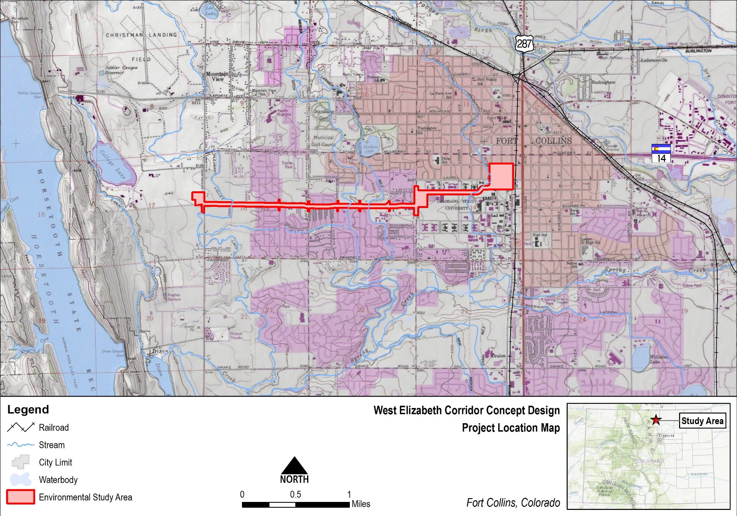

Figure 2: Environmental Study Area Map
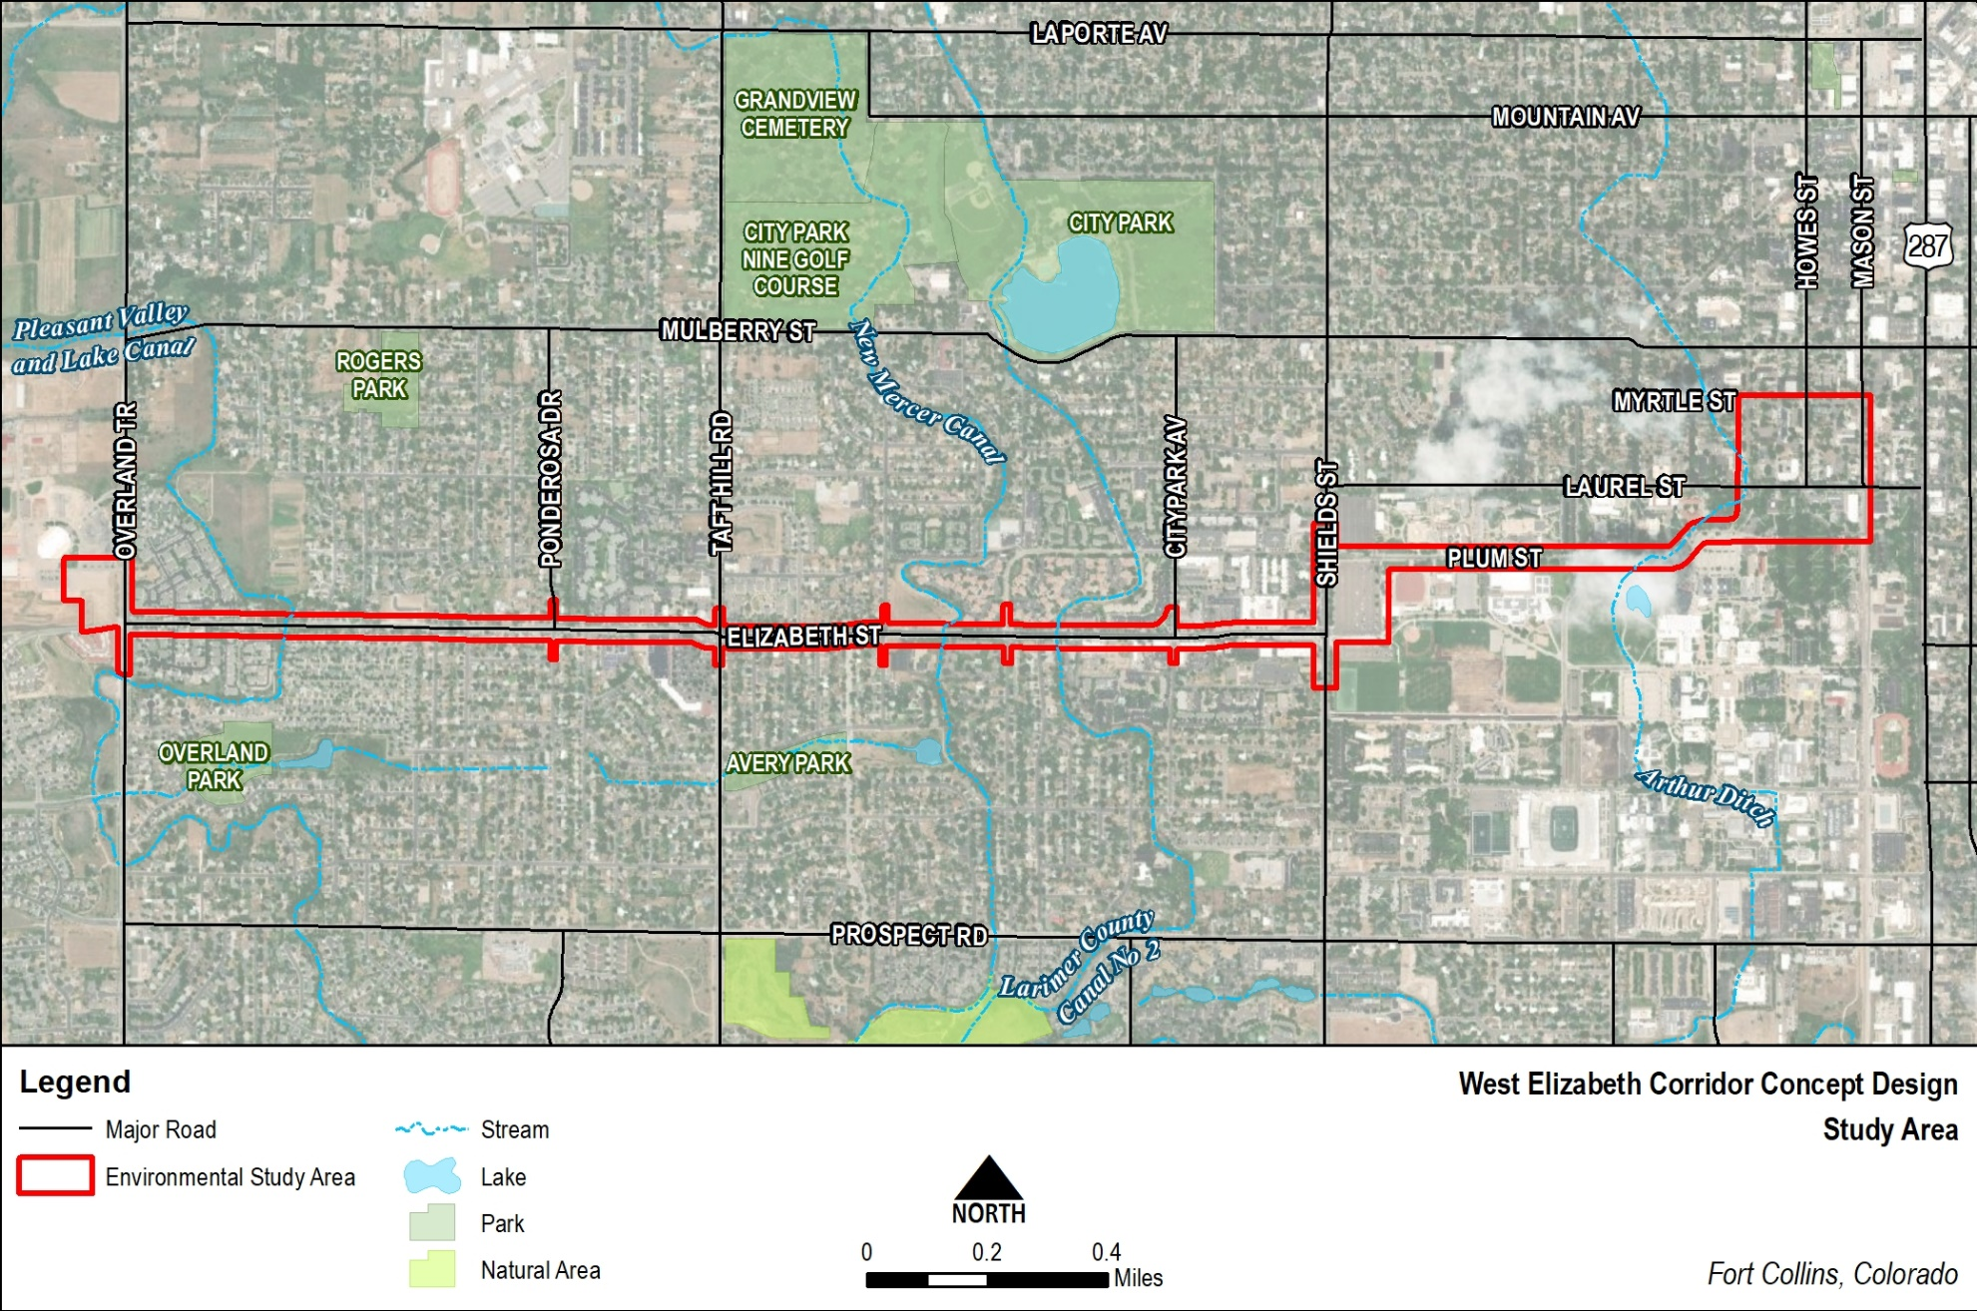

Figure 3: Zoning
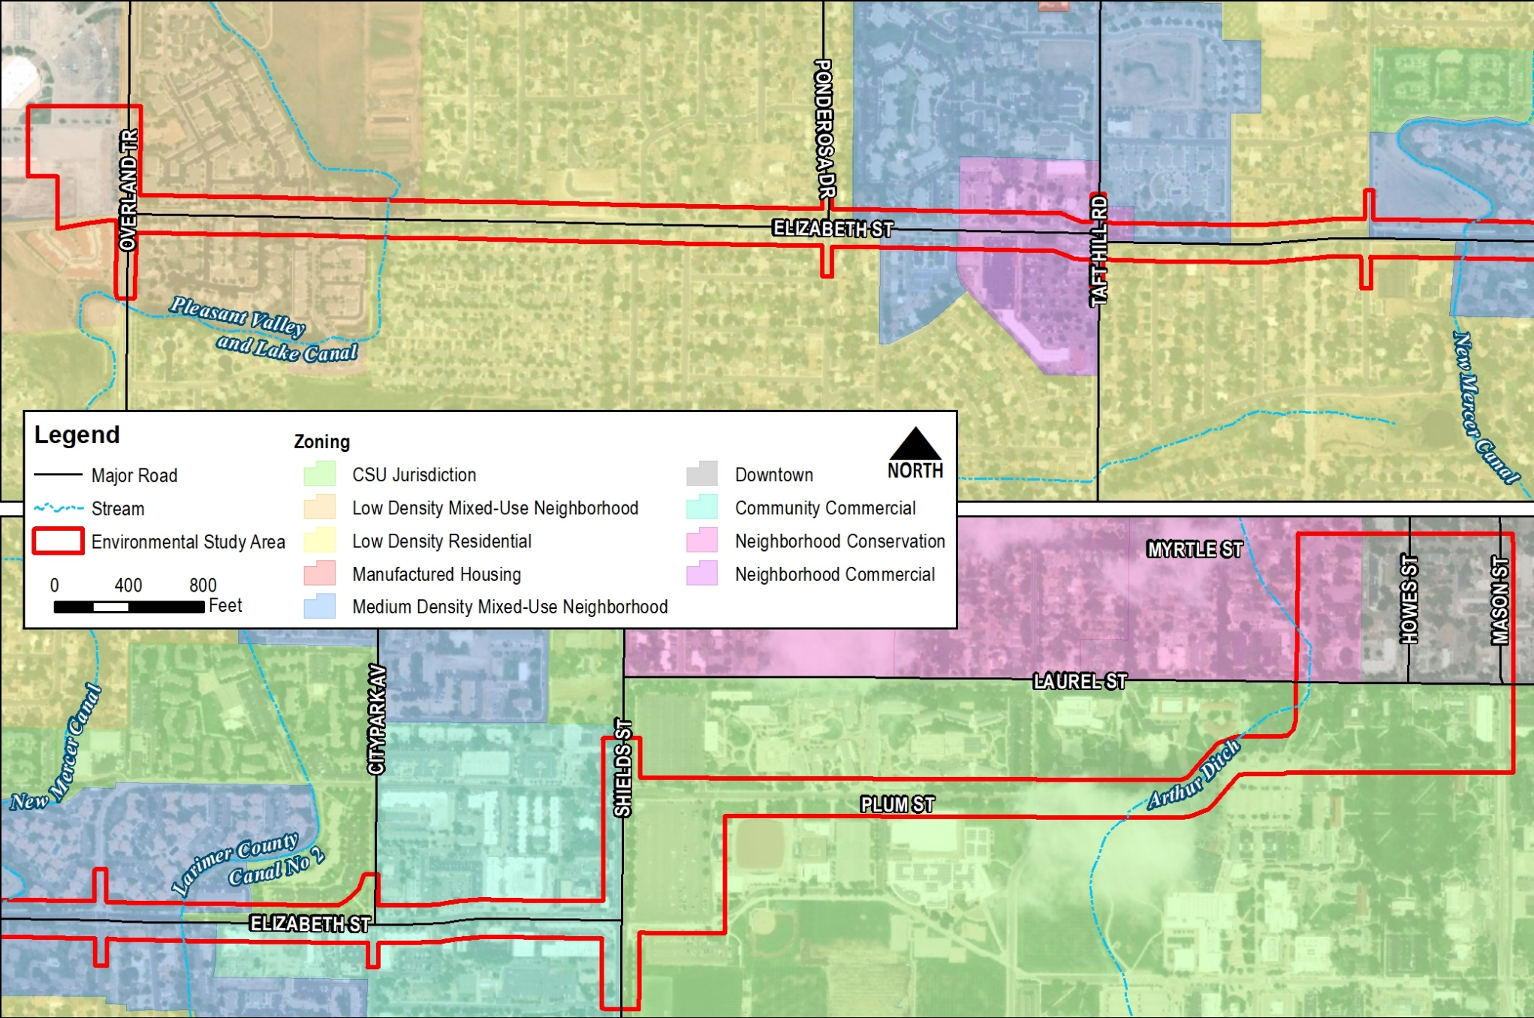

Figure 4: Draft Design (Sheet 1 of 8)
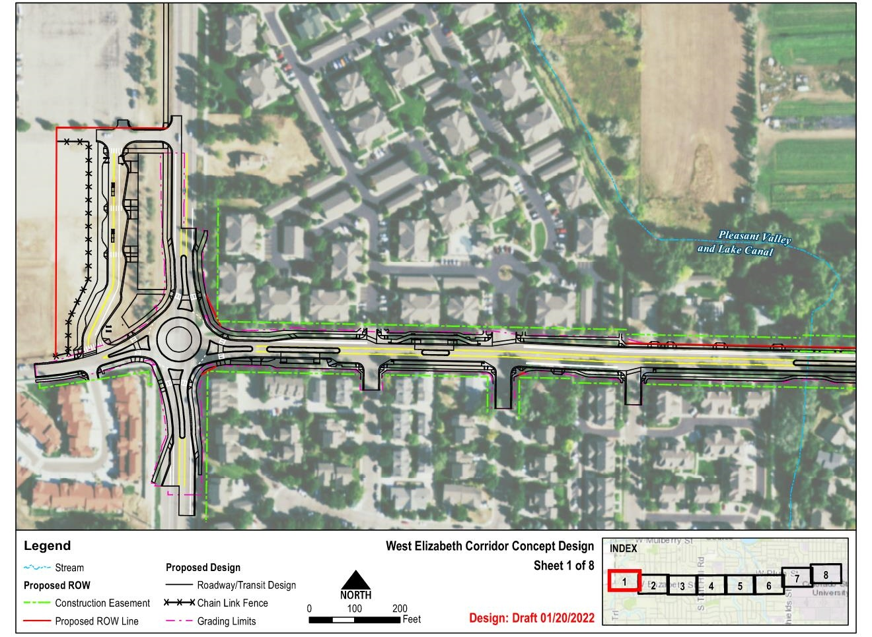
Figure 4: Draft Design (Sheet 2 of 8)
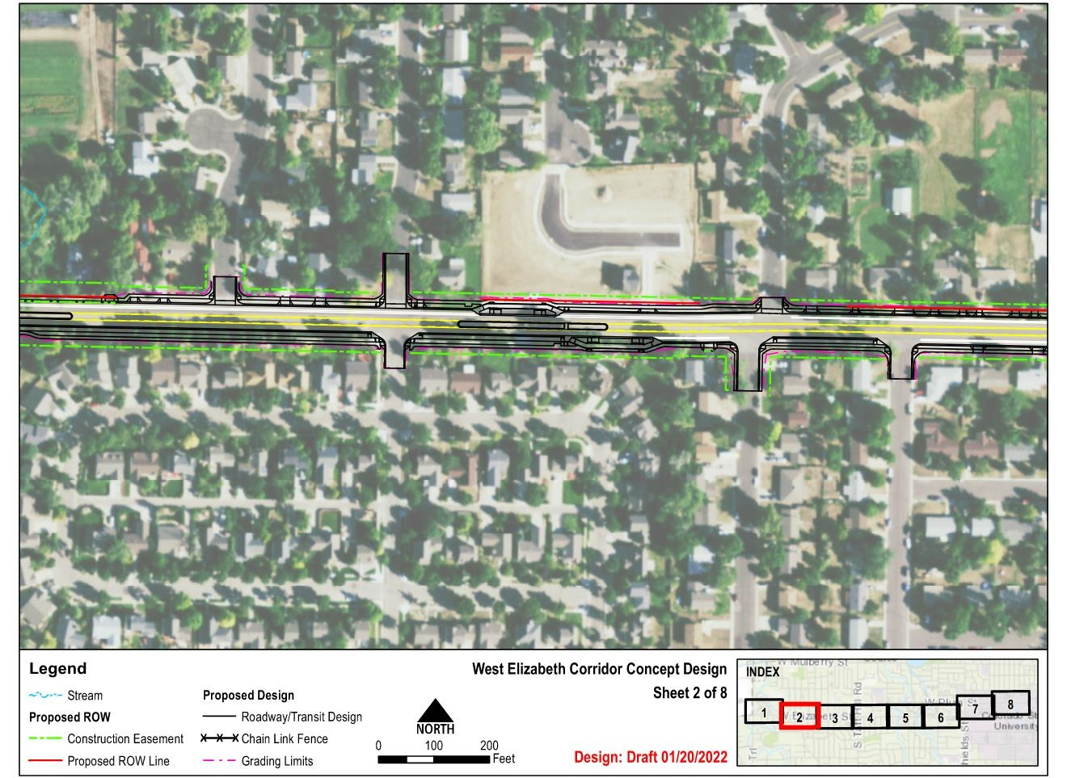
Figure 4: Draft Design (Sheet 3 of 8)
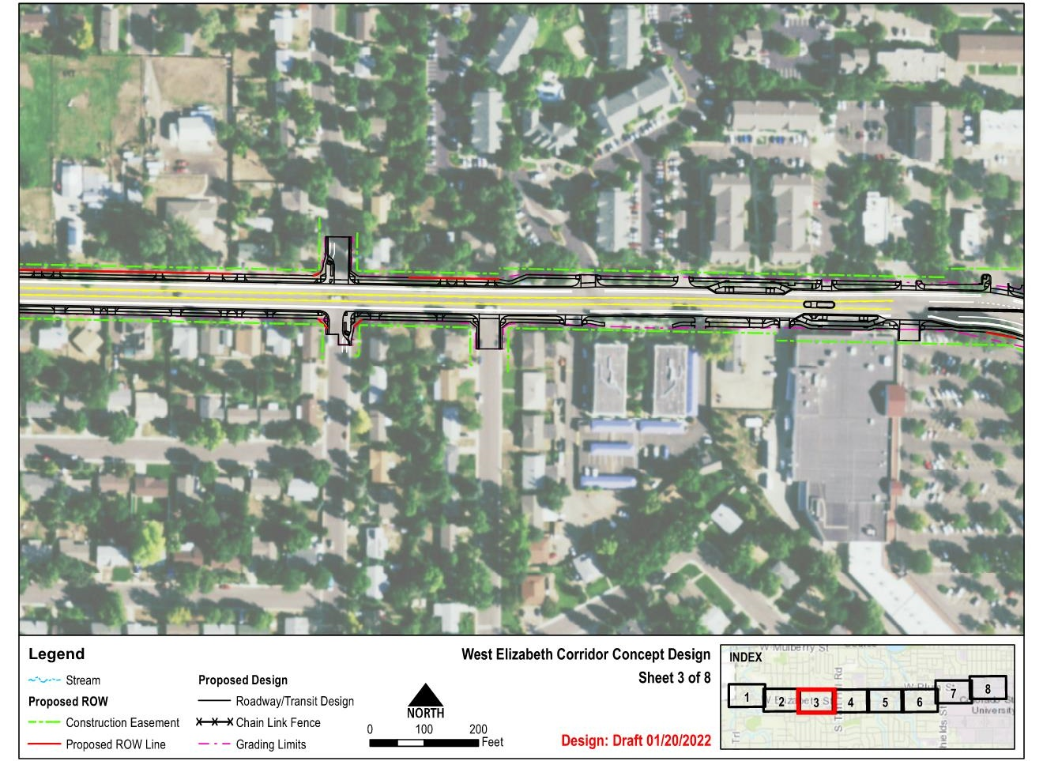
Figure 4: Draft Design (Sheet 4 of 8)
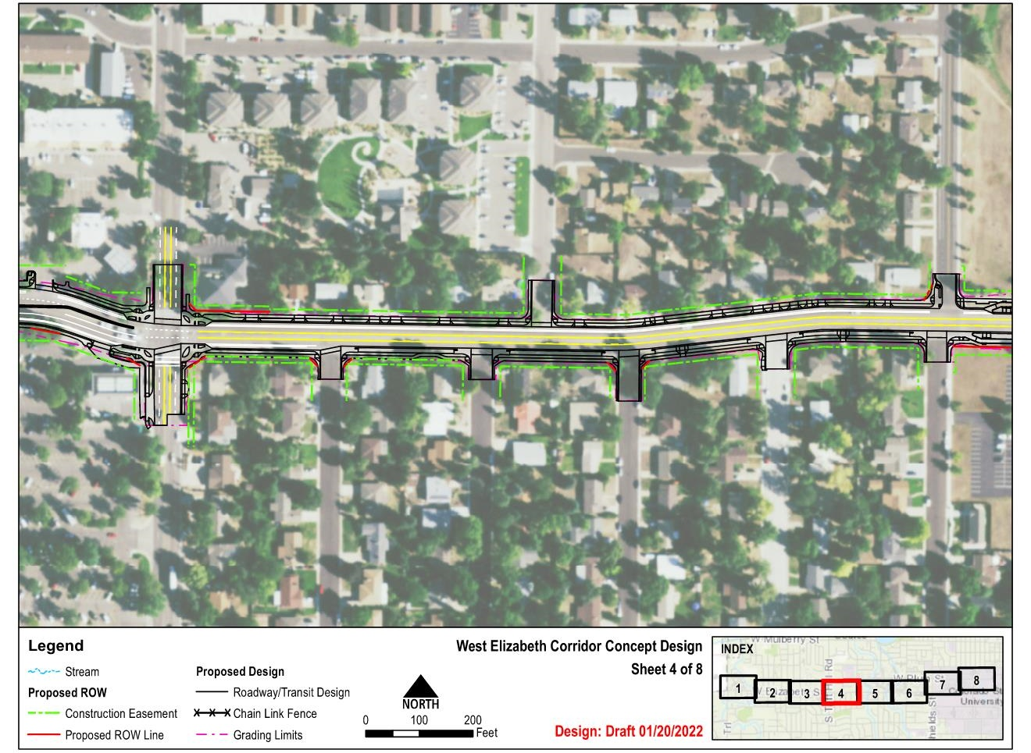
Figure 4: Draft Design (Sheet 5 of 8)
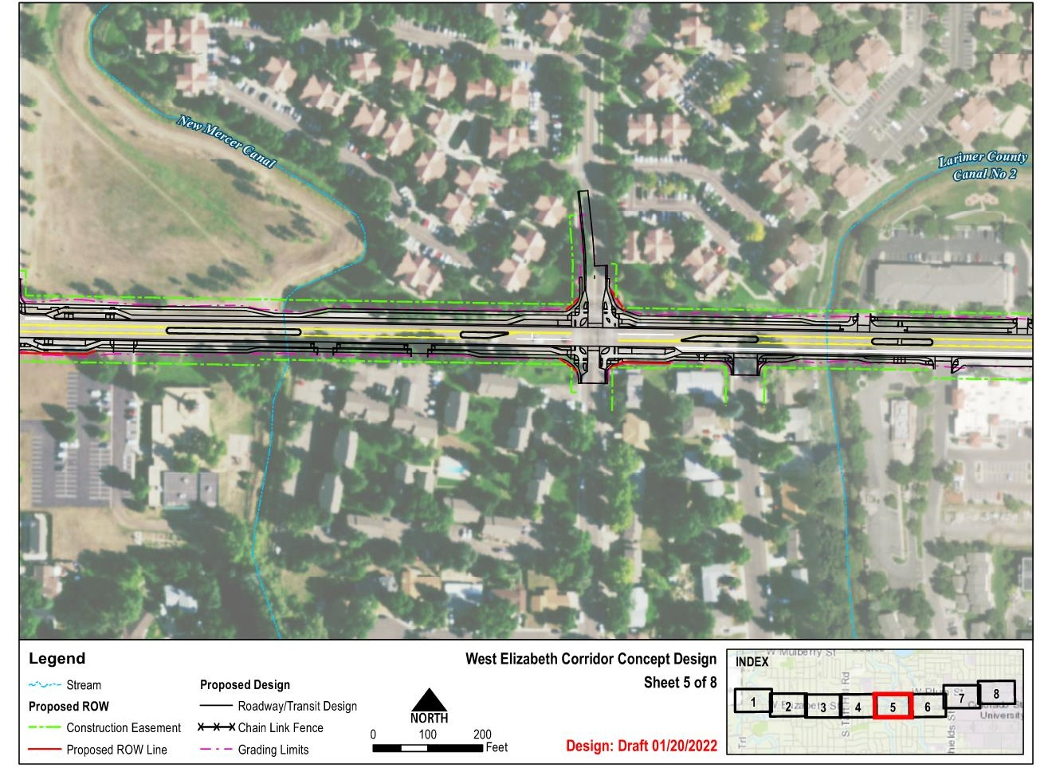
Figure 4: Draft Design (Sheet 6 of 8)
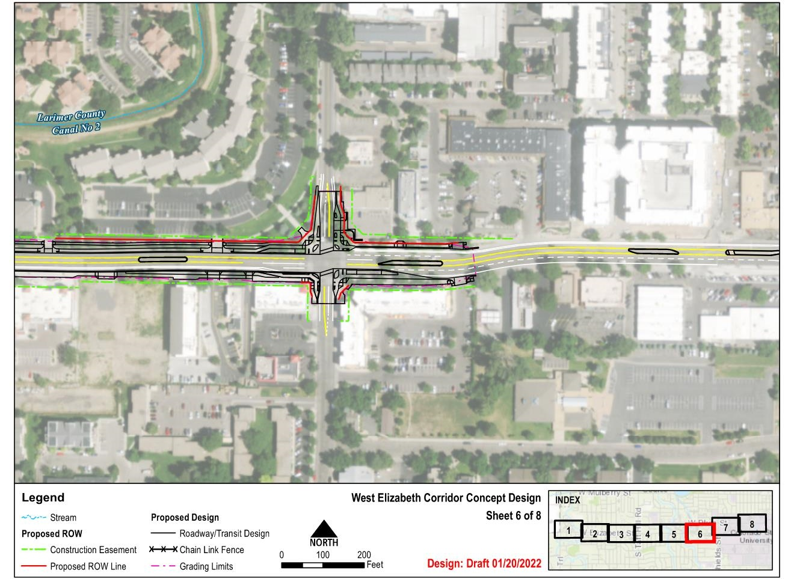
Figure 4: Draft Design (Sheet 7 of 8)
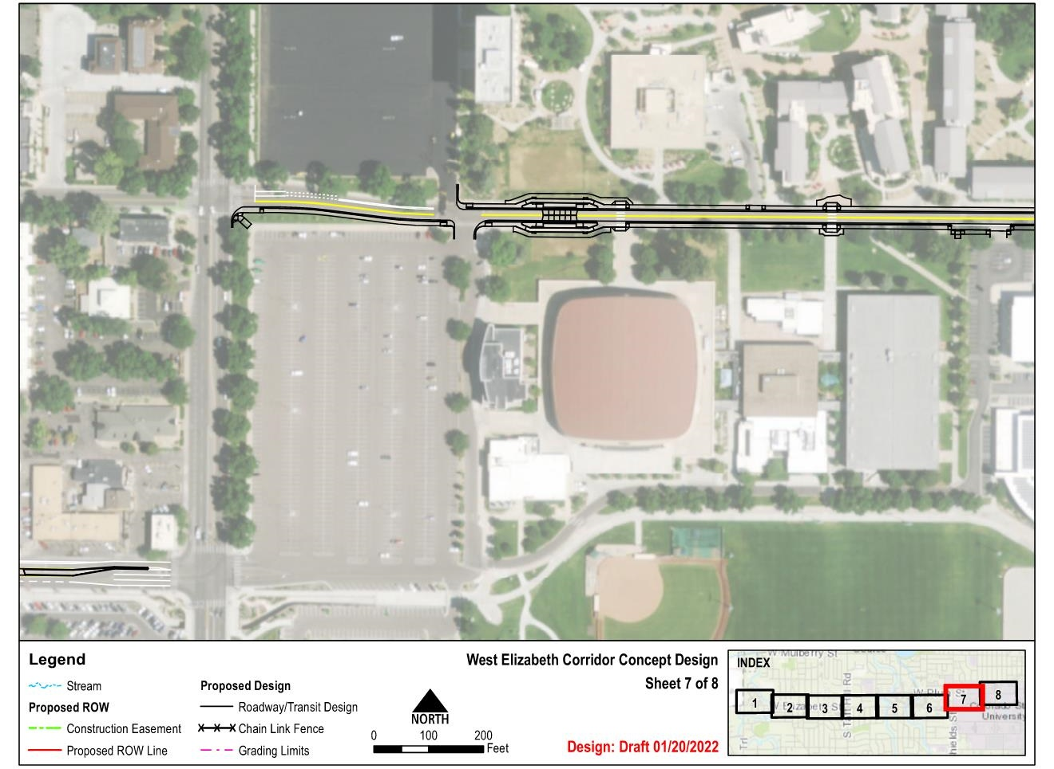
Figure 4: Draft Design (Sheet 8 of 8)
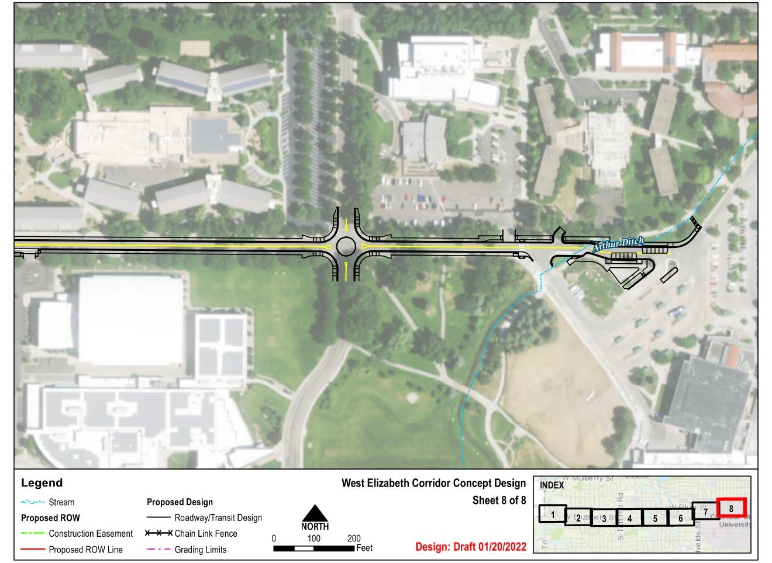
Figure 5: Low-Income Populations
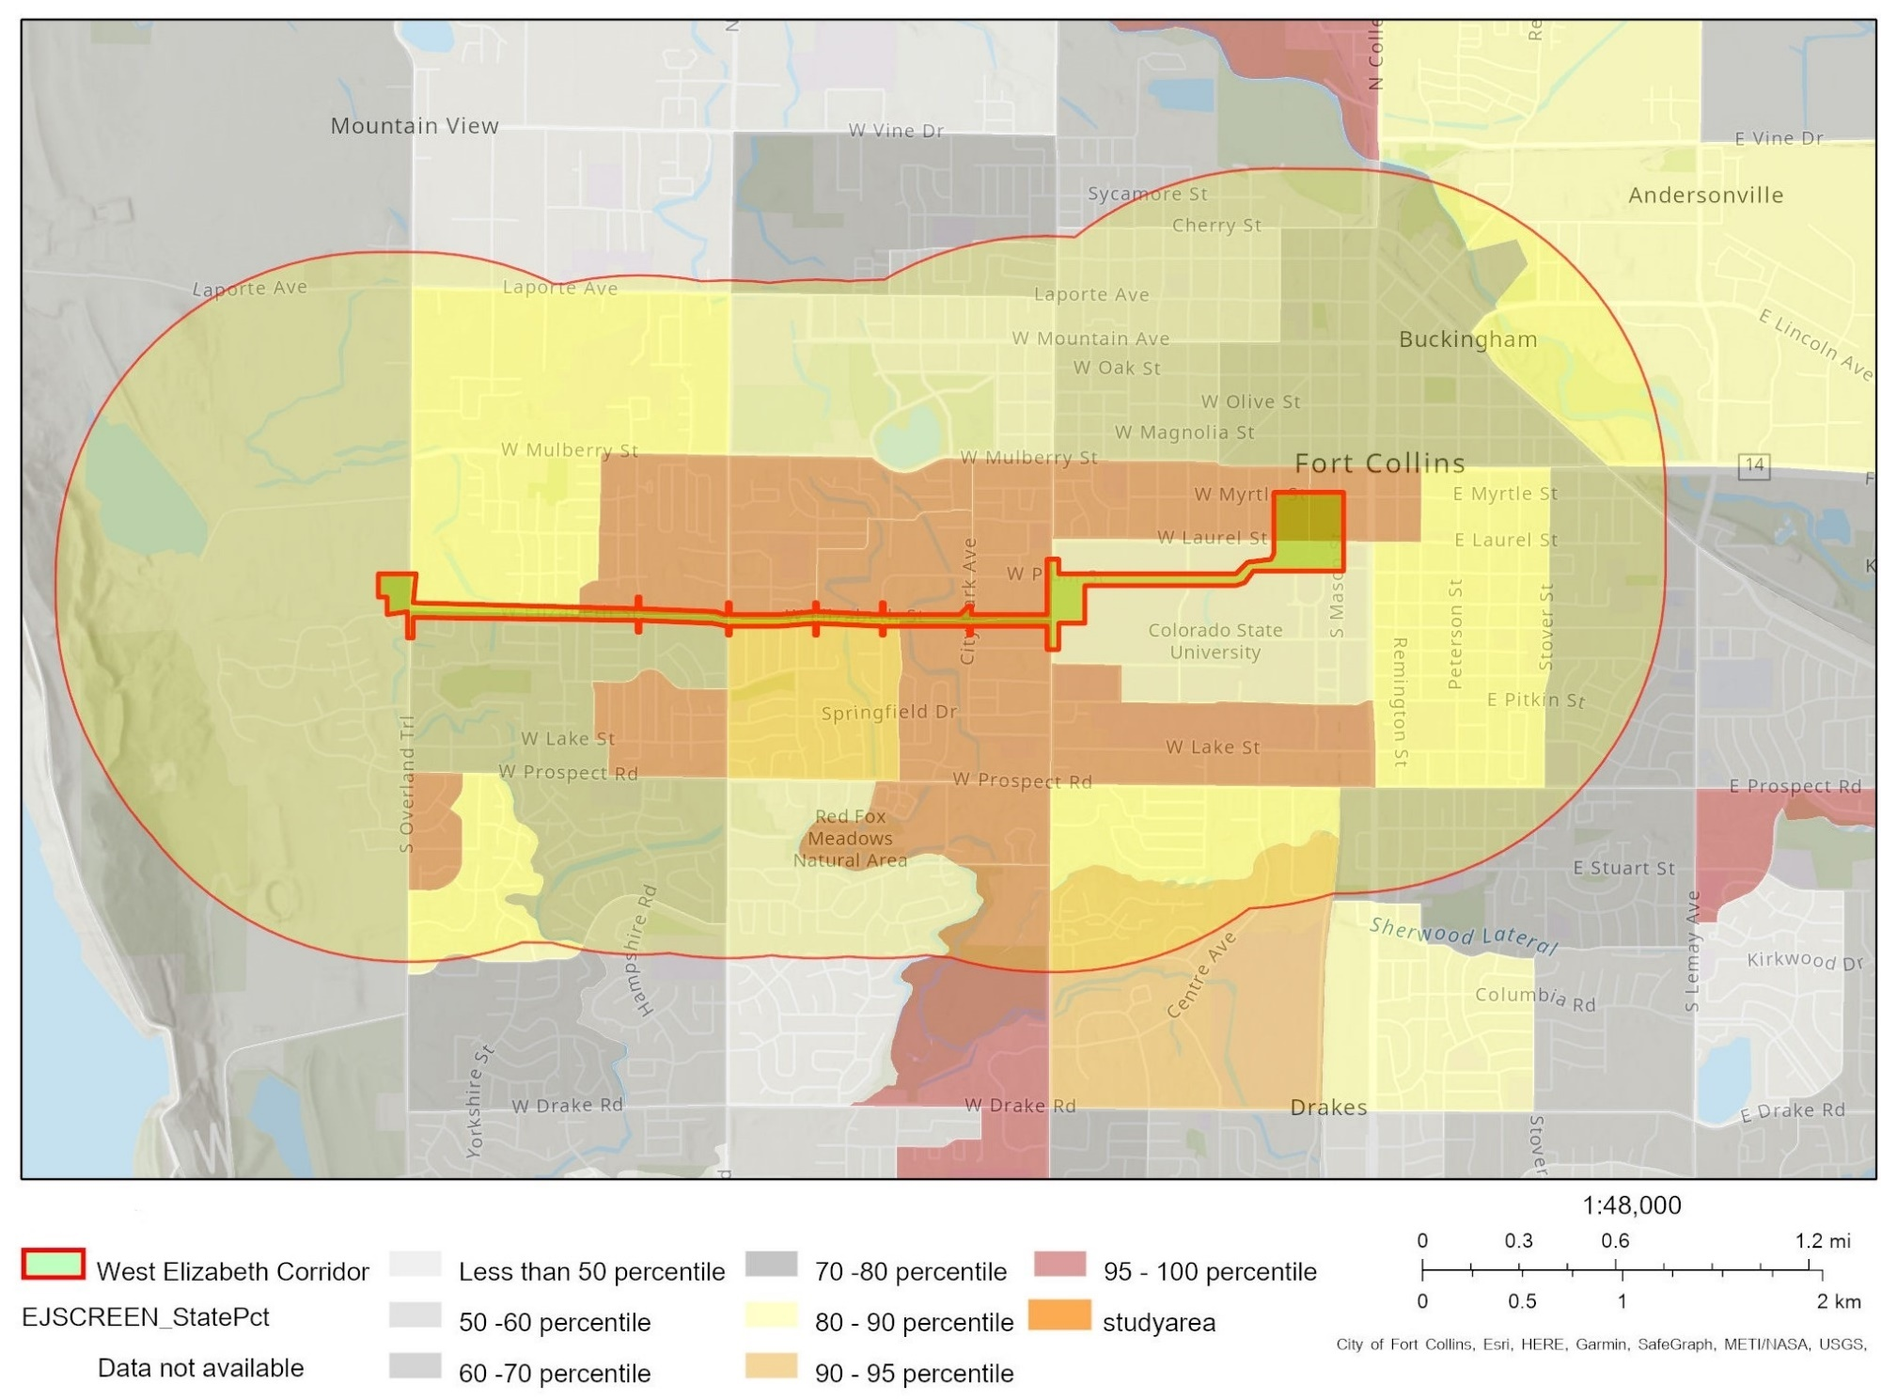
Figure 6: APE (Sheet 1 of 4)
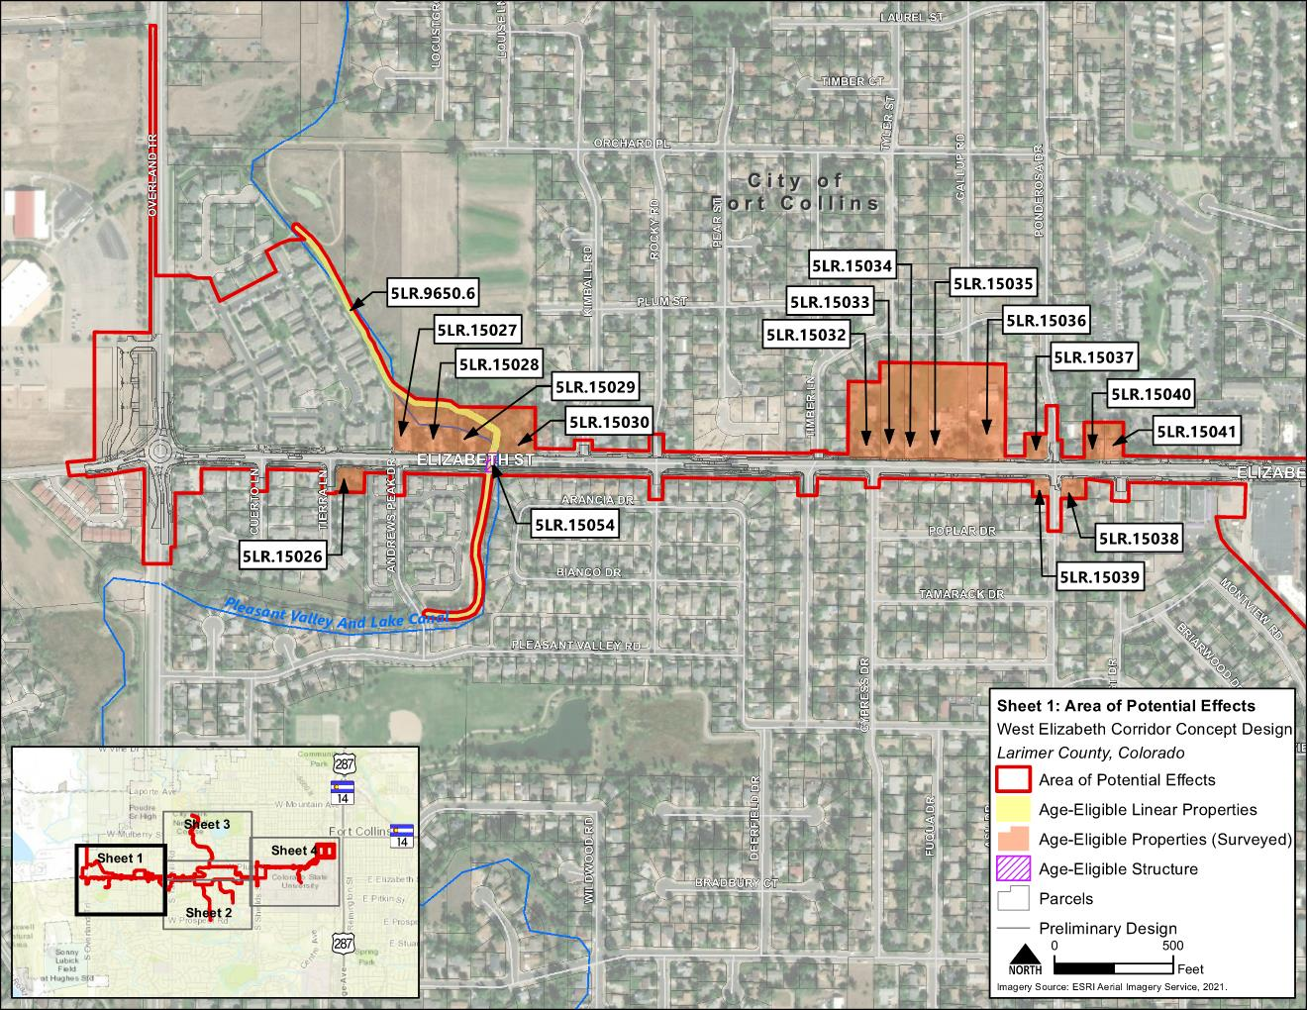
Figure 6: APE (Sheet 2 of 4)
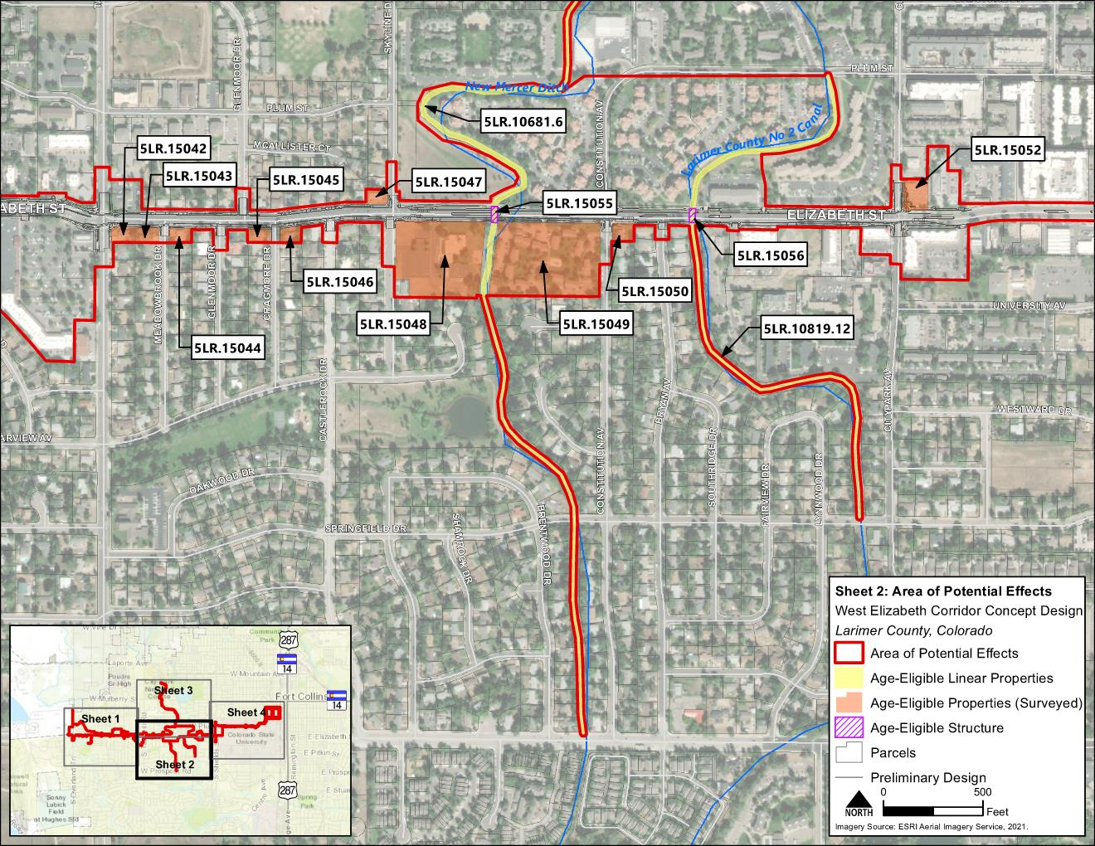
Figure 6: APE (Sheet 3 of 4)
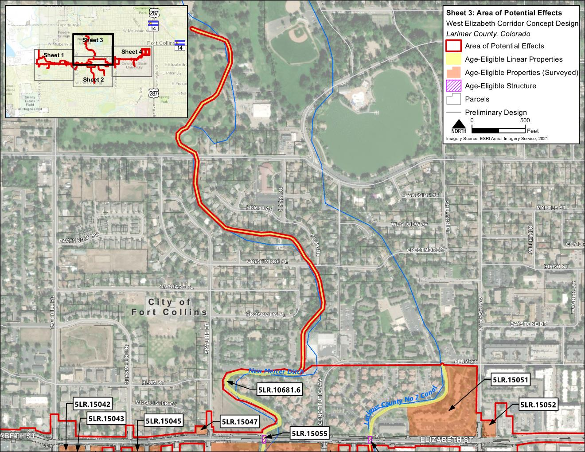
Figure 6: APE (Sheet 4 of 4)
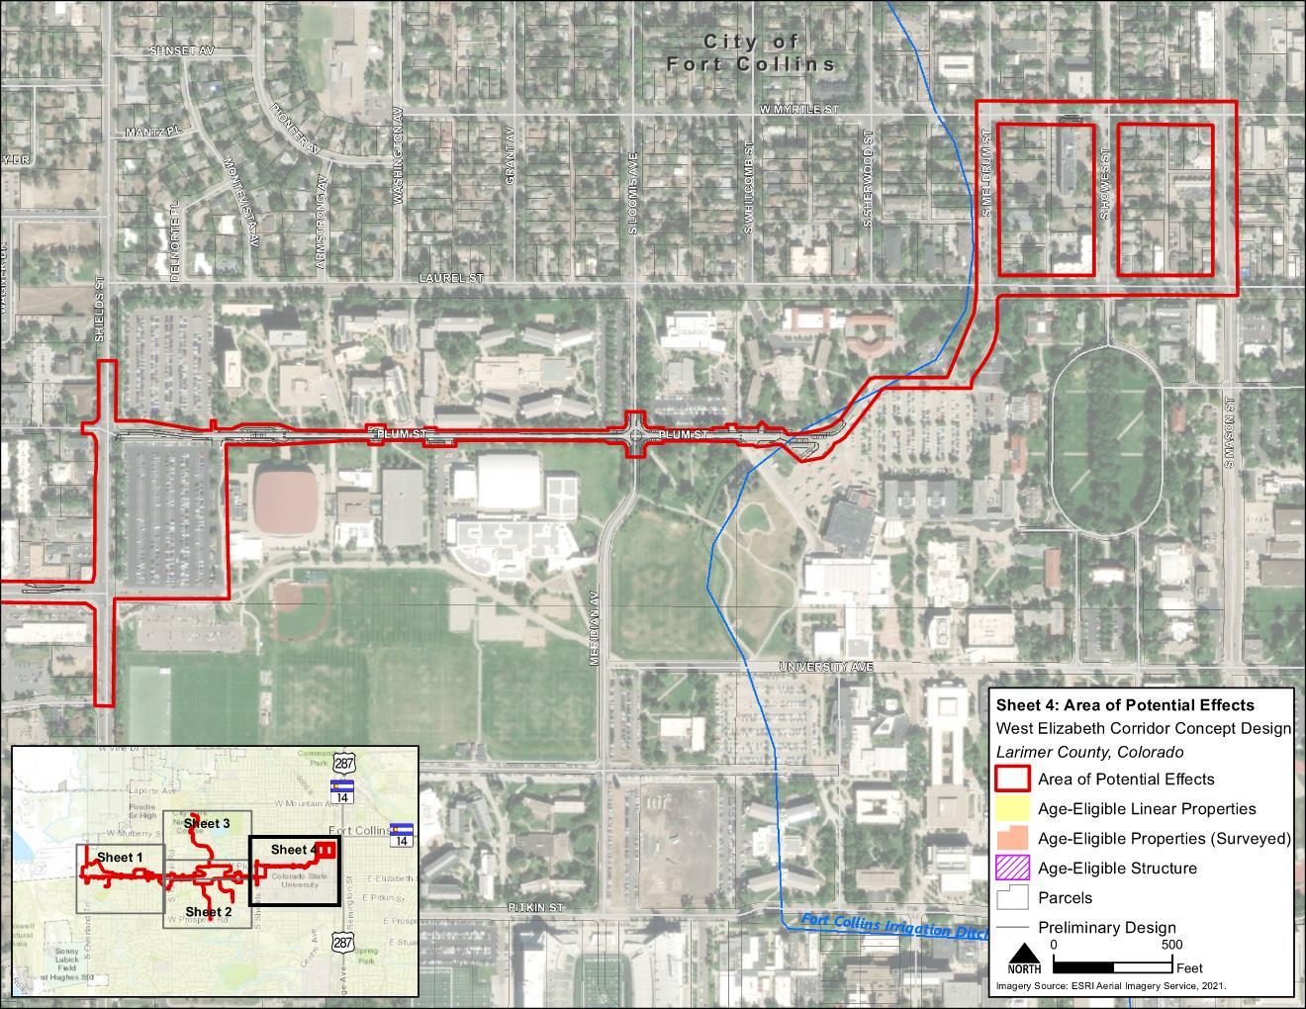
Figure 7: Parks and Recreation
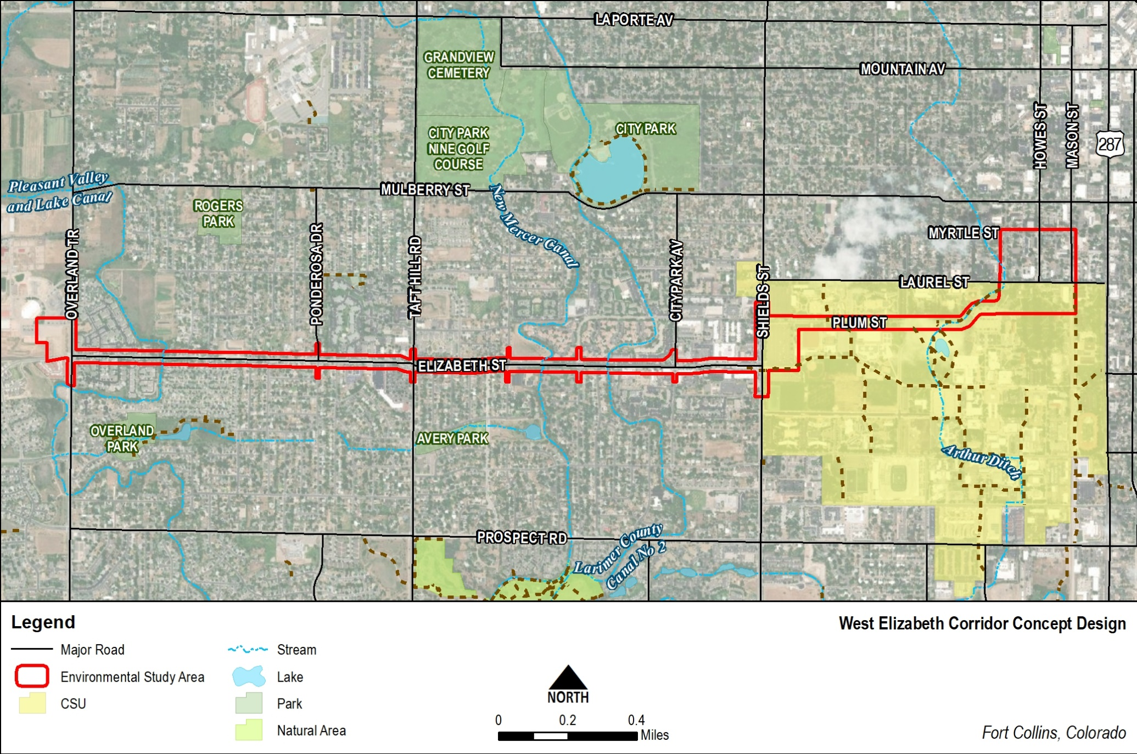

Figure 8: Typical Transit Stop
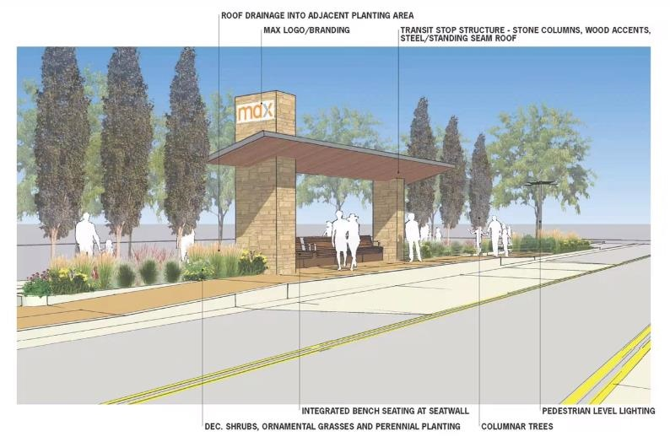

Figure 9: Waters of the U.S., Including Wetlands
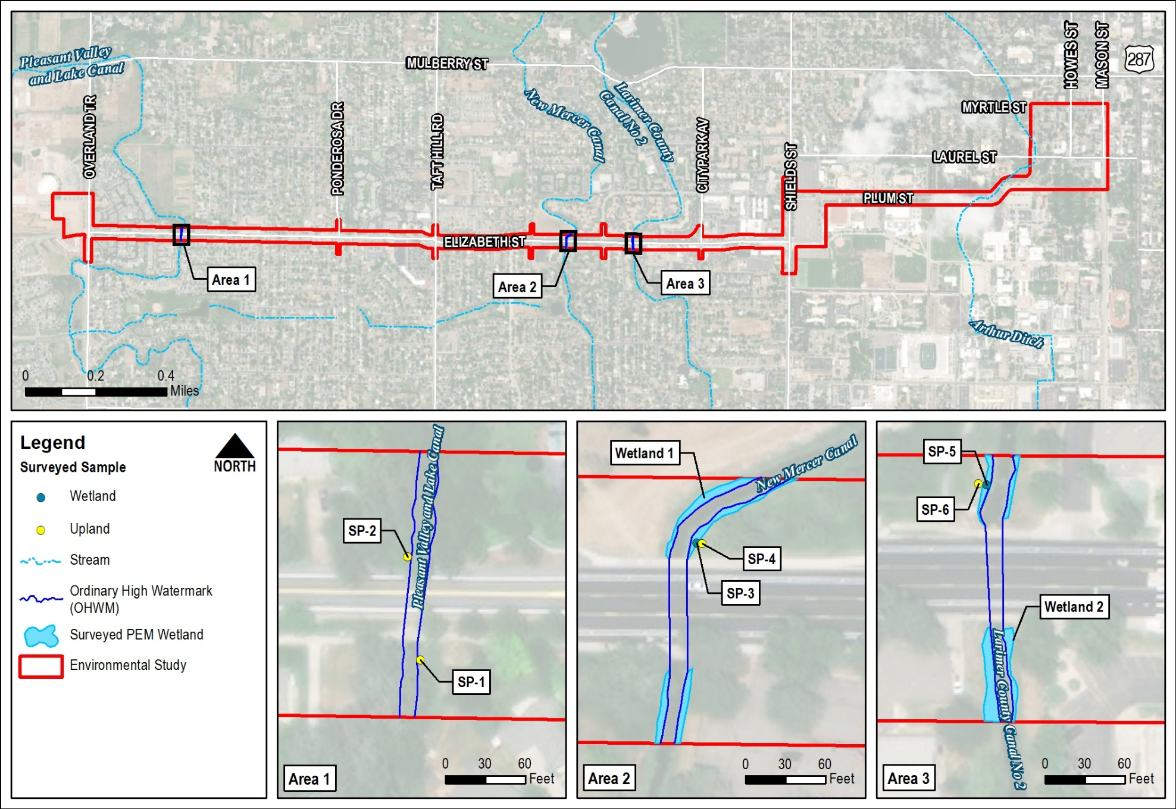

Attachment A – Noise Memo

Attachment B – Phase I ESA Report

Attachment C – Wetland Delineation Report

Attachment D – Biological Resources Technical Report

