



Integrated Design Assistance Program (IDAP) Program Manual

October 10th , 2024

Contents

Section 1 Introduction 1-1

1.1 Program Overview 1-1

1.2 Contact Information 1-1

1.3 Manual Use and Organization 1-1

1.4 Additional Program Documentation 1-2

Section 2 Program Requirements 2-1

2.1 Building Owner Eligibility 2-1

2.2 Project eligibility 2-1

2.3 Energy Cost savings Target 2-2

2.4 IDAP Whole Building Strategy 2-2

Section 3 Modeling Methodology and Energy Target 3-1

Section 4 Incentives 4-1

4.1 Existing building project Baselines – no change of use 4-2

4.2 Existing building project Baselines – change of use 4-2

4.3 Incentive Caps 4-2

4.4 Incentive Availability 4-2

Section 5 IDAP Design Process 1

5.1 IDAP process overview 1

5.2 Design team meetings and reports 1

5.3 Post-construction activities 7

5.4 Recommendations for Coordination & Communication 2

Section 6 Appendix A: EC Qualifications, Applications, and SOW 1

Section 7 Appendix B: Energy Modeling Guidelines 1

Energy Simulation Program Selection 1

Quality Control Process 1

Section 8 Appendix C: Energy Report Guidelines 1

Section 9 Appendix D: Baseline Model Tables and Formulas 1

Build Baseline Model 1

Determine Energy Code Baseline 1

Establish Performance Target 1

Building Performance Factors 1

Section 10 Appendix E: Incentive Formulas 1

Design Incentive 1

Construction Incentive 1

Performance Incentive (Optional) 2

Section 11 Appendix F IDAP Commissioning Checklist 1

Section 12 Appendix G: Frequently Asked Questions 2

Section 13 Appendix H: Resources 1

# Introduction

## Program Overview

Fort Collins Utilities’ (Utilities) Integrated Design Assistance Program (IDAP) provides technical assistance and financial incentives to help architects, engineering professionals, and building owners optimize energy and demand savings and reduce operating costs in eligible new construction and existing building major renovation projects. Building owners are ensured a more integrated design process and overall more energy efficient building through engaging the expertise of an energy consultant (EC) early in the project to provide the energy modeling services required by the IDAP program. Key program milestones, such as an early design charrette (energy workshop) and energy modeling reports help keep energy efficiency integrated in the design.

IDAP employs a whole-building, performance-based strategy that fosters an integrated design approach with the project’s design team starting during the conceptual phase. Through this process, the design team (typically the owner, architect, mechanical and electrical engineers, energy consultant, and contractors) considers and analyzes multiple high efficiency design features and their associated economic impacts early in the design process. Early involvement combined with the comprehensive interaction of key project stakeholders affords the opportunity to cost-effectively evaluate and incorporate energy efficiency features while the design is still fluid. The program is designed to be scalable for projects of varying size and flexible to grow with building owner needs.

ECs providing modeling services under the IDAP must be pre-approved by Utilities. If building owners/design teams wish to use a modeling consultant that has not previously been approved, the consultant can submit an energy modeling application to Utilities. Approved ECs will contract directly with the building owner or design team, not with Utilities.

The IDAP energy reduction target is based on the ASHRAE 90.1 Appendix G (Performance Rating Method) modeling guidelines corresponding with the International Energy Conservation Code (IECC) adopted by the City of Fort Collins at the time of the building permit or projected permit date. The program delivers incentives during the design and construction phases of the project with the option for building owners to earn a performance incentive within the first 2 years of building occupancy based on metered data. See Figure 1‑1 for a graphical depiction of the IDAP process and how it coincides with the typical construction phases.

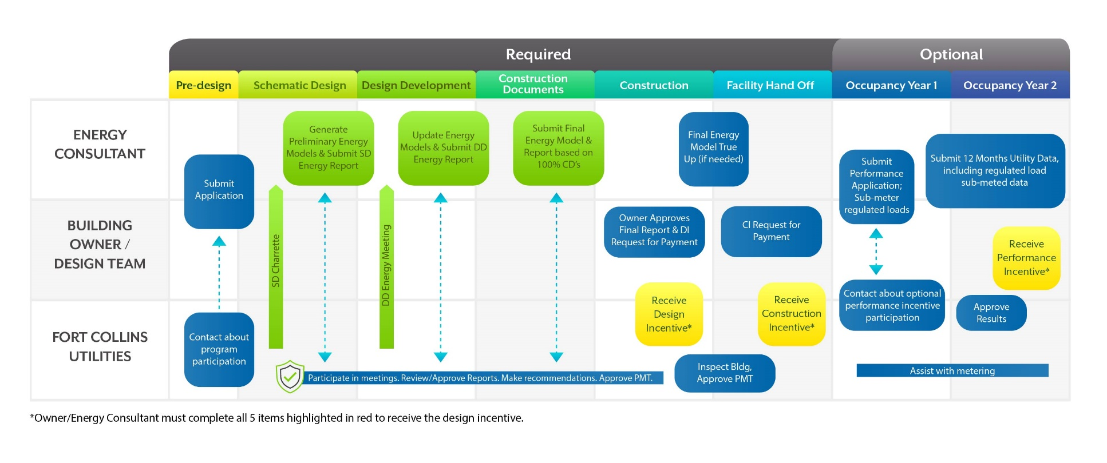

**Figure 1‑1: IDAP Program Flow through Design, Construction, and Occupancy**

The following are key elements of IDAP program participation:

* New construction and major renovation projects may participate
* Application must be submitted early in the design process (Conceptual or early Schematic Design).
* Specific deliverables align with traditional design and construction milestones allowing for a highly integrated, user-friendly, and timely design assistance process.
* Intended for projects with a focus on increased building efficiency and committed design teams using an integrated design process early in the project.
* (Optional) Owners can apply for the performance incentive, which is based on 12 consecutive months of sub-metered energy use data, within the first 2 years of building occupancy.

For new construction and existing building major renovation projects that do not lend themselves to a comprehensive whole building approach (e.g., too late in the process for IDAP or accelerated timeline), Utilities and Platte River Power Authority offer the Efficiency Works program, providing prescriptive and custom incentives for qualified building owners. Prescriptive incentives are available for high efficiency lighting, motors, refrigeration measures that meet or exceed minimum eligibility requirements. Custom incentives are also available for systems that exceed code requirements or standard industry practice. Approved IDAP projects cannot use Efficiency Works rebates for Regulated energy use (e.g. HVAC, lighting, water heating), but may apply for rebates for unregulated loads (e.g., office and IT equipment, food service, etc.) in addition to water efficient equipment.

## Contact Information

Questions about the program can be directed to the Program Administrator via:

|  |  |
| --- | --- |
| Program Website | <http://www.fcgov.com/IDAP> |
| Program Manager | David Suckling |
| Phone | (970) 416 4251 |
| Email | [dsuckling@fcgov.com](mailto:dsuckling@fcgov.com) |
| Mail | David Suckling  Integrated Design Assistance Program  Fort Collins Utilities  P.O. Box 580  Fort Collins, Colorado 80522 |

## Manual Use and Organization

This Program Manual outlines the rules and requirements of IDAP and is designed for use by building owners, energy consultants, architecture and engineering firms, energy services companies, contractors, and equipment manufacturers. This manual should be reviewed by all parties and is organized as follows:

* Section 2 - Program Requirements: Addresses building owner, project, and measure eligibility requirements
* Section 3 – Modeling Methodology and Energy Target: Details for developing the energy model and setting target to achieve program energy cost savings.
* Section 4 – Incentive Information: Discusses how to qualify for and calculate incentives
* Section 5 – IDAP Design Process: Outlines the program meetings and report submittal requirements
* Appendix A – Energy Consultant Qualifications, Application, and SOW
* Appendix B – Energy Modeling Guidelines
* Appendix C – Energy Report Guidelines
* Appendix D – Baseline Model Tables and Formulas
* Appendix E – Incentive Formulas
* Appendix F – Frequently Asked Questions
* Appendix G – Resources

## Additional Program Documentation

The IDAP web page will have the most current program application and report template documents including:

* IDAP program application
* IDAP Program Manual
* Schematic Design Energy Report (SDER) Template
* Design Development Energy Report (DDER) Template
* Final Energy Report (FER) Template (based on DDER template)
* Blended cost per kWh information for each program year
* IDAP performance incentive application

All of this and more can be found on the IDAP web page at **-** [www.fcgov.com/idap](http://www.fcgov.com/idap)

# Program Requirements

## Building Owner Eligibility

For the purposes of Fort Collins Utilities energy efficiency programs, a project qualifies for participation in IDAP if it receives or will receive electric service from Utilities. A building owner is a holder of a single account, multiple accounts in aggregate or corporate accounts. Multiple accounts or corporate accounts with a single Utilities building owner identification number will be considered a single owner. An organization of this type can participate in multiple efficiency programs, but will be subject to any applicable incentive caps. Building owners with questions regarding their account should contact the Utilities Business Resource Team at [utilitiesbizresourceteam@fcgov.com](mailto:utilitiesbizresourceteam@fcgov.com) or call 970-416-4268.

## Project eligibility

Facilities that fit the following requirements are eligible to participate in the program:

1. Projects in conceptual or early schematic design. Flexibility must still be available regarding choices for building design, envelope, HVAC and electrical systems. Early involvement in the design process by the Utilities design assistance team ensures that all energy-saving options can be considered. Please note that involving IDAP even earlier is appropriate as well.
2. The proposed project has a goal of designing to an energy target with at least 10% regulated energy savings compared to the current City of Fort Collins energy code Baseline (using ASHRAE 90.1 Appendix G modeling methodology corresponding with the International Energy Conservation Code (IECC) adopted by the City of Fort Collins at the time of the building permit or projected permit date and applying Building Performance Factors to adjust the model to current code);
3. Utilities staff and IDAP program consultants will be invited to attend design meetings for the project related to energy considerations and will be kept apprised of project progress and major energy-related decisions;
4. The minimum project size for IDAP is 5,000 SF. The available IDAP design incentive increases with building size (See Section 4 for details). For smaller buildings typically less than 10,000 square feet (SF), it is highly recommended that the owner and design team consider the cost-effectiveness of participating in the IDAP program. A cost-effectiveness assessment should include comparing energy modeling and design team costs to IDAP program benefits (potential design, construction, and optional performance incentives, long-term energy savings and life cycle costs).
5. Projects involving commercial or high-rise residential buildings (as defined by ASHRAE 90.1) planned for new construction or existing building major renovation projects. A major renovation is defined as any renovation of a building where (a) the total cost of the renovation related to the building envelope or the mechanical/electrical building systems is higher than 25% of the value of the building, excluding the value of the land upon which the building is situated, or (b) more than 25% of the surface of the building envelope undergoes renovation.
6. Low-rise multifamily residential projects and large residential developments may be eligible and are determined on a case by case basis.
7. Utilities retains the right to make final determination of project eligibility.

## Energy savings Target

In order to receive the construction incentive, the building must meet or exceed the design EUI savings target, which is based on a minimum 10% regulated energy reduction below the applicable City of Fort Collins energy code using the corresponding ASHRAE 90.1 Appendix G energy modeling methodology. The specifics of the energy baseline methodology are detailed in Section 3.

The baseline used for the energy target will be set based on the City of Fort Collins code cycle that applies at the time building is expected to be permitted.

## IDAP Whole Building Strategy

IDAP is structured to promote whole building energy efficient design through an integrated systems approach to achieve an energy target. Therefore, program design assistance concentrates on facilitating an integrated design process with all stakeholders looking at the building as a system to achieve energy efficiency as opposed to focusing on individual components in isolation. The integrated, whole-building approach provides significant benefit over evaluating each measure individually. The goal is to treat the building as a functionally integrated structure rather than a base building with “add-on” efficient systems. By combining the strategies into a design package, the influence of trade-offs and interactions between systems can be appropriately evaluated. IDAP is designed to encourage integrated high-performance building design through:

* Building shape and orientation
* Building envelope thermal design and air tightness
* Daylighting, electric lighting design and controls
* HVAC mechanical systems and duct/pipe design
* Fenestration optimization
* Enhanced control automation

Examples of specific measures often included in integrated design projects are listed in Table 2‑1. This list is not exhaustive and program participants are encouraged to incorporate other strategies not included in the table. Renewable energy generation is not counted towards the IDAP energy reduction target, but incentives for such technologies are offered by Utilities.

Table 2‑1. Examples of New Construction/Major Renovation Energy Efficiency Measures

| **Category** | **Measure** | |
| --- | --- | --- |
| Passive design strategies | External overhangs  Building orientation  Low-pressure-drop duct & pipe design  Stack & Cross Ventilation | Optimizing window to wall ratio  Trees for shading and wind protection  Solar wall systems  Building thermal mass |
| Envelope | Continuous air barrier  Improved wall insulation  High efficiency glazing  Thermochromic glazing | Improved roof insulation  Cool roof  PV-embedded glazing |
| Lighting | High efficiency fixtures (Interior)  Lower ambient lighting levels  Highly reflective ceiling | Lighting controls  Efficient exterior lighting fixtures  Task lighting |
| Daylighting | Light conveyors  Interior/exterior light shelves  Sloped ceiling  Reflective ceiling | Stepped daylighting controls  Dimming daylighting controls  Skylights/roof monitors  Integrated solar tube & LED fixtures |
| HVAC Systems | High efficiency water-cooled centrifugal chiller  Heat recovery chiller  Waterside Economizer  High efficiency electric boiler/air to water heat pump  Ground-source heat pump  Water-source heat pump  Variable refrigerant flow systems  Point-of-use electric domestic hot-water heaters  Heat pump domestic hot water heaters  Evaporative cooling technologies | Condensing infrared heaters  Displacement ventilation  Radiant heating/cooling  Chilled beams  High efficiency refrigeration equipment  Geothermal panels for underground spaces  >15°F delta T consideration for chilled water systems  Energy recovery for ventilation systems |

# Modeling Methodology and Energy Target

ASHRAE 90.1 Appendix G with Addenda (Appendix G) is the guideline for generating the baseline energy model. Building Performance Factors (BPFs) are applied to that baseline energy model (roughly equivalent to ASHRAE 90.1-2004 energy standard) to adjust it to reflect the energy use intensity (EUI) of the code baseline for the project (e.g. 2016, 2019 etc.). Another BPF is applied to adjust the baseline to the energy target. Per Appendix G, regulated energy use (equipment impacted by building energy code such as HVAC, lighting, motors, etc.) and unregulated energy use (energy consuming systems that are not impacted by building energy code, such as plug loads and process equipment) are separated. The formulas used for these calculations are summarized in Appendix D: Baseline Model Tables and Formulas

.

# Incentives

IDAP provides the following incentive types to encourage the implementation of whole-building, energy reduction strategies in new construction and existing building major renovation projects. All incentive types are paid to the owner. Figure 4‑1 illustrates the IDAP process and milestones. The formulas to calculate the incentives can be found in Appendix E: Incentive.

IDAP now offers an incentive to reduce air infiltration below what City code requires. The target air infiltration numbers could be found at Table 6.

The incentive for meeting the leakage metric for the appropriate building is $0.10/SF of envelope area. The incentive will be paid with the construction incentive upon reviewing the commissioning report or reviewing the air infiltration test data should there be no commissioning report.

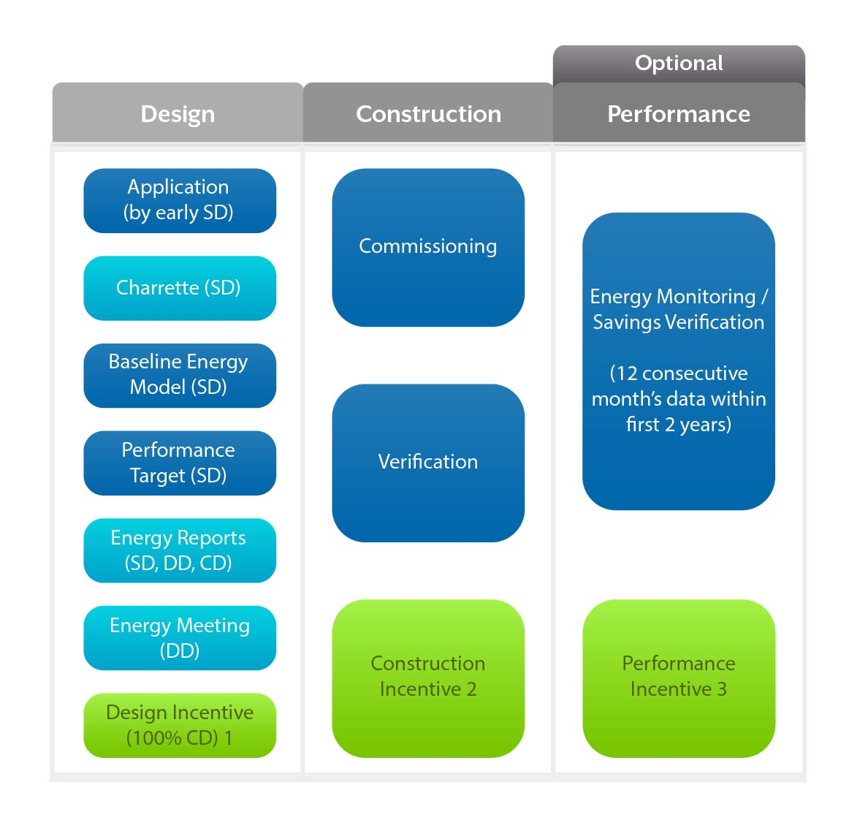

**Figure 4‑1. IDAP Process and Milestones**

1 Paid at the end of design based on meeting 5 deliverables

2 Paid at end of construction after verifying efficiency upgrades and commissioning

3 Paid within two years of occupancy. Regulated loads monitored for minimun12 consecutive months

## Existing building project Baselines – no change of use

When the use of a building is not changing, the renovation of or addition to the building will be modeled based on energy code requirements for the baseline model. Per Appendix G Table G3.1, Section 2. *Additions and Alterations*, unmodified existing building components shall follow the same rules as new and modified building components. For example, even though the renovation may only involve lighting and HVAC and not the envelope, the baseline building design model would use rules in Appendix G for modeling the envelope rather than the actual building envelope thermal performance. The same would be true for modeling HVAC systems, in that the baseline building design model would use the rules in Appendix G to model HVAC efficiencies rather than actual existing efficiencies. Once the Appendix G baseline model is assembled, the BPFCode will be used to adjust the modeled annual energy to the code baseline. Possible exceptions to this rule can be discussed with the IDAP program administrator.

For renovations to portions of buildings it is acceptable to exclude parts of the existing building in the modeling, given that conditions listed in Table G3.1 Section 2 of Appendix G for the Proposed Building Performance are met.

If the project will involve only an addition to an existing building and has independent HVAC systems, only the addition will be modeled for the IDAP program.

## Existing building project Baselines – change of use

When the use of a building is changing (e.g. building is changing from retail use to restaurant use), then all energy code requirements governing applicable equipment (in this example refrigeration equipment, ventilation, and makeup air requirements) must be incorporated into the energy model and design considerations.

## Incentive Caps

Participants will be subject to a maximum annual amount of $300,000 for the Design and Construction Incentives combined. The Performance Incentive is capped at $150,000 per year, per customer. Utilities will reserve the right to waive or adjust the incentive caps on a case by case basis and determine at their sole discretion the program year to which an incentive is attributed. In some cases, the incentive cap may be exceeded depending on funding and the IDAP Program Manager’s discretion.

## Incentive Availability

Customer applications to participate in IDAP will be reviewed on a first-come, first-served basis until all incentive funding has been committed. Customers seeking participation after reservation of available funding will be given the option to be placed on a waiting list in the order requests were received by Fort Collins Utilities. Current availability of incentive funds can be checked by contacting the IDAP Program Manager.

# IDAP Design Process

## IDAP process overview

Providing quality information in a timely fashion is critical to informing the design team in order to incorporate energy efficient design into buildings. The IDAP design process commences with a design charrette in early Schematic Design and completes with a review of the project construction documents to ensure that the final energy efficient design features are included in the final design and Final Energy Report. The schedule and duration of time between each meeting can be varied to accommodate individual design team’s needs. However, the key milestone meetings described below are required to ensure that progress towards an energy efficient design is achieved.

## Design team meetings and reports

### Program Introduction (Optional)

This optional (but highly recommended) meeting is an informal opportunity for Utilities staff or representative to learn more about the nature of the project and for the owner/design team to ask questions and learn about details of the IDAP program. Details about IDAP meetings, timeline, incentives, and questions that the design team has regarding the program manual and eligibility will be discussed.

### EARLY DESIGN CHARRETTE (REQUIRED FOR DESIGN INCENTIVE)

According to the *Integrative Process (IP) ANSI Consensus National Standard Guide for Design and Construction of Sustainable Buildings and Communities* (2012, p.48) a charrette is a “fast-paced intensive workshop with key client, design, engineering, and building participants” that is meant to “provide a framework for achieving significant production and meaningful agreement among participants in relatively brief amounts of time.” The charrette process presented here includes the minimum requirements for the IDAP program and is primarily focused on realizing energy performance goals. Project teams are encouraged to consider using the charrette process for additional topics such as refining overall integrated design process, refining building programming, improving site sustainability (e.g. stormwater, landscaping, irrigation, etc.), water conservation, sustainable materials selection, and design for occupant health and wellbeing. Examples and suggestions for expanding the charrette to include additional focus areas are available upon request. Please discuss the desire to include other project goals, beyond the basic IDAP scope, with the IDAP representative, design team, and facilitator before planning the charrette.

The IDAP charrette should be done in early Schematic Design (SD), and include the following minimum goals:

1. Create alignment and common understanding around the project vision and goals
2. Form a strong, inclusive, and collaborative project team committed to integrative design
3. Identify and analyze potential high efficiency building features.
4. Outline important steps in the integrative design process and assign champions to each task
5. Build momentum for the project and set it on a course to meet project goals

#### CHARRETTE PARTICIPANTS AND ROLES

The charrette process helps build relationships and consensus within the design team and project stakeholders early on, leading to more robust design solutions, better design collaboration and project execution. The charrette process works best when guided by a trained facilitator. A pre-approved third-party facilitator is provided by Utilities for the IDAP charrette. The facilitator’s role is to moderate and expedite the meeting, helping to build trust and an open environment to explore options, and to keep the meeting on track. In addition, a facilitator familiar to the IDAP process can help to ensure that the IDAP requirements for this meeting are met, as well as any other support and guidance that may be necessary to help the owner/design team organize the charrette.

Table 5-1, below, identifies key stakeholders and their respective roles and responsibilities. Required participants for IDAP are identified with an asterisk (*).

**Table 5‑1: Key Stakeholders, Roles and Responsibilities**

|  |  |
| --- | --- |
| **Team member** | **Roles & responsibilities** |
| Building owner and/or representative* | * Help organize and participate in early design charrette * Provide guidance on overall project goals and aspirations |
| Design team*: architect(s), engineer(s) (MEP, civil, structural, etc.) and other designers (landscape architect, interior designer, lighting designer, etc.) | * Help organize and participate in the charrette process * Provide programming documents for the charrette and to the energy consultant * Provide ideas, strategies, information (estimated costs, measures, etc.) and expertise on integrating all aspects of the project including high-performance energy saving features into the electrical, mechanical and other building systems |
| IDAP pre-approved energy consultant (EC)* | * Participate in the charrette process * Provide expertise regarding high-performance building strategies and energy simulation modeling * Create a list potential high-performance building features that may generate 10% or more energy cost savings beyond code requirements. * After charrette, develop at least 3 energy simulation model packages utilizing documentation from the design team (OPR, BOD, building layouts, design narrative, etc.). * Prepare Energy Reports (see template on IDAP web site) and submit the report and model for QC review at the end of SD and DD phases. * Finalize SD report. |
| IDAP design assistance team*: IDAP program administrator or representative | * Participates in the charrette process, facilitating questions or concerns. * Contributes expertise related to high-performance building features, lessons learned from previous IDAP projects, building codes * Acts as liaison to Utilities & City of Fort Collins departments (building department, etc.) * Review and comment on SD Report |
| IDAP pre-approved third-party facilitator*: Contact information provided by Utilities representative | * Help in planning the charrette process * Facilitate the charrette event, keep on schedule and progressing toward goals ensuring that the IDAP requirements for the event are met * Encourage participation, the exchange of ideas and information, and ensure your group doesn’t get lost in politics, power struggles, or lack of alignment on goals and strategies |
| General Contractor and/or subs | * Participate in the charrette process and provide expertise on the construction process and costs |
| Future building operators (if possible) | * Participate in the charrette process and provide expertise on building operations and maintenance |
| Future building occupants and/or community members (if possible) | * Participate in the charrette process and provide insight and occupant and community perspectives on potential building features, goals, and integration with existing community |

#### CHARRETTE FORMAT AND DURATION

A typical IDAP early design charrette is a half-day (~4 hours), though some projects may require or benefit from a full-day (~6-8 hours) event. There may be a need for a multi-day charrette (~1.5-2.5 days), and additional follow-up meetings, depending on the building complexity, size, and make-up of the project team. Planning and execution of the IDAP early design charrette should include the following steps (Fig. 5-1):

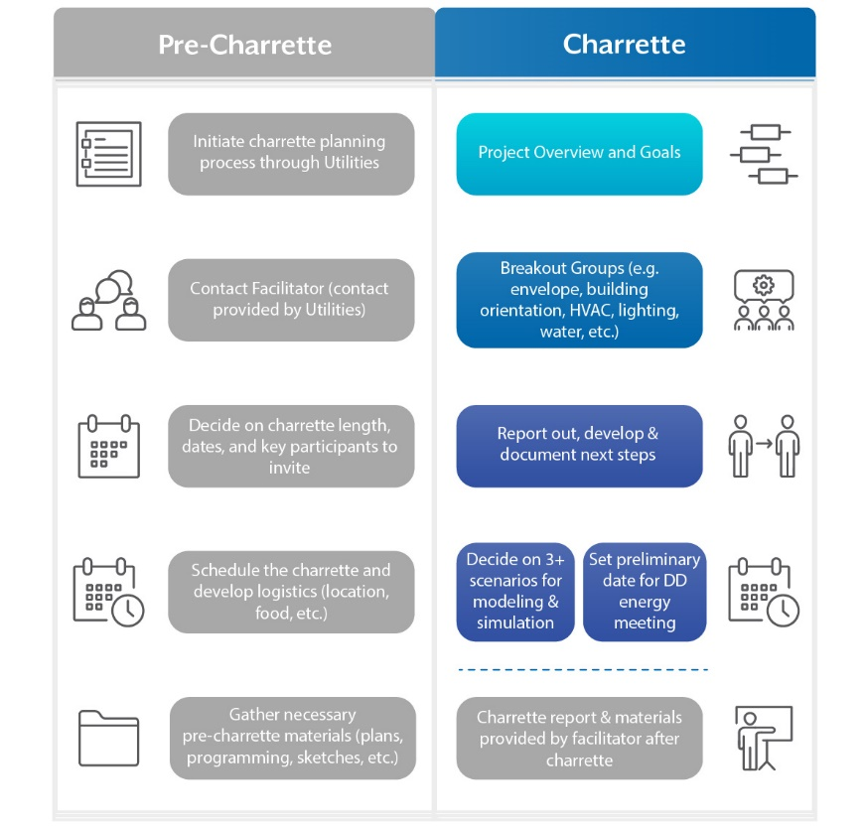

**Figure 5-1: Charrette Process**

#### CHARRETTE OUTCOMES

Providing quality information in a timely fashion is critical to incorporating energy efficient design into buildings. By the end of the charrette, all team members will have direction on their responsibilities and next steps, including:

1. Necessary information for the energy consultant (EC) to conduct energy simulation modeling for a minimum of three different scenarios;
2. Schedule for the design team members to provide cost estimates for design strategies identified in the charrette;
3. Anticipated design scope, strategies, activities, milestones, assistance needs, and schedule of future meetings.

All materials generated during the charrette will be digitized and emailed to participants by the facilitator immediately following the charrette. A brief summary report will also be generated and emailed to participants within a week of the charrette.

### Schematic design energy report (required for design incentive)

During SD, the EC will submit a Schematic Design Energy Report containing modeling results of design packages determined in the early design charrette. The report will include energy cost savings, life cycle costs and potential IDAP incentives. A template for the SD Energy Report can be found on the IDAP web site. The approved SD Energy Report will be used as a resource for discussion in the DD energy meeting to help inform the design going forward.

### Design Development Energy Meeting (Required for Design Incentive)

The purpose of the Design Development (DD) Energy Meeting is to choose a specific direction for energy related building design strategies and further refine them. This meeting should take place in very early DD to have the greatest benefit. The IDAP Program Administrator or a representative will attend this meeting to provide support. The EC will facilitate a discussion of the Schematic Design Energy Report containing energy simulation results, potential construction incentive and life cycle costs for each of the high-performance building design packages discussed during the early design charrette.

The design team is challenged to weigh the value of each whole building package and select a single high-performance design that meets or exceeds the PBPt for IDAP as well as the design team savings and economic targets. The solution could be a hybrid of the proposed packages and require further analysis. It may include a core package with some modifications to be evaluated going forward. Once a single high-performance design is selected, the EC will develop and refine the model and costs for the selected design based upon input from the design team.

### design development energy report (required for design incentive)

During the DD phase, the EC will deliver a Design Development Energy Report containing refined modeling results, estimated construction incentive and life cycle costs of the selected design package. A template for the DD Energy Report can be found on the IDAP web site. The approved report will be used as a resource by the design team and owner to incorporate the selected high-performance design package into the design construction documents.

Table 5‑2**Error! Reference source not found.** below summarizes design development roles and responsibilities.

Table 5‑2: Design Development Roles & Responsibilities

| **IDAP Program Administrator** | **Energy Consultant (EC)** | **Design Team/Owner** |
| --- | --- | --- |
| Participate in DD Energy Meeting  Maintain contact with design team.  Facilitate questions or concerns with process.  Review and comment on DD Energy report. | Participate in Design Development meeting and technical discussions to acquire direction for the final design package | Provide refined design features and costs for selected high-performance design strategy (if necessary).  Design team to review design strategies and assumptions prior to finalization of DD report. |
| Develop and refine model for selected high-performance design package based upon input from design team. |
| Prepare Design Development Energy Report (DDER) for a single design package for the DD design and submit the report and model for review. |
| Incorporate review comments into the DDER and submit report to owner and design team. |

### Final ENERGY report (required for design incentive) and Construction Document Review

The purpose of the Final Energy Report (FER) is to document the designed and budgeted energy efficient features that are included in the 100% CD package, show the results of the energy model demonstrating that the PBPt can be achieved or exceeded, and state the inputs and assumptions used for the energy model.

After the high-performance design package has been selected and incorporated into the CDs, the EC will review the documents and specifications to ensure the selected energy efficient design features are included and identified as intended. If some measures of the final design selection have been excluded, efforts will be made to encourage the design team to incorporate them at this point. These efforts may include the EC reviewing the energy and financial impact to the integrated design. The energy model will be adjusted to reflect any changes from the Design Development model, which could affect the Construction Incentive.

Following the CD review process, the EC will develop a Final Energy Report (FER) containing refined model results, estimated construction incentive and costs based on the complete 100% CD package provided by the design team. The report will then be sent to the design team, owner, and IDAP Program Manager for review. The Construction Incentive (paid at the end of construction) will be based on the results of the FER. A template for the FER can be found on the IDAP web site and any deviations from this template must be approved in writing by Utilities. The Design Incentive Request and Construction Incentive Request forms (found in the Program Application) will be signed by the customer and submitted to Utilities to initiate incentive payments. A separate application for the optional Performance Incentive can also be found on the IDAP web site. Table 5‑3 below outlines Construction Document phase roles and responsibilities.

Table 5‑3: Construction Document Phase Roles & Responsibilities

| **IDAP Program Administrator** | **Energy Consultant (EC)** | **Design Team/Owner** |
| --- | --- | --- |
| Maintain contact with design team.  Facilitate questions or concerns with process.  Review CDs and Final Energy Report  Review Design Incentive Application  Pay Design Incentive after satisfactory review of CDs and FER | Review 100% construction documents (CDs) for inclusion of selected measures.  Modify energy model to reflect Energy Efficiency Measures (EEMs) contained in the CDs to ensure that the project is still designed to meet or exceed the PBPt.  Write and submit Final Energy Report | Correct omissions in construction documents. Communicate changes to EC.  Design team to review design strategies and assumptions prior to finalizing deliverables.  Owner to review and sign Final Energy Report. |

## Post-construction activities

### Commissioning

Commissioning is a City of Fort Collins building code requirement for all buildings larger than 15,000 SF larger. Building air tightness testing is a City code requirement for all new construction buildings and additions. These requirements apply to all new construction and additions under IDAP, even if they are not under the jurisdiction of City of Fort Collins building code. Commissioning shall follow ASHRAE 90.1 -2022. In addition, the IDAP Commissioning Checklist must be completed (see Section 11 ).

Commissioning is the responsibility of the building owner. The building owner is required to submit electronic copies of the commissioning items to the IDAP Program Manager in order to remain eligible for the IDAP Construction and optional Performance Incentives.

**Buildings failing to meet City of Fort Collins code requirements, including the commissioning requirements listed above, will not be eligible to receive the Construction or optional Performance Incentive.**

### Building Air Tightness

Building air tightness testing is a city code requirement for all new construction buildings and additions. These requirements apply to all new construction and additions under IDAP, even if they are not under the jurisdiction of City of Fort Collins building code.

For the purposes of this program, air tightness includes the measurement and verification of the building’s air barrier system to achieve a total building leakage of less than or equal to 0.20 cfm per square foot of envelope area at 75 Pascal positive and negative pressures, per the City of Fort Collins Building Air Leakage Test Protocol. Different metrics exist for small commercial buildings less than 5,000 sf, stacked multi-family, and attached single family. Air tightness testing requirements for different building types are summarized in Table 4 below. Consult City of Fort Collins code requirements for details.

Table 5 Air Tightness Testing Required for Different Building Types: IDAP

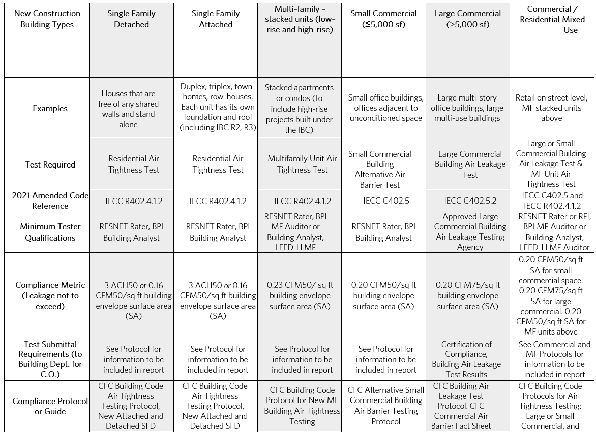

Any building that exceeds the allowable leakage is eligible to receive an incentive which is detailed in the metric shown below:

Table 7 Single Family Incentive Metric

|  |  |  |
| --- | --- | --- |
| Incentive ($/sq ft) | Min (cfm50/ft2) | Max (cfm50/sq ft) |
| 0.25 | 0.05 | <0.1 |
| 0.2 | 0.1 | 0.12 |

Table 8 Multi-Family Incentive Metric

|  |  |  |
| --- | --- | --- |
| Incentive ($/sq ft) | Min (cfm50/sq ft) | Max (cfm50/sq ft) |
| 0.3 | 0.05 | <0.1 |
| 0.25 | 0.1 | <0.15 |
| 0.2 | 0.15 | 0.22 |

Table 9 Small Commercial Incentive Metric

|  |  |  |
| --- | --- | --- |
| Incentive ($/sq ft) | Min (cfm50/sq ft) | Max (cfm50/sq ft) |
| 0.3 | 0.05 | <0.1 |
| 0.25 | 0.1 | <0.15 |
| 0.2 | 0.15 | 0.19 |

Table 10 Large Commercial Incentive Metric

|  |  |  |
| --- | --- | --- |
| Incentive ($/sq ft) | Min (cfm75/sq ft) | Max (cfm75/sq ft) |
| 0.3 | 0.05 | <0.1 |
| 0.25 | 0.1 | <0.15 |
| 0.2 | 0.15 | 0.19 |

Air tightness testing is the responsibility of the building owner. The building owner is required to submit electronic copies of the air tightness test results to the IDAP Program Manager in order to remain eligible for the IDAP Construction and optional Performance Incentives.

**Buildings failing to meet City of Fort Collins code requirements, including air tightness requirements listed above, will not be eligible to receive the Construction or optional Performance Incentive.**

### Final Inspection

Upon review of the customer’s Commissioning Report, Utilities will evaluate any variations found for each energy efficient feature as compared to its expected functionality, characteristics, and scope of installation. If variations are found for specific energy efficient features, the energy simulation model shall be refined to match the functionality, characteristics and/or scope of the verified features to determine if the PBPt for IDAP is still obtainable. If the as-built model shows the PBPt is obtainable, then the Construction Incentive payment will be calculated using the modeled energy performance of the high efficiency design (PBPnre). If the as-built model shows energy performance does not meet the PBPt, the owner has the choice to make changes to the building to meet the PBPt or forfeit payment of the Construction Incentive.

### Building occupancy phase

To be considered for a Performance Incentive, the customer must have qualified for the Construction Incentive and must submit a separate application within 6 months of receiving the Construction Incentive. The Performance Incentive amount will be evaluated when actual utility and sub metered regulated load data for any 12 consecutive months within the first two years of occupancy is submitted. The two-year period will allow a buffer during early occupancy to get the building working optimally, if necessary. If the average occupancy during the period for which the 12 months of utility data is submitted is less than 80%, adjustments will be made to the Performance Incentive by the IDAP Program Manager to account for those factors. Sub-metering of regulated loads will be required to qualify for this incentive. Support for sub-metering can be provided by Fort Collins Utilities. The building electrical distribution system must be configured such that separate monitoring of regulated and unregulated loads is possible.

During the 12-month utility data collection period, the IDAP Program Manager can assist the building owner to monitor project building energy use (using metered data) to ensure the building is on track for meeting the modeled energy performance and provide support for evaluating and tuning the building if energy use is not projected to exceed the modeled performance goal.

## Recommendations for Coordination & Communication

It is recommended that a formal plan be established to communicate official project information, deadlines and contact persons for the various tasks to all stakeholders. Drawing and modeling files, including specific software viewers, can be accessed by multiple parties via a secure file transfer website. Also, the design team should consider including IDAP project deliverables in their project tracking software.

# Appendix A: EC Qualifications, Applications, and SOW

### Energy consultant Qualifications

The IDAP administrator will evaluate energy consultant (EC) applicants based on the firms’ qualifications, experience and ability to meet the requirements of the program. Selection as an EC does not guarantee any minimum level of work. The selection criteria for ECs may include, but not necessarily limited to:

* Demonstrated level of individual and company experience in determining and recommending whole building, energy efficient design strategies to be implemented in the design of new construction and existing building projects.
* Demonstrated level of individual and company experience in the use of an energy simulation program consistent with the guidelines provided in the ASHRAE Standard 140.
* Experience in reviewing construction documents (CDs) for verification of the inclusion of a selected high-performance energy design features:
  + Ability to develop reports and lead technical discussions.
  + Verifiable contacts and references for past energy simulation and design assistance projects.
* Demonstrated experience modeling one or more building types and summarizing the results in a clear/concise report to be presented to customer’s of varying experience and skills.
* Energy consultants that have not been approved for IDAP can still act as energy consultants if they are working with an approved EC and at the same firm.

### ENERGY CONSULTANT APPLICATION and Required Training

IDAP ECs provide valuable resources and technical education to energy design, engineering, and consulting firms. By applying to become an EC, participants can enhance their business offerings for commercial and industrial customers. Approved ECs will become a part of the pool of qualified individuals/firms eligible to provide services under Utilities IDAP program. Other potential benefits may include:

1. ECs may receive marketing materials to aid in the promotion and marketing of the Utilities IDAP program at no charge.
2. Company information may be included on the Utilities web site, www.fcgov.com/IDAP, where consumers will be directed to locate a firm that can help them identify and evaluate potential whole building, energy efficient design strategies.

To apply, please complete an Energy Consultant application and allow 3 weeks for processing and notification. Please contact the IDAP Program Manager, David Suckling for application materials and further details regarding the application process at (970) 416-4251 or [dsuckling@fcgov.com](mailto:gschroeder@fcgov.com).

### Consultant scope of work (SOW)

The EC, working closely with the design team, is required to complete the following five elements:

* + Participate in a Schematic Design Charrette,
  + Submit a Schematic Design Energy Report (Utilities format),
  + Participate in a Design Development energy meeting,
  + Submit a Design Development Energy Report (Utilities format), and
  + Submit a Final Energy Report (Utilities format) at the end of design and Construction Documents.

The key deliverables during each phase are detailed as follows:

**Key EC Schematic Design Phase Deliverables**

* Participate in schematic design phase charrette including technical discussions with the design team and building owner regarding high-performance building design features and energy modeling.
* During the charrette, the EC shall be prepared to discuss several potential energy efficient features to be analyzed based on the building type, size, and code requirements.
* Conduct simulation modeling for three or more high-performance building design packages for Schematic Design Energy Report to evaluate what is necessary to reach the PBPt
* Submit Schematic Design Energy Report to the design team and IDAP Program Manager for QC

**Key EC Design Development Phase Deliverables**

* Facilitate a Design Development meeting and technical discussion regarding the schematic design energy report and energy simulation results to acquire direction for the final design package.
* Refine simulation model for selected design package to document that the PBPt for IDAP is obtainable.
* Submit draft Design Development Energy Report to the design team and IDAP Program Manager for QC.

**Key EC Construction Document Phase Deliverables**

* Review 100% CD package that the design team is responsible to provide the EC.
* Revise energy simulation model as necessary to reflect actual Energy Efficiency Measures (EEMs) contained in CDs to ensure that the project is still designed to reach the PBPt.
* Provide necessary support and coordination with design team.
* Submit Final Energy Report to the IDAP Program Manager for QC including refined energy model results, estimated Construction Incentive, and life cycle costs based upon the complete 100% CD package.
* Support owner in submitting Design Incentive Request.

# Appendix B: Energy Modeling Guidelines

## Energy Simulation Program Selection

1. A high-performance building design strategy that can reduce the overall energy usage (electricity and natural gas) of a building, meets or exceeds PBPt, while meeting project budgets, can be considered a viable design strategy for IDAP. The objectives of IDAP with regards to energy modeling include:

* Optimize passive building elements, such as shape, orientation, envelope design (roof, wall, windows), insulation type and quantity, thermal mass (i.e., building “fly wheel” effect), and daylighting schemes;
* Identify multiple high-performance building design features with regards to HVAC, lighting and other building systems;
* Select the most promising high-performance building design package based on life-cycle cost, energy reduction goals, and collaboration with the design team and contractors.

It is up to the EC’s expertise to recommend high-performance building design features to the design team that will have a reasonable simple payback period (SPB), life-cycle cost, or meet the expectations of the design team. Since there are limitations in the accuracy that certain energy building simulation programs can provide in modeling high-performance building design features, it is up to the EC to choose a program that is appropriate for the anticipated design strategy.

The energy simulation program used by the energy modeling consultant is required to be tested in compliance with ASHRAE 140. Common ASHRAE 140 complaint programs are Energy Plus/OpenStudio, eQuest, Trane Trace 700 and 3D Plus, Carrier HAP, IESVE, WUFI® Passive V.3.2.0.1) and PHPP v9.6. The selected energy simulation program shall be capable of modeling all proposed building systems, outputting annual site energy use (electricity and natural gas).

If the selected energy simulation program cannot explicitly model a particular design feature, the energy modeling consultant may utilize a thermodynamically similar component model that can approximate the expected performance. ECs shall have the flexibility to utilize industry accepted methodologies where such deficiencies in the selected modeling software occur.

## Quality Control Process

In order to maintain consistency in the energy simulation process and to achieve high quality results, the IDAP has established a quality control checklist in Table B‑1 below. This checklist shall be utilized by the energy modelers prior to submitting deliverables to Utilities.  *Energy modelers will be expected to follow their company required internal quality control process and quality control measures specific to each project, in addition to utilizing the quality control checklist below.*

Once the EC has completed their internal quality control process, the deliverables will be sent to Utilities and the design team for review. Utilities will provide a thorough quality control review of the energy simulation model, reports, Construction Incentive estimate and provide review comments back to the energy modeling consultant. This initial review process typically requires 1 week, depending on the project schedule and size of the project. The EC will then be expected to respond to the comments from Utilities and the design team, make necessary changes to the deliverables, and submit back to Utilities for review within 1 week or sooner. Once the review and quality control process is complete and deliverables are approved by the Utilities, the EC will then submit the report deliverable to the design team and building owner.

Table B‑1: IDAP Deliverable Quality Control Checklist

|  |  |  |
| --- | --- | --- |
| Step # | Task to Complete | Completed (X) |
| 1 | Early in the design process, verify the design team and customer are considering appropriate high-performance building design features for the project. |  |
| 2 | Verify the PBPt for IDAP has been met. |  |
| 3 | Check all incentive calculations, simple payback estimates, life cycle costs, utility rates and appropriate design feature costs are used. |  |
| 4 | Verify that selected energy simulation model meets program requirements. |  |
| 5 | Verify model includes all process, plug loads, and exterior lighting. |  |
| 6 | Check proper weather file is being used – Fort Collins TMY3. |  |
| 7 | Check peak cooling load is reasonable (sf/ton). |  |
| 8 | Check for appropriate fan sizing - energy consultants are encouraged to communicate directly with the mechanical design team to insure that they are using similar or the same values (e.g., envelope characteristics, occupant densities and heat gains, equipment and lighting power densities) for sizing the fans. Design airflows are typically input in the model based on sea level conditions (if required by model). Check that modeled airflows and zone temperatures are consistent with design airflows and temperatures. |  |
| 9 | Check building net area compared to known area. |  |
| 10 | Check that custom equipment performance curves are used when necessary. |  |
| 11 | Check lighting density in spaces (check no lights in plenums). |  |
| 12 | Check building schedules, thermostat settings and other control strategies match design team and owner requirements. |  |
| 13 | Check that wall/roof thermal performances includes thermal bridging |  |
| 14 | Check daylighting controls are properly modeled. |  |
| 15 | Verify that unmet hours cooling and heating hours are not excessive, and comply with project requirements Total unmet hours should be less than 300 for most projects. |  |
| 16 | Where default values are used, verify that they are appropriate:  E.g.1) In eQuest, check whether water loop operation is modeled as “demand” or as “standby”  E.g.2) In eQuest, if an IDEC system has been used, verify that an appropriate kW/CFM has been calculated, rather than accepting the default. |  |
| 17 | Verify that fan energy has been backed out of the SEER rating, if required by model. |  |
| 18 | Verify that appropriate glass values have been used (assembly vs. center of glass). Remember, the glass U-value entered in eQuest does not include the outside air boundary layer, so this must be removed (see eQuest help files for details). Check window model input VT (Visible Transmittance) matches design window VT. |  |
| 19 | Proofread report. Check that model inputs and outputs match model data contained in report. |  |

# Appendix C: Energy Report Guidelines

IDAP has established report templates and calculation methodologies for each design phase of the program. To maintain consistency of deliverables and results, energy modeling consultants will be required to utilize program report templates for the Schematic Design, Design Development and Final Design phases of IDAP (provided on the program website).

### Schematic Design Energy Report (SDER):

The intent of the SDER is to provide a whole building energy modeling analysis, preliminary energy consumption, Construction Incentive estimate, and Optional Performance Incentive estimate for multiple (3 or more) high-performance building design packages discussed in the schematic design charrette meeting. Deviations from the report template must be approved in writing by Utilities.

Each design package modeled for the SDER shall contain varying architectural, mechanical and lighting design features, meeting owner, design, code, and IDAP requirements. Efforts should be focused on reducing energy consumption by taking into account the whole building and not just individual components. An example of this would be investigating how the building orientation affects the heating/cooling loads or how duct size, lengths and configurations impact static pressure and fan motor sizes. The SDER is the first of three reports and is intended to summarize preliminary findings as the design may continue to evolve during this phase.

To properly portray the impacts of each measure within the interactive model, the ideal order in which the EEMs are modeled is based on the EEM type. Modeling ideally should start with measures that affect the building loads, then systems, and conclude with EEMs that affect the central plant. Table C‑1 shows examples of the types of EEMs and their hierarchy in determining the energy modeling order.

Table C‑1: Example EEMs Measures and Modeling Order

|  |  |  |  |
| --- | --- | --- | --- |
|  | **Loads** | **Systems** | **Plant** |
| **EEMs** | Envelope Measures | Enhanced Efficiency Motors | Chiller Plant |
| Cool Roof | Air Handler VFDs | Plant Controls |
| Lighting/ Plug Loads | Air Handler Controls | Pumping Arrangements |
| Lighting/Equipment Controls | Dedicated Outside Air System | Cooling Tower VFD |

In an attempt to provide the design team with useful information that can be incorporated into their design of an energy efficient building, the EC may be required to dissect systems for the overall building down to the zone level. Some examples include modeling different daylighting control strategies for different zones in the building or modeling a varying window type for each building facade.

### Design development Energy Report (DDER):

After the design team selects a high-performance building design package, the EC develops and refines a single model for the DDER. It is anticipated that this design package will be incorporated into the final construction documents. The DDER documents decisions related to selection of this strategy and details estimates for multiple (2 or more) high-performance building energy efficiency measures (EEMs) that could yield additional savings beyond the core design package.

### Final Energy Report (FER) and CD Review

Upon completion of the 100% CD’s, should the project closely follow one of the proposed models (including EEMs) in the DD energy report with only minor variations (e.g. only small changes to values and not entirely different building components or energy savings measures), then the FER tabular memo (found in the DD and FER Report Template appendix) shall be filled out and submitted by the consultant to the IDAP program administrator.

-OR-

Upon completion of the 100% CD’s, should the project have substantial changes that requires additional energy modeling (e.g. major building design components have changed or energy savings measures have changed), then this DD and FER Report Template will need to be fully filled out with the new design modeled and all measures completely described. All references in the report should be updated to “Final” energy report language in red.

The FER serves to ensure that the modeled design is completely reflected in the construction documents and vice-versa. The goal is to identify inconsistencies, inaccuracies, and omissions from the design that could impact the project’s energy performance. Following completion of the FER, Utilities will evaluate the report for approval and send the FER and FER Approval Form (located in the back of the program application) to the customer to sign. Once the FER is approved and the Design Incentive Request for Payment is received, the Design Incentive will be paid to the Owner.

The FER will document the high-performance design package implemented by the design team in the 100% CD drawing set. If the performance values of a given system (e.g., glazing) are different in the CDs than the values used in the energy simulation model, the report will include both values and make recommendations to adjust the values accordingly before the final set of drawings are issued.

If the Optional Performance Incentive will be pursued, then the EC should include the preliminary submetering plan for the regulated loads, and how the data will be collected either with permanent or temporary metering equipment

***Following the submittal of the FER to the owner and design team, the building owner will sign the Design Incentive Request for Payment and submit it to the IDAP Program Manager, to receive the Design Incentive.***

### Post FER Energy Simulation Modeling

In rare cases, it may be necessary to revise the energy model at or near the end of construction when the as-built condition differs from that reflected in the FER. In those situations, the IDAP Program Manager may request an updated model to ensure the building is still on track to meet or exceed the PBPt before authorizing payment of the Construction Incentive. If the post-construction building inspection by the IDAP Program manager and the final commissioning report show that the as-built condition closely matches that in the FER, the Construction Incentive will be paid.

### Estimating Design Package Costs

Customer decisions and program cost-effectiveness are based upon accurate costs recorded for each design. As such, project costs shall be reviewed by the EC for accuracy and reasonableness. Costs shall be provided by the appropriate design team member (mechanical, electrical, architect, contractor, etc.). However, if a general contractor (GC) or professional cost estimator is already a part of the team at the schematic design phase of the project, this would be the best resource. If neither has been hired, then the architect shall provide the costs for envelope related measures, the mechanical engineer shall provide mechanically related cost data, and so-forth for the electrical engineer.

* **SDER:** The level of detail that the design team may be able to provide in terms of cost data will likely be based on cost per square foot. Since the project is typically unspecified at this point in time, building size, envelope parameters (e.g. quantity of windows), quantity, type and size of HVAC and lighting systems have not yet been determined. If the design team does not have this cost information at a cost per square foot level, at the minimum, the consultant may recommend the design team refer to data from other previous projects. The rough nature of these initial cost estimates should be considered before rejecting energy efficiency strategies.
* **DDER:** During the DDER phase of the project, the building envelope parameters should be nearing finalization and the mechanical and electrical system types, quantity, and capacities should be defined. The consultant shall ask the design team if the costs from the SDER need to be revised or if they are still accurate. If they do need to be revised, it is the design team’s responsibility to provide these revised costs.
* **FER:** The EC should confirm with the project team whether the costs in the DDER are still accurate. The EC should revise the costs in the FER if changes are required

# Appendix D: Baseline Model Tables and Formulas

## Build Baseline Model

Use Table G3.1 and associated tables in the applicable version of ASHRAE 90.1 to build the Baseline Building Performance (BBP) model.

Separate kWh and therms of regulated and unregulated loads to determine the Baseline Building Unregulated Energy (BBUE) and the Baseline Building Regulated Energy (BBRE).

## Determine Energy Code Baseline

Calculate the Code Baseline Building Performance (PBPCode) using the Building Performance Factor relative to current code (BPFCode), from ASHRAE 90.1, below, using the following formula.

**PBPCode = BBUE + (PPFCode x BBRE)**

**PBPCode** = Baseline Building Performance, the annual energy of the Baseline Building adjusted to current code.

**BBUE** = Baseline Building Unregulated Energy, from Baseline energy model.[1]

**BPFCode** = Building Performance Factor (BPF), from Table D‑1, for a building meeting the applicable energy code

**BBRE** = Baseline Building Regulated Energy, from BBP Appendix G model.

## Establish Performance Target

The Proposed Building Performance Target (PBPt) corresponds to 10% regulated energy savings and is the maximum energy for which the Construction Incentive is eligible. The PBPt is determined by applying the IDAP Building Performance Factor (BPFIDAP) to the Regulated Energy, using the following formula.

**PBPt = BBUE + (BPFIDAP x BBRE)**

**PBPt** = Proposed Building Performance energy target, the maximum total energy of Proposed Building (unregulated + regulated energy). Unregulated energy will be the same in the proposed and baseline energy models.

**BPFIDAP** = IDAP BPF, from Table D‑1. These factors represent a 10% savings from the applicable code.

## Building Performance Factors

The following Building Performance Factors (BPFs) are used with the BBP model to establish the code baseline (PBPCode) and Performance Target (PBPt). Check the IDAP web page to ensure that BPFs aligned with the current City of Fort Collins building code are being used.

Table D‑1: Building Performance Factors (Permitted Under ASHRAE 2022)

|  |  |  |
| --- | --- | --- |
| **Building Type** | **BPFCode\*** | **BPFIDAP\*\*** |
| Multifamily | 0.63 | 0.57 |
| Healthcare/Hospital | 0.63 | 0.57 |
| Hotel | 0.66 | 0.59 |
| Office | 0.52 | 0.47 |
| Restaurant | 0.69 | 0.62 |
| Retail | 0.47 | 0.42 |
| School | 0.50 | 0.45 |
| Warehouse | 0.37 | 0.33 |
| All Others | 0.57 | 0.51 |

*ASHRAE 90.1 – 2022 Table I3-1

** 10% savings from code

In buildings with a variety of space uses, a weighted average of the BPF will be used (e.g. 10,000 SF Multi-family + 5,000 SF Retail: BPFCode = [(0.80*10,000+0.59*5,000)/15,000] = 0.73). The same methodology shall be used for both the code baseline and the IDAP target.

# Appendix E: Incentive Formulas

## Design Incentive

IDAP provides a design incentive to help partially offset the cost of energy consulting. The Design Incentive is a fixed value based on the gross floor area of the project. Gross floor area is the total conditioned floor area, expressed in square feet (SF), measured from the principal exterior surfaces of the building, not including parking areas. The incentive is calculated using the formula shown below.

**Table E‑1. Design Incentive Schedule**

| **Incentive Receipient** | **Incentive** |
| --- | --- |
| Owner | $5,000 + $0.12/SF |

In order to receive the full design incentive, the following five milestones need to be met:

* 1. Hold a design charrette in early Schematic Design,
  2. Submit a Schematic Design Energy Report,
  3. Hold a Design Development energy meeting in early DD,
  4. Submit a Design Development Energy Report, and
  5. Submit a Final Energy Report based on Construction Documents (CDs) at the end of design.

*Completion of all five milestones is required to receive the Design Incentive.* The design incentive will be paid at the end of design after the Final Energy Report and drawings have been reviewed by the IDAP Program Manager (or representative) and the Design Incentive Request for Payment has been received.

## Construction Incentive

The Construction Incentive represents two years’ worth of modeled energy savings from the code baseline (PBPCode) and is paid at the end of construction after commissioning and confirmation by the IDAP program manager that energy efficiency features in the completed building match those specified in the construction documents and reflected in the Final Energy Report.

**Construction Incentive = 2 x EPincv x (PBPcode - PBPnre)**

**EPincv =** Blended Energy Price/kBtu (Note: the EPincv will be set at the beginning of the project)

**PBPcode =** Proposed Building Performance by taking the Building Performance Factor into account (kBtu)

**PBPnre =** Proposed Building Performance without any credit from renewable energy generation systems (kBtu)

**BBPCode = BBUE + (BPFCode x BBRE)**

**BBUE =** Baseline Building Unregulated Energy (kBtu)

**BBRE =** Baseline Building Regulated Energy (kBtu)

In order to qualify for IDAP construction incentives, **PBPnre** must be <=**IDAPtarget***.*

**IDAP target = BBUE + (BPFIDAP x BBRE)**

**BPF idap = BPF code x 0.9**

*.*

## Performance Incentive (Optional)

To be considered for a Performance Incentive, the customer must have qualified for the Construction Incentive and must submit a separate application within 6 months of receiving the Construction Incentive. The performance period is within the first two years of occupancy and requires submetering the regulated loads for 12 consecutive months within that period to determine the Actual Regulated Energy Cost. Both utility data and submetered regulated electrical and gas data need to be submitted for review by the IDAP program administrator. Utilities will partner with the applicant to provide support for sub-metering the regulated loads. Regulated loads are associated with building equipment that is regulated by building energy codes (e.g., HVAC equipment, lighting, motors, water heating, etc.). The electrical distribution system design must include the ability to easily add sub-metering equipment for those loads.

The Performance Incentive will be paid when actual utility data for any 12 consecutive months within the first two years of occupancy is submitted. The two-year period will allow a buffer during early occupancy to get the building working optimally, if necessary.

**Performance Incentive = (BPFcode x BBRE) - Actual Regulated Energy) x EPincv**

**BBRE: Baseline Building Regulated Energy (kBTU)**

This represents the actual annual regulated energy savings. If the Actual Regulated Energy is more than the target IDAP regulated energy **(**BPFIDAP x BBRE), the project is still eligible for the incentive, although it will be reduced per the calculation above.

# Appendix F IDAP Commissioning Checklist

Project address_______________________________ Permit #______________________________

Commissioning Authority

Company Name ­­­­­­­­­­­­­­­_____________________________ Project Manager _____________________________

Submit proof of qualifications of Commissioning Authority (CxA) to Building Official. CxA must carry one of the following certifications: CxA by ACG (AABC Commissioning Group), CBCP by AEE (Assoc of Energy Engineers), CPMP or BCxP by ASHRAE, CCP by BCA (Building Commissioning Assoc), CxAP/CAP/CxM/GcxP or GCP by Univ of Wisconsin Madison.

|  |  |  |
| --- | --- | --- |
| **Initials** | **Date** | **Item** |
|  |  | Review Owner’s project requirements (OPR) |
|  |  | Review Basis of Design (BOD) |
|  |  | Design Review |
|  |  | Include commissioning requirements in project specifications |
|  |  | Submittal Review |
|  |  | Develop Commissioning Plan |
|  |  | Complete Pre-functional Checklists |
|  |  | Complete Function Performance Tests |
|  |  | Issues and resolution log with all issues closed |
|  |  | Complete a commissioning report |
|  |  | Verify owner requirements for training personnel and building occupants is complete. |
|  |  | Verify that a system manual that includes operations and maintenance documentation and full warranty information and provides operating staff the information needed to understand and operate the commissioned systems as designed has been completed. |
|  | | Commissioning of the following systems has been completed: |
|  |  | HVAC, Lighting, Service Water Heating, Refrigeration, Renewables, and associated controls for each system |
|  |  | The air barrier assembly has been inspected for continuity and integrity at the follow locations in the building within 5% completion of each:   1. Roof-wall intersections 2. Fenestration flashing 3. Fenestration installation 4. Bottom of wall (wall-to-foundation connection) 5. Connection of dissimilar wall and roof assemblies 6. Wall and roof penetrations |

I hereby attest the above-mentioned address has been commissioned per the ASHRAE 90.1-2022 commissioning requirements.

­­­­­­­­­­­­­____________________________ ___________________________ ____/____/_____

Commissioning Authority Signature Date

____________________________ ____/____/_____

Certification Number or Stamp Date of Expiration

# Appendix G: Frequently Asked Questions

***Question 1):*** For the Performance Incentive, should the baseline energy model be updated with Actual Meteorological Year (AMY) weather data to match the 12 months of collected utility data?

***Answer 1):*** No. A HDD/CDD analysis comparing TMY3 to various years’ AMY weather data determined the difference to be less than 1%. Exceptions can be made at the IDAP program manager’s discretion when warranted.

***Question 2):*** Before the Construction Incentive request for payment is submitted, should the proposed energy model’s infiltration be revised to match the results of the building air leakage test?

***Answer 2):*** If the actual building infiltration determined during the air leakage testing is +/- 20% or more of the modeled value of 0.25 CFM/SF at 75 Pa, then the proposed model shall be updated with the measured values. This includes if the actual measured infiltration is more than the baseline (i.e., which will have a negative impact on the proposed building’s energy use).

***Question 4):*** Which weather file should be used to run simulations?

***Answer 4):*** Fort Collins TMY3

***Question 5):*** How to obtain the utility rates?

***Answer 5):*** For current City of Fort Collins Utility Blended Electrical Rates and natural gas rates to use in calculations, please visit the program website at <http://www.fcgov.com/IDAP>

***Question 6):*** What room temperature set-points should be used during the early design phase?

***Answer 6):*** Room temperature set points input into the model shall be specified by the owner or the appropriate member of the design team (Architect or Mechanical Engineer). However, if they are unknown, ASHRAE Comfort Zone chart shall be utilized to determine the appropriate setpoint temperatures both for heating and cooling. Typically, 70˚F 30% RH is used for heating and 75˚F 50% RH is used for cooling.

# Appendix H: Resources

A brief listing of energy efficiency resources available on the Web is provided below.

* AHRI Online Directory of Certified Equipment. The Air Conditioning, Heating and Refrigeration Institute (AHRI) is a national trade association of HVAC equipment manufacturers. A publicly available online directory lists detailed equipment information for all certified equipment. ([www.ahridirectory.org](http://www.ahridirectory.org))
* Air Conditioning Contractors of America (ACCA). The ACCA is a non-profit organization representing HVAC contractors in the U.S. Current industry information and resources are available from their web site. ([www.acca.org](http://www.acca.org))
* American National Standards Institute (ANSI) - Whole Systems Integrated Process Guide for Sustainable Buildings & Communities. (www.ansi.org)
* Consortium for Energy Efficiency (CEE). CEE is a non-profit organization that develops national initiatives to promote the manufacture and purchase of energy-efficient products and services. ([www.cee1.org](http://www.cee1.org))
* Department of Energy – Energy Efficiency and Renewable Energy (EERE). EERE provides information for consumers on a wide range of energy efficiency topics. ([www.eere.energy.gov](http://www.eere.energy.gov))
* ENERGY STAR®. ENERGY STAR is a government-backed program designed to help consumers increase their energy efficiency. ([www.energystar.gov](http://www.energystar.gov))
* Electrical Apparatus Service Association, Inc. (EASA). EASA provides its members with current information on materials, equipment, and technological advances in the electromechanical industry. ([www.easa.com](http://www.easa.com))
* Motor Decisions Matter. Motor Decisions Matter is a national program encouraging proper motor selection and management. The program is supported by a number of industry trade groups and orchestrated by the Department of Energy’s Office of Industrial Technologies. ([www.motorsmatter.org](http://www.motorsmatter.org))
* National Electrical Manufacturers Association (NEMA). The Motor and Generator section of NEMA has developed an industry standard for premium efficiency motors. ([www.nema.org](http://www.nema.org))
* Rocky Mountain Institute (RMI) – “Tunneling Through the Cost Barrier”. (www.rmi.org)

US Green Building Council (USGBC). USGBC is composed of more than 13,500 organizations from across the building industry that are working to advance structures that are environmentally responsible, profitable, and healthy places to live and work. ([www.usgbc.org](http://www.usgbc.org))

1.