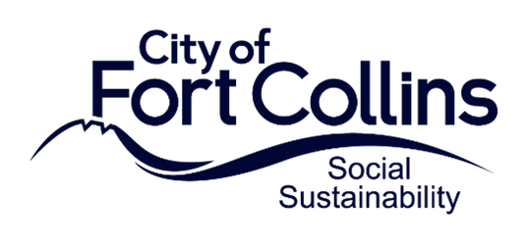

**2024 ARPA Application Questions:**   
**Social Services Recovery Grants**

All responses must be submitted via ZoomGrants. This document is provided as a helpful reference.

**Organization Information**

1. **Type of Organization**

Select the following organization type that best fits the organization for which you are requesting ARPA funding.

* + Nonprofit, IRS-designated 501(c)(3) agencies in good standing
  + Cooperative groups of organizations with an IRS-designated 501(c)(3) agency serving as its fiscal host
  + Libraries, museums, higher education institutions or other government entities that offer services for K-12 students
  + Other

**2. Provide a brief description of your organization. Please also include any details about previous experience delivering similar activities related to your proposed funding request.**

**Program Information**

1. **Select which of the following focus areas primarily apply to your program.**
   * + Food Insecurity
     + Social Isolation and Seniors
     + Mental and Behavioral Health
     + Housing Stability
     + Abuse
     + Access to Transportation
     + Services for Disabled Residents
     + None of the above
2. **Describe the program for which you plan to use the ARPA funding assistance. Please include whether it is a new or existing program and describe how the program will impact your clients and/or the community.**
3. **Describe how the program is clearly mitigating the impacts resulting from the COVID-19 pandemic or related public health measures.**
4. **Please indicate the number of unduplicated Fort Collins residents (or households) you anticipate will benefit from this request.**
5. **Please describe the population that you will serve including any available information on client income levels and demographics. How will your program prioritize diversity, equity and inclusion within the populations that it will serve?**
6. **Describe two measurable outcomes that you will use to determine the success of the program. These should be achievable by December 31, 2024. (i.e. Distribute 20,000 lbs of nutritious food).**
7. **Is there any additional information about the proposed program or project for which you are requesting assistance that would be helpful for the review panel to know?**

**Funding Information**

1. **Briefly summarize the expense(s) to be paid with the requested assistance. For each category include a description and the total anticipated expense. If you are listing more than one category, please list them in order of priority.** Please review the Application Guide closely to ensure the project costs are eligible.Example: (1) Staffing - 50% of direct service salaries and benefits - totaling $xxx; (2) Direct Client Assistance - totaling $xxx ; (3) Material costs – totaling $xxx
2. **If awarded, can the funding be fully expended by December 31, 2024?**

* Yes
* No

1. **Do you currently have funding commitments and/or other proposals out for review (local, state, federal, community) to cover the expenses you are requesting this ARPA assistance for in 2024? If so, please describe.**
2. **Are you currently receiving any additional funding from the City of Fort Collins?** If so, please describe.

**Additional Information**

1. **Provide your Unique Identification Number (UEI): __________________________________**

To be considered for funding, you must submit a UEI number from SAM.gov by October 25, 2023. If you do not currently have a UEI number, you can still apply for funding but must submit your UEI to [amcgimpsey@fcgov.com](mailto:amcgimpsey@fcgov.com) by October 25, 2023.

1. **Do you have an active status on SAM.gov?** To be considered for funding, you must have an active status on SAM.gov by October 25, 2023. If you do not currently, you can still apply for funding but must send proof of active status to [amcgimpsey@fcgov.com](mailto:amcgimpsey@fcgov.com) by October 25, 2023.

* Yes, my organization has an active status on SAM.gov.
* No, my organization does not have an active status on SAM.gov. We will obtain active status by October 25, 2023.
* In Progress, my organization has applied for active status from SAM.gov and have not received it yet.

1. **Have you completed the Financial Qualification Survey due by September 26, 2023?**

The Survey can be completed here: <https://survey.alchemer.com/s3/6945898/Grant-Recipient-Qualification-Survey>

* Yes, I have completed the Financial Qualification Survey.
* No, I have not completed the Financial Qualification Survey but will do so by September 26, 2023.

**Required Documents**

* **If applicable, Board of Directors Roster (2023)**
* **If applicable, IRS 501c3 Designation**
* **If applicable, Certificate of Good Standing (2022 or 2023)**
* **Current year organizational budget (revenue and expenses)**