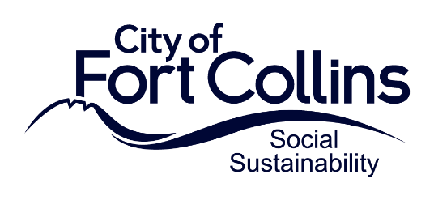

2024 ARPA Application Questions:
24/7 Homeless Shelter Grants

Please provide your answers in this document. All responses must be submitted via email to amcgimpsey@fcgov.com by September 26, 2023 at 12 p.m. (Checkboxes are clickable).
Name of Organization: ____________________________________________________
Name and Email for Application Contact(s): ________________________________________
Organization Address: ____________________________________________________
Organization Information

- Type of Organization
Select the following organization type that best fits the organization for which you are requesting ARPA funding.
☐ Nonprofit, IRS-designated 501(c)(3) agencies in good standing
☐ Cooperative groups of organizations with an IRS-designated 501(c)(3) agency serving as its fiscal host
☐ Other
2. Provide a brief description of your organization. Please also include any details about previous experience delivering similar activities related to your proposed funding request.

Program Information

- Describe the program for which you plan to use the ARPA funding assistance. Please include whether it is a new or existing program and describe how the program will impact your clients and/or the community.

- What is the estimated number of 24/7 shelter beds that will be made available as a result of this funding?

- What is the estimated number of duplicated individuals served by the 24/7 shelter services during the 12-month grant period?

- Describe the population that you will serve including any available information on demographics.

- Describe how the program is clearly mitigating the impacts resulting from the COVID-19 pandemic or related public health measures.

- Is there any additional information about the proposed program or project for which you are requesting assistance that would be helpful for the review panel to know?

Funding Information

- Briefly summarize the expense(s) to be paid with the requested assistance. For each category include a description and the total anticipated expense. If you are listing more than one category, please list them in order of priority. Please review the Application Guide closely to ensure the project costs are eligible.
Example: (1) Category: Staffing, Description: 50% of direct service salaries and benefits, Funding Estimate: totaling $x

- If awarded, can the funding be fully expended by December 31, 2024?
☐ Yes
☐ No

- Do you currently have funding commitments and/or other proposals out for review (local, state, federal, community) to cover the expenses you are requesting this ARPA assistance for in 2024? If so, please describe.

- Are you currently receiving any additional funding from the City of Fort Collins? If so, please describe.

Additional Information

- Provide your Unique Identification Number (UEI): __________________________________
To be considered for funding, you must submit a UEI number from SAM.gov by October 25, 2023. If you do not currently have a UEI number, you can still apply for funding but must submit your UEI to amcgimpsey@fcgov.com by October 25, 2023.

- Do you have an active status on SAM.gov? To be considered for funding, you must have an active status on SAM.gov by October 25, 2023. If you do not currently, you can still apply for funding but must send proof of active status to amcgimpsey@fcgov.com by October 25, 2023.
☐ Yes, my organization has an active status on SAM.gov.
☐ No, my organization does not have an active status on SAM.gov. We will obtain active status by October 25, 2023.
☐ In Progress, my organization has applied for active status from SAM.gov and have not received it yet.

- Have you completed the Financial Qualification Survey due by September 26, 2023?
The Survey can be completed here: https://survey.alchemer.com/s3/6945898/Grant-Recipient-Qualification-Survey
☐ Yes, I have completed the Financial Qualification Survey.
☐ No, I have not completed the Financial Qualification Survey but will do so by September 26, 2023.

Required Documents
Please submit the following documents to amcgimpsey@fcgov.com if your organization type is applicable.
☐ If applicable, Board of Directors Roster (2023) (Required if organization has a Board of Directors)
☐ If applicable, IRS 501c3 Designation (Required if organization is a 501c3)
☐ If applicable, Certificate of Good Standing (2022 or 2023) (Required if organization is a 501c3)
☐ Current year (or most recent) organizational budget (revenue and expenses) (Required by all applicants)

