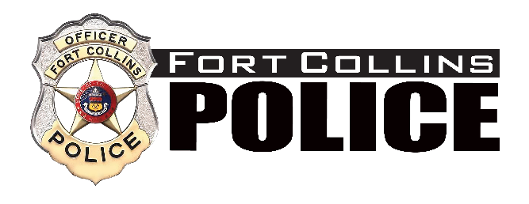

PUBLIC NOTICE
FOR
COMMITTEE MEETING

Date of Posting: September 17, 2024
Name of Board/Commission Chief’s Community Advisory Committee

Date of Meeting: September 18, 2024
Time of Meeting: 12:00

Location of Meeting: Fort Collins Police Services
2221 S Timberline Road
Fort Collins, CO 80525

For additional information, including agenda information, please contact Executive Administrative Assistant Sara Guerrero at (970) 416-2963.

The City of Fort Collins will make reasonable accommodations for access to City service, programs and activities and will make special communication arrangement for persons with disabilities. Please call (970) 416-2963 or e-mail sguerrero@fcgov.com for assistance.

