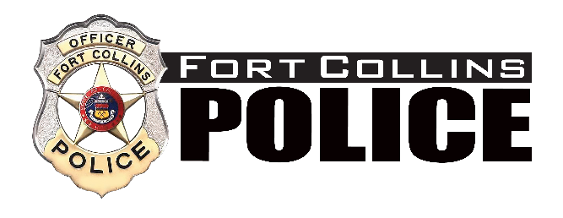

PUBLIC NOTICE
FOR
COMMITTEE MEETING

Date of Posting: April 17, 2023
Name of Board/Commission Chief’s Community Advisory Committee

Date of Meeting: April 19, 2023

Time of Meeting: 12:00

Location of Meeting: Fort Collins Police Services
2221 S Timberline Road
Fort Collins, CO 80525

For additional information, including agenda information, please contact Administrative Assistant Kelly Valdez at (970) 416-2960.

The City of Fort Collins will make reasonable accommodations for access to City service, programs and activities and will make special communication arrangement for persons with disabilities. Please call (970) 416-2960 or e-mail kvaldez@fcgov.com for assistance.

