Explore Solar Output in Fort Collins
More than 3,000 Fort Collins Utilities residential and commercial customers generate solar power. Utilities partnered with Colorado State University (CSU) to create a visual representation of the estimated total power that grid-connected photovoltaic (PV) systems make each day.

CSU developed the model called PVSTEM. It captures a variety of data listed below from each solar system in Utilities’ service area and combines it with information from three CSU weather stations around Fort Collins. The model also considers any power losses that happen due to shading, system downtime (assumed repairs, maintenance or power outages) and system ageing. Finally, it creates a graph to display the estimated total solar power output.

capacity (kW-dc)

orientation (tilt and azimuth)

location

installation date

sunlight intensity

temperature

wind speed

snow coverage

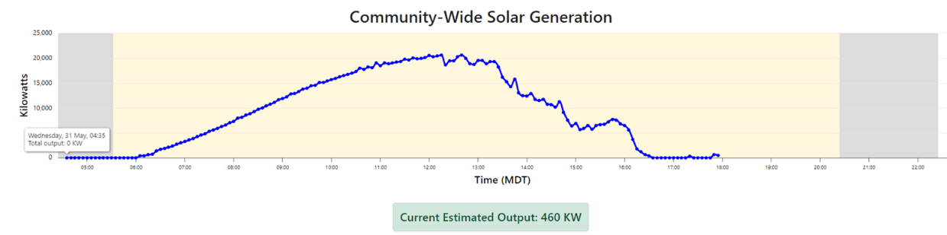

How we can use PVSTEM
Anyone can see the model at fcgov.com/community-solar-generation. The data will initially be used educationally by people in the solar industry or anyone who’s interested. Over time, Utilities may use the information to support its work to reach the community’s Our Climate Future energy and grid flexibility goals.

Collaborative effort
CSU and Utilities have a long-standing collaborative research partnership based on data sharing and joint projects. CSU Research Associates Jerry Duggan and John Bleem developed this model, with support from She’s in Power and the Energy Institute.

Going solar in Fort Collins

Going solar can reduce your carbon footprint and your electricity bill. Utilities offers resources to customers interested in generating their own renewable energy and for those who already have solar installed. If you are interested in learning more about solar options, please visit fcgov.com/renewables.

