**Click here to type project name**

Schematic Design Energy Report

Located at:

**Click here to type address**

**Click here to type City, State, ZIP**

Presented to:

**Click here to type customer's name**

IDAP Project # **Click here to type project # (Provided by Prog. Admin)**

**Click here to type date (For e.g. January XX, 20XX)**

# Disclaimer

The intent of this Schematic Design Energy Report (SDER) is to provide a preliminary estimate of the Energy Use Intensity (EUI) for design strategies for Click here to type building name, evaluated in schematic design as well as a discussion/assessment of those strategies. While the preliminary findings in this report have been reviewed for technical accuracy and are believed to be reasonably accurate, the actual results may vary. As a result, Fort Collins Utilities (Utilities) and/or Click here to type CONSULTANT name are not liable if estimated savings or economics are not realized. All savings and cost estimates in the report are for informational purposes, and are not to be construed as a design document or as guarantees.

In no event will Fort Collins Utilities and/or Click here to type CONSULTANT namebe liable for the failure of the project to achieve a Target EUI, the operation of the customer’s facilities, or any incidental or consequential damages of any kind in connection with this report or the installation of evaluated measures.

# Project Contacts

**Owner / Owner Representative**

Click here to type Name

Click here to type title

Click here to type company

Click here to type street

Click here to type City, State, and Zip

P: Click here to type phone #

E: Click here to type email

**Energy Modeling Consultant**

Click here to type Name

Click here to type title

Click here to type company

Click here to type street

Click here to type City, State, and Zip

P: Click here to type phone #

E: Click here to type email

**City of Fort Collins Utilities**

Click here to type Name

Click here to type title

Click here to type company

Click here to type street

Click here to type City, State, and Zip

P: Click here to type phone #

E: Click here to type email

**IDAP Project Administrator:**

Click here to type Name

Click here to type title

Click here to type company

Click here to type street

Click here to type City, State, and Zip

P: Click here to type phone #

E: Click here to type email

[Update TOC after writing report]

Table of Contents

Disclaimer i

Project Contacts ii

Executive Summary 1

Introduction 2

Project Description 2

Energy Goals 2

Design Strategies 2

Design Package A: INSERT NAME OF DESIGN PACKAGE 2

Design Package B: INSERT NAME OF DESIGN PACKAGE 3

Results and Discussion 3

Energy Tables 4

Heating/Cooling Loads 8

Discussion 10

Project Performance Target EUI 11

Target Finder Inputs 11

Target Finder Outputs 12

Construction Incentive 12

Performance Incentive 12

Energy Model Documentation 14

Energy Model 14

Utility Rates 15

Energy Model Input Details 16

Model supply airflows and cooling loads 17

Lighting Summary 17

Appendix A – Life Cycle Cost Analysis 18

Appendix B – Summary Of IDAP Process 18

# Executive Summary

This Schematic Design Report is a tool to assist the design team in making decisions to improve the energy performance of the Click here to type Project Name design. As a participant in Fort Collins Utilities Integrated Design Assistance Program (IDAP) a goal of the project is to achieve a Target EUI (Energy Use Intensity) of Click here to type Target EUI kBtu/SF/year, a 60% energy reduction below the regional median EUI of Click here to type Median EUI for Click here to type project building type. This goal aligns the project design with the Architecture 2030 Challenge. Other energy goals include …

This report contains details of the energy model simulation results, incentives and life cycle costs for each of the high performance building design strategies discussed during schematic design, including the SD charrette.

Following is a summary of the design strategies considered and analyzed during schematic design. [optionally, insert a table]

1. Describe building orientation, shape, envelope and mechanical and electrical systems for Option A.
2. Describe building orientation, shape, envelope and mechanical and electrical systems for Option B.
3. …

Summary results for each design strategy are presented in Table 1, below.

Table 1 - Summary Modeling Results

|  |  |  |  |  |
| --- | --- | --- | --- | --- |
| Design Package | Package Name | EUI (kBtu/SF/yr) | Life Cycle Cost ($) | CO2e (tons) |
| A |  |  |  |  |
| B |  |  |  |  |
| C |  |  |  |  |

Provide qualitative summary/assessment of strategies. Also describe potential for all or some to achieve Target EUI.

Additional individual energy efficiency measure (EEMs) were also considered. [Include if true and describe other EEMs]

The design team is challenged to weigh the value of each whole building design strategy contained in this report and work toward selecting a single high performance design strategy meeting the IDAP Target EUI as well as owner and design team energy and economic goals. This strategy will be more fully developed during Design Development. The Click here to type name of Energy Consultant will develop a Design Development Energy Report at the end of DD containing refined model results, incentives and costs of the selected design package.

# Introduction

## Project Description

The Click here to type building name is a new 110,420 SF educational facility including: classrooms, auditorium, cafeteria, gymnasium, kitchen, and administration offices. Other building characteristics can be found in the energy model takeoff sheet in the Appendix. This building is being designed and constructed through a [e.g. design-build, CM/GC, design-bid-build] process. Key design team members include [list owner, architect, ME, EE, CxA, energy consultant, CM - if hired and other key design team members].

## Energy Goals

[Describe all project energy goals (e.g. Target EUI for IDAP, net zero, number of energy points in LEED, renewable goals, etc.)]

## Design Strategies

Click here to type # of design strategies potential design packages were investigated as part of this SDER. Likely combinations of design package elements (energy efficiency measures - EEMs) were chosen as combinations potentially providing the greatest systems-approach benefits, thus capturing the synergies between the EEMs included. Each strategy has inherent savings and its value has been analyzed in the modeling software to quantify its EUI.

### Design Package A: INSERT NAME OF DESIGN PACKAGE

Architectural Systems

PROVIDE SYSTEM SUMMARY: Discuss orientation, building site, window-to-wall ratio, overhangs, building shape, daylighting, landscaping and other passive design strategies impact on energy reduction. Discuss building envelope, insulation and fenestration energy reduction strategies.

DESCRIBE INTERACTION WITH OTHER SYSTEMS: (e.g. overhangs reduce cooling load)

Electrical Systems

PROVIDE SYSTEM SUMMARY Discuss interior and exterior lighting system and lighting system controls

DESCRIBE ENERGY SAVINGS INTERACTION WITH OTHER SYSTEMS (e.g. reduced lighting power density reduces cooling load)

Mechanical Systems

PROVIDE SYSTEM SUMMARY: Include description of HVAC system, equipment and equipment efficiencies (using tables if necessary), control system and key control strategies to reduce energy. Include description of design considerations to save energy (e.g. short duct runs used to reduce fan static pressure).

DESCRIBE INTERACTION WITH OTHER SYSTEMS: (e.g. IDEC system saves a significant amount of electrical energy and demand because it is cooling the building with water instead of using mechanical cooling).

On-site Renewable Systems

PROVIDE SYSTEM SUMMARY AND DESCRIBE INTERACTION WITH OTHER SYSTEMS

Process Systems

PROVIDE SYSTEM SUMMARY AND DESCRIBE INTERACTION WITH OTHER SYSTEMS (e.g. Datacenter equipment, plug loads, manufacturing equipment, laboratory systems, etc)

Modeling Methodology And Measure-Specific Requirements

DESCRIBE HOW SPECIFIC FEATURES WERE MODELED, DETAIL KEY VALUES AND ASSUMPTIONS.

Package A Observations

DESCRIBE KEY BENEFITS OF INTEGRATED DESIGN STRATEGY (e.g. IDEC saves a significant amount of electrical energy and demand because it is cooling the building with water instead of using a packaged unitary DX system).

### Design Package B: INSERT NAME OF DESIGN PACKAGE

***REPEAT FOR ALL DESIGN PACKAGES***

# Results and Discussion

The tables below summarize key results from SD energy modeling. A discussion of these results follows.

## Energy Tables

Table , below summarizes modeled EUI performance metrics. To qualify for the Construction and Performance Incentives, there must be a minimum reduction of 40% from the median through efficiency measures (e.g. building shape and orientation, efficient envelope, daylighting, efficient HVAC, etc.). Total reduction must be 60%, 1/3 of which (20%) can come from on-site renewables. The larger the reduction is from efficiency, which provides the majority of the incentive. See IDAP Participant Program Manual for details.

Table 2 - IDAP EUI Metrics

|  |  |  |  |  |  |  |  |
| --- | --- | --- | --- | --- | --- | --- | --- |
|  |  |  | **Building energy use – no PV** | | **Energy use with proposed PV** | |  |
| **Design Package** | **Median EUI (kBtu/sf/yr)\*** | **Target EUI (kBtu/sf/yr)\*** | **EUI (kBtu/sf/yr)** | **% Reduction (must be ≥ 40%)** | **EUI (kBtu/sf/yr)** | **% Reduction (must be ≥ 60%)** | **Potential Performance Incentive** |
| **A** |  |  |  |  |  |  |  |
| **B** |  |  |  |  |  |  |  |
| **C** |  |  |  |  |  |  |  |
| **D** |  |  |  |  |  |  |  |

* from Energy Star Target Finder or approved alternative. If there is no change in building size or occupancy, the Median and Target EUIs will be the same for all options.

Table , below summarizes electric energy usage, electric demand, natural gas usage, energy cost and life cycle cost. Life cycle cost is based on the following inputs:

* Fuel Escalation Rate: [rate %]
* Labor & Materials Inflation Rate: [rate %]
* Discount Rate (excluding inflation): [rate %]
* Term: [years]

Table 3 - Estimated Energy Consumption and Cost Summary

|  |  |  |  |  |  |  |  |  |
| --- | --- | --- | --- | --- | --- | --- | --- | --- |
| **Design Package** | **Package Name** | **Building Area (Square Feet)** | **Annual Electric Usage (kWh/yr)** | **Peak Electric Demand (kW)1** | **Average Monthly Demand**  **(kW/mo.)** | **Annual Natural Gas Usage (therm/yr)** | **Annual Energy Cost ($)** | **Life Cycle Cost Present Value (w/incentives)**  **($)2** |
| **A** | Package A name |  |  |  |  |  |  |  |
| **B** | Package B name |  |  |  |  |  |  |  |
| **C** |  |  |  |  |  |  |  |  |
| **D** |  |  |  |  |  |  |  |  |

1. Peak Electric Demand in the highest one-hour peak demand for the year.
2. Calculation for life cycle cost is detailed in Appendix A

Add columns for other fuel types (e.g. steam)

Table , below summarizes monthly electric energy usage, electric demands and gas usage for the design packages.

Table 4 - Monthly Utility Use

|  |  |  |  |  |  |  |  |  |  |  |  |  |  |
| --- | --- | --- | --- | --- | --- | --- | --- | --- | --- | --- | --- | --- | --- |
| **Design Package A** | **Jan** | **Feb** | **Mar** | **Apr** | **May** | **Jun** | **Jul** | **Aug** | **Sep** | **Oct** | **Nov** | **Dec** | **Total** |
| Facility Peak (kW)* |  |  |  |  |  |  |  |  |  |  |  |  | - |
| Coincident Peak (kW)* |  |  |  |  |  |  |  |  |  |  |  |  | - |
| Electric Energy (kWh) |  |  |  |  |  |  |  |  |  |  |  |  |  |
| Gas Use (Therms) |  |  |  |  |  |  |  |  |  |  |  |  |  |
|  |  |  |  |  |  |  |  |  |  |  |  |  |  |
| **Design Package B** | **Jan** | **Feb** | **Mar** | **Apr** | **May** | **Jun** | **Jul** | **Aug** | **Sep** | **Oct** | **Nov** | **Dec** | **Total** |
| Facility Peak (kW)* |  |  |  |  |  |  |  |  |  |  |  |  | - |
| Coincident Peak (kW)* |  |  |  |  |  |  |  |  |  |  |  |  | - |
| Electric Energy (kWh) |  |  |  |  |  |  |  |  |  |  |  |  |  |
| Gas Use (Therms) |  |  |  |  |  |  |  |  |  |  |  |  |  |
|  |  |  |  |  |  |  |  |  |  |  |  |  |  |
|  |  |  |  |  |  |  |  |  |  |  |  |  |  |
| **Design Package C** | **Jan** | **Feb** | **Mar** | **Apr** | **May** | **Jun** | **Jul** | **Aug** | **Sep** | **Oct** | **Nov** | **Dec** | **Total** |
| Facility Peak (kW)* |  |  |  |  |  |  |  |  |  |  |  |  | - |
| Coincident Peak (kW)* |  |  |  |  |  |  |  |  |  |  |  |  | - |
| Electric Energy (kWh) |  |  |  |  |  |  |  |  |  |  |  |  |  |
| Gas Use (Therms) |  |  |  |  |  |  |  |  |  |  |  |  |  |
|  |  |  |  |  |  |  |  |  |  |  |  |  |  |
|  |  |  |  |  |  |  |  |  |  |  |  |  |  |
| **Design Package D** | **Jan** | **Feb** | **Mar** | **Apr** | **May** | **Jun** | **Jul** | **Aug** | **Sep** | **Oct** | **Nov** | **Dec** | **Total** |
| Facility Peak (kW)* |  |  |  |  |  |  |  |  |  |  |  |  | - |
| Coincident Peak (kW)* |  |  |  |  |  |  |  |  |  |  |  |  | - |
| Electric Energy (kWh) |  |  |  |  |  |  |  |  |  |  |  |  |  |
| Gas Use (Therms) |  |  |  |  |  |  |  |  |  |  |  |  |  |

* For a description of Facility and Coincident Peak, see http://www.fcgov.com/utilities/business/rates/electric/ . Specific hours used for calculation of Coincident Peak can be found in the IDAP Consultant Manual. Coincident Peak is billed to E-300 (GS-50) and E-400 (GS-750) rates.

Add additional tables for specifics of your project. For example, if comparative modeling is being done for LEED, insert performance metrics with comparison of a code baseline and models with energy efficiency measures (EEMs).

Include pie charts with energy component breakouts.

## Heating/Cooling Loads

Although it is understood that this energy model is not intended to generate loads used for equipment sizing, model load outputs can often be useful as a reference point for discussing design strategies and evaluating engineering design loads. Following are peak cooling and heating loads from the model (these represent building [coil] loads, and as such, do not take into account equipment efficiencies).

Table - Building Cooling Load

|  |  |  |  |  |
| --- | --- | --- | --- | --- |
| Design Option | Design Load (tons) | Load density (SF/ton) | Date/time of Peak (MM/DD: Hour Ending) | Weather Conditions (DBT/WBT)** |
| A |  |  |  |  |
| B |  |  |  |  |
| C |  |  |  |  |
| D |  |  |  |  |

Table - Building Heating Load

|  |  |  |  |  |
| --- | --- | --- | --- | --- |
| Design Option | Design load (kBtuh)* | Load density (Btuh/SF) | Date/time of Peak (MM/DD: Hour Ending) | Weather Condition (DBT)** |
| A |  |  |  |  |
| B |  |  |  |  |
| C |  |  |  |  |
| D |  |  |  |  |

* 1 kBtuh = 1 MBtuh = 1,000 Btuh

** Dry bulb temperature / Wet bulb temperature, °F

For reference, a 2013 study by the Colorado Climate Center at Colorado State University show that the 99.6% and 99% heating temperatures are 0.4 and 6.6 degrees Fahrenheit respectively. The 2%, 1% and 0.4% cooling temperatures are 86.9, 89.7 and 92.5 degrees Fahrenheit respectively. The mean coincident wet-bulb temperatures associated with the 2%, 1% and 0.4% cooling temperatures are 61.3, 61.6 and 61.6 respectively. These results are based on 23 years of data from 1990 – 2013 at the Fort Collins, CO weather station located at CSU (COOP#05-3005-4).

## Discussion

What are the salient points of this analysis? Based on these results and other observations/discussions, what are recommended next steps the design team should take to improve energy performance and overall integration? Include narrative interpretation of tables above, either here or below the tables.

# Project Performance Target EUI

The IDAP requires that new buildings and existing building major renovations be designed and constructed to meet a site EUI target of 60% (reduction goal in 2014) below the regional median for the project building type. The EUI target goal for the project was established through the use of EPA’s ENERGY STAR Target Finder for Click here to type project building type.

## Target Finder Inputs

[If using method other than Target Finder to establish Target EUI, describe it here.]

The performance target and regional average EUI for the Click here to type Project Name building was created with EPA’s ENERGY STAR Target Finder by inputting the building’s characteristics. Figure 1 below shows a screen shot of the Target Finder inputs for the project.

**Figure 1:** **Target Finder Building Inputs** (insert actual building characteristics with screen shot from Target Finder)

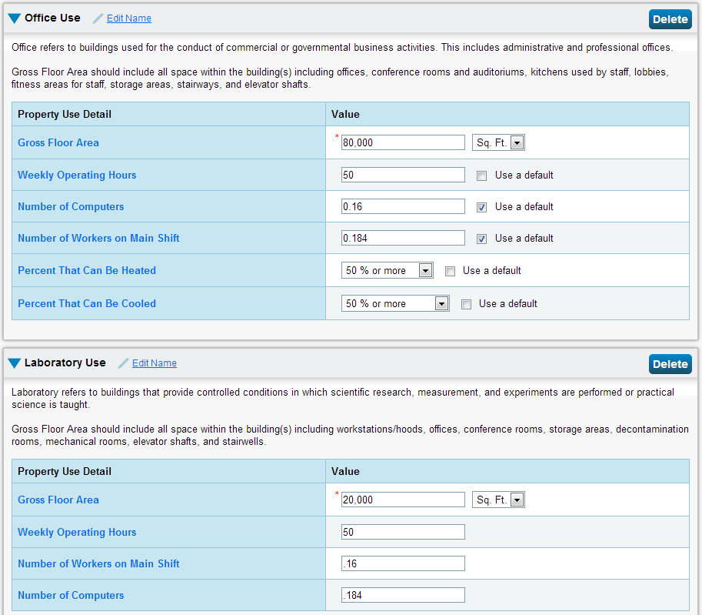

If needed, describe building to supplement the building inputs in Figure 1.

## Target Finder Outputs

Once the necessary inputs were entered into the Target Finder tool and results were generated, Target Finder then calculated the new ‘Target’ EUI based on a 60% reduction in energy usage for the project. Figure 2 shows a screenshot of the Target Finder results page for the project, showing the median (or regional) baseline EUI, project performance target EUI and other results.

Figure 2 - Target Finder Median (Baseline) & Design Target EUI (insert actual results)

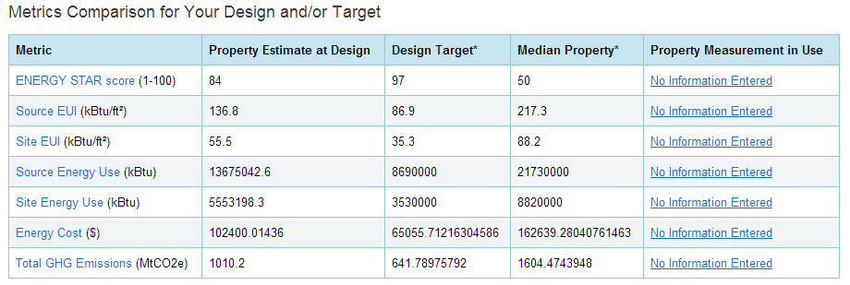

## Construction Incentive

based on the results from the table above, the Owner Performance Incentive is estimated to be *Click here to type Owner Construction Incentive $* and the Design Team Performance Incentive is estimated to be *Click here to type DT Construction Incentive $.*



## Performance Incentive

Also, based on the Target Finder results, the Owner Performance Incentive is estimated to be *Click here to type Owner Performance Incentive $* and the Design Team Performance Incentive is estimated to be *Click here to type DT Performance Incentive $.*



# Energy Model Documentation

## Energy Model

The tool used to perform this analysis is eQUEST (A Quick Energy Simulation Tool). This is a robust program that allows one to perform an hourly simulation of the building’s energy use based on local weather data, geometry and envelope characteristics, internal gains, system size and performances, schedules, and utility rates. The information used to assemble this model is based on feedback from the project team. Appendix A contains key model inputs for each design strategy. Appendix C and D provide the design team with the equipment sizing run information and lighting design information from the energy model, respectively. The design team and energy modeling consultant are encouraged to communicate, to ensure model inputs and assumptions are consistent with the design team’s schematic design.

Figure 3 shows a 3D picture of the facility as generated by eQUEST.

**Figure 3: Building Perspective**

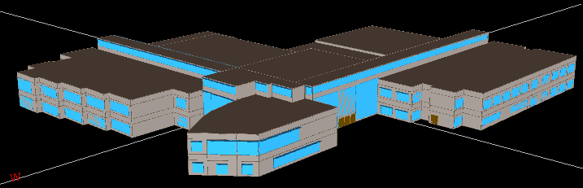

## Utility Rates

This project will be on the ______ electric rate from Fort Collins Utilities and _____ gas rate from Xcel [or other] [include other utilities if applicable, e.g. steam]. Details of the electric and gas rates used to estimate annual energy costs are detailed in the tables, below. Taxes [do / do not] apply to rates for this facility.

Table 7 - Electric Rate Schedule

|  |  |  |
| --- | --- | --- |
| Fort Collins Utilities Rate | X | |
| Monthly Customer Service Charge | YY | |
| Tax Rate (City, County, State) | Z% | |
| Price Plan XYZ Amount | AA% | |
| Energy ($/kWh) | BB | Summer |
| CC | Winter |
| Facility Demand ($/kW) | DD | Summer |
| EE | Winter |
| Coincident Demand ($/kW) | FF | Summer |
| GG | Winter |

(Tables to be formatted to fit various rate structures)

Table – Natural Gas Rate Schedule

|  |  |  |
| --- | --- | --- |
| Fort Collins Utilities Rate | X | |
| Monthly Customer Service Charge | YY | |
| Tax Rate (City, County, State) | Z% | |
| Price Plan XYZ Amount | AA% | |
| Energy Cost ($/therm) | BB | Summer |
| CC | Winter |

(Tables to be formatted to fit various rate structures)

## Energy Model Input Details

The following energy model takeoff sheet summarizes the technical inputs to the models for each design package that were obtained from the design team.

|  |  |  |  |
| --- | --- | --- | --- |
|  | **Package A** | **Package B** | **Package C** |
| Model file name |  |  |  |
| Total Building gross SF |  |  |  |
| Conditioned Area (SF) |  |  |  |
| Weather file used for computer model |  |  |  |
| Internal Loads |  |  |  |
| Occupancy (sf/person) |  |  |  |
| Ambient Lighting (W/sf) |  |  |  |
| Daylighting (% Ltg. Controlled) |  |  |  |
| Task Lighting (W/sf) |  |  |  |
| Plug Loads (W/sf) |  |  |  |
| Other equipment (W/sf) |  |  |  |
| Envelope |  |  |  |
| Exterior wall construction |  |  |  |
| Overall wall R-value |  |  |  |
| Roof construction |  |  |  |
| Overall roof R-value |  |  |  |
| Glazing SHGCs & U-values for North, South, East & West |  |  |  |
| Window/Wall ratio |  |  |  |
| Infiltration (e.g. cfm/sf² of wall & roof area) |  |  |  |
| HVAC |  |  |  |
| Primary cooling system type (centrifugal chiller, DX, etc.) |  |  |  |
| Cooling Plant fuel type (electric, gas, etc.) |  |  |  |
| Primary Cooling efficiency (kW/ton) |  |  |  |
| Primary heating system type (condensing boiler, furnace, etc.) |  |  |  |
| Thermal storage (Y/N), type, capacity |  |  |  |
| Heating plant fuel type (gas, electric, etc.) |  |  |  |
| Heating plant efficiency |  |  |  |
| Secondary system type (VAV w/ electric reheat, constant volume, etc.) |  |  |  |
| Supply fan control (inlet vanes, VFD, etc.) |  |  |  |
| Return fan control |  |  |  |
| Supply air temperature |  |  |  |
| OA reset used (Yes/No) |  |  |  |
| Occupied Setpoints (Htg./Clg.) |  |  |  |
| Unoccupied Setpoints |  |  |  |
| Total supply CFM |  |  |  |
| Outside air CFM |  |  |  |
| Exhaust air CFM |  |  |  |
| Heat recovery used (Y/N) |  |  |  |
| Demand Ventilation Control (Y/N) |  |  |  |
| Other |  |  |  |
| External lighting (kW) |  |  |  |
| Hours of operation |  |  |  |
| Elevator (kW) |  |  |  |
| Domestic Hot Water (occupied gpm) |  |  |  |
| DHW source (gas/electric) |  |  |  |
| Server Room loads (kW) & diversity |  |  |  |

## Model supply airflows and cooling loads

The table below shows the calculated supply airflows and cooling loads from the modeled design packages. Many of the airflows are very close to what the mechanical drawings indicate for design supply air. (ADD A TABLE FOR EACH DESIGN PACKAGE)



## Lighting Summary

The following table provides a summary of the lighting controls, lighting power density and lighting power for each space the model for each design package.

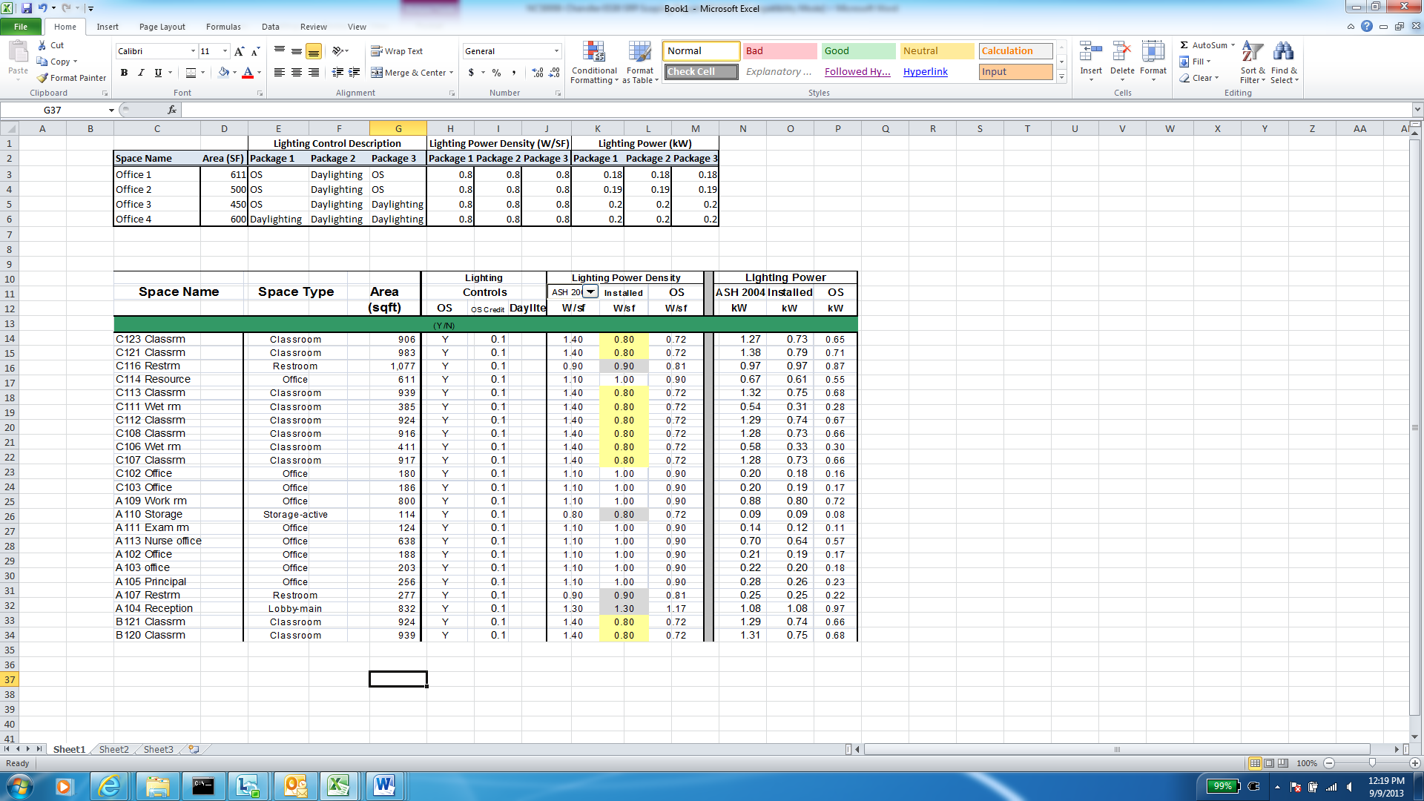

# Appendix A – Life Cycle Cost Analysis

Provide detail of life cycle cost analysis, including , including end of equipment useful life, maintenance costs, utility escalation rate and discount factor

# Appendix B – Summary Of IDAP Process

The following is a summary of the IDAPprocess (see Participant and Consultant manuals for details):

* Schematic Design Charrette (Click here to type Date)
  + Set Target EUI.
  + Establish 3 or more high performance building design strategies to be modeled.
  + Schedule for the design team to provide costs for each design strategy to the consultant.
  + Discuss anticipated integrated design assistance schedule and future meeting date
* Schematic Design Report
  + Analyze the interactive system effects and summarize the results at the whole building level for 3 or more design strategies.
* Design Development Meeting
  + Review impacts of the analyzed design strategies and select one to use as the proposed design Review changes or updates to the building design.
* Design Development Energy Report (DDER)
  + Revise the energy calculations and costs based on the proposed design strategy
* Final Energy Report
  + Confirm the selected design strategy and associated individual measures are incorporated in construction documents and refine model (if necessary).
* Final Energy Report Approval
  + Following completion of the FER the utility will perform a review. Owner submits signed Final Energy Report Approval form to Utilities
  + Design team submits application for design incentive
* Commissioning and air barrier testing conducted by the owner
  + Owner submits electronic versions of commissioning and air barrier test reports to Utilities
* Final Inspection
* Confirm design operation and energy savings post occupancy: Construction Incentive is paid to Owner and Design Team
  + Occupancy year 1: Participant tracks building performance relative to Target EUI. Program manager provides assistance to improve building performance if requested.
  + Occupancy year 2: Request for payment of Performance Incentive is submitted. Performance Incentive is paid if Target EUI is achieved.