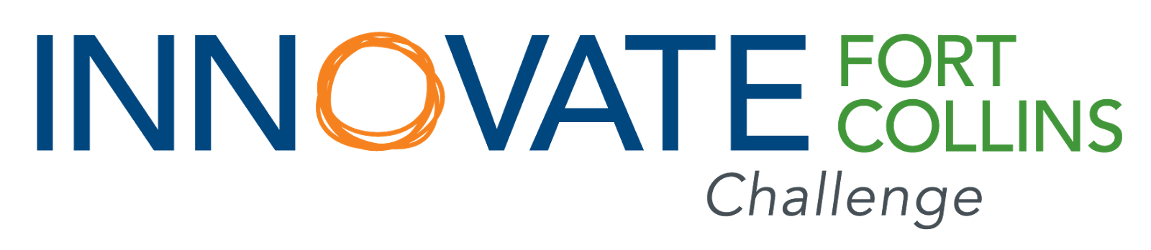
Letter of Intent (LOI) for Innovate Fort Collins Challenge Competition (IFCC)

Information and Eligibility
The City of Fort Collins has adopted ambitious goals to curb the effects of climate change and to ensure a safe, healthy and quality environment for our citizens and businesses to enjoy. The City knows it can’t achieve these lofty goals alone. Community and local business engagement and participation have been—and will continue to be—essential. To that end, the City is pleased to launch a new initiative in 2017 entitled, Innovate Fort Collins Challenge (IFCC). This competition seeks to engage the Fort Collins community by requesting innovative project solutions to help achieve the ambitious climate action goals. This initiative will award funding for entities such as, community and neighborhood groups, public-entities, businesses and nonprofit agencies, who want to engage in the scale-up and development of new or existing projects, technologies or initiatives that can contribute to helping the City meet its climate-action objectives. Advancement of the City’s climate-action objectives can be achieved primarily through programs, projects and technologies that can demonstrate Greenhouse Gas (GHG) emissions reductions and savings. Applications should focus on one or more of the following key areas:
- Accelerated uptake by city residents or businesses in conservation, efficiency and renewable energy (e.g. reduced energy use or increased alternative energy production);
- Increased utilization by city residents or businesses of alternative transportation options and behavior change vs. traditional automobile usage (e.g. reducing vehicle trips / reduced single-occupant travel in the city, etc.); and
- Greater reduction, reuse and recycling of waste materials by city residents or businesses.
Applicants are advised to read the application instructions fully before submission. It is the sole responsibility of the applicant to ensure that their application is complete and properly submitted. The City of Fort Collins may request supplemental materials from the applicant and such materials must be submitted within five business days of the request or the application may be rejected without further review.

LETTER OF INTENT INSTRUCTIONS AND PROCESS:
All applicants for the IFCC will need to go through an initial screen via submission of a Letter of Intent (LOI). Using the LOI questionnaire attached, tell us about how your project or idea will help us reach our climate action goals (i.e., directly/indirectly reduce greenhouse gas emissions) in the areas of waste/materials management, energy use and transportation. Once submitted, the LOI will be evaluated by the City’s IFCC Judging and Scoring Team to determine project fit and feasibility, according to the criteria found on our website and in the basic evaluation criteria listed below. A selected number of LOI applicants will then be invited to submit a full application for review. Only LOI applicants who are invited to submit a full application will be evaluated for full or partial funding.

The purpose of this LOI is for the IFCC Judging and Scoring Team to learn more about your project, concept, product or technology and to understand how you think your initiative can play a role in reducing greenhouse gas emissions and further help meet the climate-action goals adopted by the citizens of Fort Collins. Please answer the questions on the following page to the best of your ability: the IFCC Judging and Scoring Team understands that not all projects will be able to answer each question with the same degree of depth and clarity.

COMMUNICATIONS AND TIMELINE:
LOI material should be submitted no later than 5pm MDT on Friday, April 28, 2017. Due to the amount of expected interest, LOI deadline extensions will not be considered. The City’s IFCC Judging and Scoring Team will alert selected applicants that they are invited to submit a full application in early May.
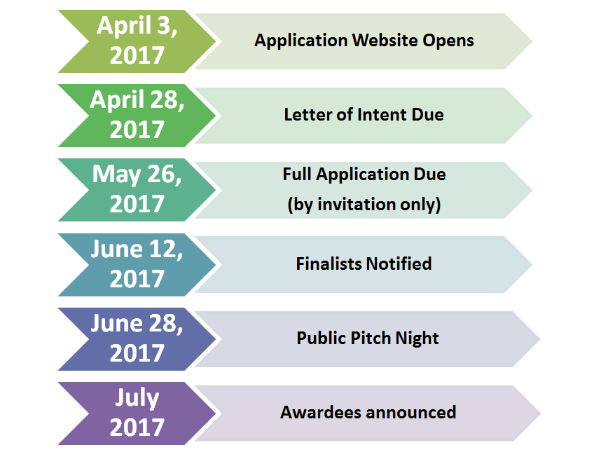

ELIGIBILITY REQUIREMENTS:
Eligible applicants will be located within the United States and may include, but not be limited to, businesses, organizations, foundations, nonprofits, HOAs, academic institutions, at the City’s sole discretion. Individuals and City of Fort Collins employees will not be eligible to be awarded funds. Eligible applicants will demonstrate:
- Clear alignment with targeted themes (see below)
- Clear articulation of project plan and schedule, budget, goals, metrics and data collection process
- Clear potential to reduce greenhouse gas reductions in Fort Collins
- Primary impact localized to Fort Collins (i.e. project benefits are within City limits)
- Sufficient, credible and current insurance, licensing and other documentation, as appropriate

FUNDING AMOUNTS AND DISTRIBUTION
Award amounts may range from $5,000 to $250,000 USD depending on project scope, project need, estimated impact to key areas mentioned below and approved budget. Up to one-third of the total project award may be distributed upon review of the project work plan, schedule and budget, final evaluation of the metrics and data collection plan. The remaining funds will be paid in installments, based on the successful completion of milestones to be established in the approved project workplan.

TARGETED THEMES AND PROJECT TYPES:
Targeted Themes
Qualified projects will be able to make progress and demonstrably achieve GHG reductions within the City of Fort Collins in one or more of three key areas. These key areas include energy, transportation and waste materials management.
- Energy
In this target area, the City seeks to fund projects that will decrease the environmental and social impact of energy use. Specifically, we are looking to invest in projects that can:
- Demonstrate direct changes in household or businesses energy efficiency and conservation (e.g. where homes and businesses focus efforts on using more energy efficient devices, appliance and infrastructure or use less energy through behavior change);
- Improve access to or allow for a switch to cleaner, renewable energy resources (e.g. those that emit negligible air emissions like solar or wind); and
- Provide energy education or awareness which would indirectly lead to reduced energy demand, increased energy efficiency and/or conservation and increased participation in clean energy programs and technology.

2. Transportation
The primary measure of performance for this area is Vehicle Miles Traveled (VMT). In this target theme we are looking to support community and business engagement and innovation around:
- Reducing traditional fuel use;
- Advancement of alternative modes of transportation including bikes, public transit (e.g. bus); and
- Changes in behaviors related to single occupancy vehicle travel and walking.

3. Waste and Materials Management
This target area is intended to help reduce the wasting of materials (goods and food) consumed in the community in support of the City’s adopted Road to Zero Waste goals. Keeping resources out of landfills when they are no longer useful (i.e., diversion) is one key strategy to achieving this goal. However, greenhouse gas emissions associated with waste and materials management occur all along the product “life cycle”- not only during use and disposal. Projects that reduce emissions from material consumption could focus on diverting waste from landfills and also on reducing waste at the source. Innovative project proposals might include elements of:
- Increasing reuse/repair/sharing of materials
- Processing waste into value-added products (composting, upcycling, milling, etc.)
- Developing/expanding local markets for waste materials
- Encouraging sustainable consumption in the community

Project types
- Pilot projects- limited test or trial of a technology, strategy, application, etc.
- Concept feasibility/demonstration- test the impact and viability of a new idea
- Education and awareness programs and campaigns- educate community members, neighbors, employees or businesses in new or creative ways.
- New product/service provision- continued development of a new product or service that has already demonstrated viability.
- Efforts to encourage behavior change- mobilization efforts aimed at altering behaviors for businesses and residents.
- Other- please specify in Application Narrative

PREFERRED PROJECT ATTRIBUTES:
Projects that demonstrate one or more of the qualities below will be prioritized during the selection and judging phase.
Matching Funds: There are no matching funds or cost-share requirements but projects securing additional funding will be prioritized during the application phase. Projects with a 2:1 leverage (or more) will receive additional points in the review process.
- For the purposes of this application, matching funds are defined as cash contributions to the total project cost. Matching funds do not flow through City of Fort Collins administration in any way. By definition, matching funds are managed or administered by the awardee or project partners who provided the funds, as part of the total project budget and project administration, and will be verified by written certification from a licensed accountant, CPA or executive leadership of the partnering organization.
- Prior investments that the partnering organization may use to indirectly support a proposed innovation project (e.g., tools, computers or vehicles) will not be considered to be matching funds for purposes of this application.
Inclusive Project Management: Projects that support authentic engagement from underrepresented populations (including but not limited to women, people of color, seniors (ages 55+) or people experiencing disabilities) in a leadership role (e.g., project manager, inventor, founder, etc.) are highly encouraged.
Social Equity: Projects that demonstrate an authentic equity component (i.e., impact of, integration with, or outreach) to underrepresented populations, including but not limited to women, people of color, people experiencing disabilities, youth and seniors, are highly encouraged.
Focused Collaboration: Projects demonstrating a regional collaboration with able partners, located in or around the Front Range, will be prioritized as long as the estimated GHG reductions are focused primarily in Fort Collins.
Scalability: The IFCC is squarely focused on projects and programs that have the potential for long-term impact and/or replication and scalability. Applicants are strongly encouraged to clearly explain long-term viability and potential impact.

PROPRIETARY AND LEGAL INFORMATION
Please note, project applications are subject to disclosure by the City of Fort Collins under statutory open records laws; they are not confidential. Please do not include proprietary information or other materials that cannot be publically disclosed within the application. Submitted concept videos may be used to promote the program and/or the community ‘pitch-night’ event. Any proposed changes to the transportation right-of-way would require City review and approval. Applicants are advised to consider all City, County and Federal laws, ordinances, zoning regulations and codes and other legal constraints, prior to submission.

Letter of Intent (LOI)
Please fill out and submit this LOI document to innovate@fcgov.com by April 28th, 2017 (5:00PM MDT)

Applicant Name(s):
Project Name:
Organization Name (i.e., organization you are submitting on behalf of):
Organization Type (e.g., public entity, non-profit association, neighborhood association, etc.):
Contact information
Phone:
Email:
Address:

    - PROJECT INFORMATION

1. Which prioritized area does your project most closely align with?
__Waste/materials management
__Energy, energy use and energy conservation
__Transportation

2. What type of project is this?
__Pilot projects- limited test or trial of a technology, strategy, application, etc.
__Concept feasibility/demonstration- test the impact and viability of a new idea
__Education and awareness programs and campaigns- educate community members, neighbors, employees or businesses in new or creative ways.
__New product/service provision- continued development of a new product or service that has already demonstrated viability.
__Efforts to encourage behavior change- mobilization efforts aimed at altering behaviors for businesses and residents.
__Other--(please specify below in 100 words or less).

3. What scale does this project attempt to impact? (Please select those that apply)
__This project intends to impact households
__This project intends to impact offices or businesses
__This project intends to impact the Fort Collins community-at-large
__This project intends to impact the region or nation

4. Please list the funds requested:

____________________________

    - ANTICIPATED IMPACTS

- In 250 words or fewer, tell us about your project, how long it will last and your expected impacts:

- In 250 words or fewer, describe who will be affected by your project. What primary target populations are you aiming to reach? Who else might be affected and why?

- Beyond greenhouse gas reductions, what other estimated/expected benefits do you see this project contributing? For example, are there additional health benefits, quality of life benefits, etc.? Please use fewer than 250 words.

4. If you are a business entity, are you a ClimateWise partner? (Please select applicable)
__Yes
__No

    - METRICS

1. In 500 words or less, please describe how your project will work to reduce greenhouse gas emissions and support the City’s goals to reach carbon-neutrality. Walk us through the link between your project concept, our prioritized areas (transportation, waste/materials management and energy use) and how it will reduce emissions.

2. In 250 words or less, describe your project goals. Be as specific and provide numbers (please note that you can opt to provide a high/low range).

3. Which of the following metrics do you plan to track? Select all that you can/plan to track.
__Gallons of gasoline/diesel (expected fuel savings over project duration)
__Passenger vehicles or vehicle miles traveled (i.e., vehicle miles reduced)
__Engagement or participation data (e.g., # of households/people reached)
__Tons of waste material (i.e., tons diverted from landfills)
__Other(s) (specify below)

    - IMPLEMENTATION:

- Tell us about how you plan to start your project. What, if anything, do you need in order to start implementation? Please answer in 250 words or less.

- What kind of support might you need during your project? For example, do you need access to any City assets? City staff? Technical assistance providers? Please answer in 250 words or less.

